UNITED STATES
SECURITIES AND EXCHANGE COMMISSION
Washington, D.C. 20549

FORM 8-K

CURRENT REPORT
Pursuant to Section 13 or 15(d)
of the Securities Exchange Act of 1934

Date of Report (Date of earliest event reported): April 30, 2026

Willis Towers Watson Public Limited Company
(Exact name of registrant as specified in its charter)

Ireland | 001-16503 | 98-0352587
(State or other jurisdiction  of incorporation) | (Commission  File Number) | (IRS Employer  Identification No.)

c/o Willis Group Limited, 51 Lime Street, London, EC3M 7DQ, England
(Address, including Zip Code, of Principal Executive Offices)

Registrant’s telephone number, including area code: (011) (44)-(20)- 3124-6000

Not Applicable
(Former name or former address, if changed since last report)

Check the appropriate box below if the Form 8-K filing is intended to simultaneously satisfy the filing obligation of the registrant under any of the following provisions:

 | ☐ | Written communications pursuant to Rule 425 under the Securities Act (17 CFR 230.425)

 | ☐ | Soliciting material pursuant to Rule 14a-12 under the Exchange Act (17 CFR 240.14a-12)

 | ☐ | Pre-commencement communications pursuant to Rule 14d-2(b) under the Exchange Act (17 CFR 240.14d-2(b))

 | ☐ | Pre-commencement communications pursuant to Rule 13e-4(c) under the Exchange Act (17 CFR 240.13e-4(c))

Securities registered pursuant to Section 12(b) of the Act:

Title of each class |  | Trading  Symbol(s) |  | Name of each exchange on which registered
Ordinary Shares, nominal value $0.000304635 per share |  | WTW |  | NASDAQ Global Select Market

Indicate by check mark whether the registrant is an emerging growth company as defined in Rule 405 of the Securities Act of 1933 (17 CFR §230.405) or Rule 12b-2 of the Securities Exchange Act of 1934 (17 CFR §240.12b-2).

Emerging growth company ☐

If an emerging growth company, indicate by check mark if the registrant has elected not to use the extended transition period for complying with any new or revised financial accounting standards provided pursuant to Section 13(a) of the Exchange Act. ☐

Item 2.02 |  | Results of Operations and Financial Condition.

On April 30, 2026, Willis Towers Watson Public Limited Company (“WTW”) issued a press release announcing its financial results for the period ended March 31, 2026.

A copy of WTW’s press release is attached hereto as Exhibit 99.1 to this Current Report on Form 8-K and is incorporated by reference herein. A reconciliation between certain non-GAAP financial measures and reported financial results is provided as an attachment to the press release.

Item 7.01 |  | Regulation FD.

WTW also posted to the investor relations section of its website a slide presentation which it may refer to during its conference call to discuss the results. The slide presentation is attached hereto as Exhibit 99.2 to this Current Report on Form 8-K and is incorporated by reference herein.

The information contained in Item 2.02 and Item 7.01 of this Current Report on Form 8-K (including Exhibits 99.1 and 99.2) is being furnished and shall not be deemed “filed” for the purposes of Section 18 of the Securities Exchange Act of 1934, as amended (the “Exchange Act”), or otherwise subject to the liabilities of that section. Such information shall not be incorporated by reference into any registration statement or other document pursuant to the Securities Act of 1933, as amended, or the Exchange Act, except as shall be expressly set forth by specific reference in any such filing.

Item 9.01 |  | Financial Statements and Exhibits.

(d) | Exhibits

The following exhibits are furnished herewith:

Exhibit  No. |  | Description
99.1 |  | Press release, dated April 30, 2026, announcing the financial results for the period ended March 31, 2026, for WTW.
99.2 |  | Slide Presentation, supplementing the above press release.
104 |  | Cover Page Interactive Data File (embedded within the Inline XBRL document).

SIGNATURES

Pursuant to the requirements of the Securities Exchange Act of 1934, the registrant has duly caused this report to be signed on its behalf by the undersigned hereunto duly authorized.
WILLIS TOWERS WATSON
PUBLIC LIMITED COMPANY
Date: April 30, 2026 | By: /s/ Andrew Krasner________________  Name: Andrew Krasner  Title: Chief Financial Officer

EXHIBIT 99.1
WTW Reports First Quarter 2026 Earnings
- Revenue1 increased 8% from prior year to $2.4 billion for the quarter
- Organic Revenue growth of 3% for the quarter
- Diluted Earnings per Share was $3.10 for the quarter, up 33% over prior year
- Adjusted Diluted Earnings per Share was $3.72 for the quarter, up 19% over prior year
- Operating Margin was 18.6% for the quarter, down 80 basis points from prior year
- Adjusted Operating Margin was 22.3% for the quarter, up 70 basis points from prior year
LONDON, April 30, 2026 (GLOBE NEWSWIRE) -- WTW (NASDAQ: WTW) (the “Company”), a leading global advisory, broking and solutions company, today announced financial results for the first quarter ended March 31, 2026.
“WTW delivered first quarter results that demonstrate our strong operating discipline and continued progress of our strategy,” said Carl Hess, WTW’s Chief Executive Officer. “Our ongoing focus on enhancing efficiency drove margin expansion and significant EPS growth, despite a more challenging global market that created near-term headwinds to organic growth. Our investments in talent, AI and innovation to accelerate performance continue driving client value, and we remain confident in delivering our full-year commitments.”
Consolidated Results
As reported, USD millions, except %
Key Metrics | Q1-26 | Q1-25 | Y/Y Change
Revenue1 | $2,412 | $2,223 | Reported 8% | CC 4% | Organic 3%
Income from Operations | $448 | $432 | 4%
Operating Margin % | 18.6% | 19.4% | (80) bps
Adjusted Operating Income | $537 | $480 | 12%
Adjusted Operating Margin % | 22.3% | 21.6% | 70 bps
Net Income | $303 | $239 | 27%
Adjusted Net Income | $357 | $316 | 13%
Diluted EPS | $3.10 | $2.33 | 33%
Adjusted Diluted EPS | $3.72 | $3.13 | 19%

1 | The revenue amounts included in this release are presented on a U.S. GAAP basis except where stated otherwise. The segment discussion is on an organic basis.
Revenue was $2.41 billion for the first quarter of 2026, an increase of 8% compared to $2.22 billion for the same period in the prior year. Excluding the impact of foreign currency, revenue increased 4%. On an organic basis, revenue increased 3%. See Supplemental Segment Information for additional detail on book-of-business settlements and interest income included in revenue.
Net Income for the first quarter of 2026 was $303 million compared to $239 million in the prior-year first quarter. Adjusted EBITDA for the first quarter was $589 million, or 24.4% of revenue, an increase of 11%, compared to Adjusted EBITDA of $532 million, or 23.9% of revenue, in the prior-year first quarter. The U.S. GAAP tax rate for the first quarter was 18.6%, and the adjusted income tax rate for the first quarter used in calculating adjusted diluted earnings per share was 20.3%.
Cash Flow and Capital Allocation
Cash flows used in operating activities were $10 million for the quarter ended March 31, 2026, compared to cash flows used in operating activities of $35 million in the prior year. Free cash flow for the quarters ended March 31, 2026 and 2025 was $(65) million and $(86) million, respectively, an increase of $21 million. The increase was primarily due to operating margin expansion and the abatement of remaining Transformation program cash outflows (this program was completed in December 2024), offset by increased transaction and integration expenses in the current-year quarter as compared to the prior-year quarter. During the first quarter, the Company repurchased $300 million of WTW shares.
First Quarter 2026 Segment Highlights
Health, Wealth & Career (“HWC”)
As reported, USD millions, except %
Health, Wealth & Career | Q1-26 | Q1-25 | Y/Y Change
Total Revenue | $1,265 | $1,165 | Reported 9% | CC 5% | Organic 3%
Operating Income | $346 | $311 | 11%
Operating Margin % | 27.3% | 26.7% | 60 bps
The HWC segment had revenue of $1.27 billion in the first quarter of 2026, an increase of 9% (5% increase constant currency and organic growth of 3%) from $1.17 billion in the prior year. Health delivered organic revenue growth driven by strong performance across international markets driven by new business wins and renewals. Wealth generated organic revenue growth supported by higher levels of retirement work across all regions, alongside growth in the Investments business. Career organic revenue declined as clients deferred discretionary work amid geopolitical uncertainty in the Middle East. Career also saw clients delaying projects with a moderation in advisory-related demand in North America, partially offset by growth outside North America. Benefits Delivery & Outsourcing (BD&O) organic revenue declined modestly, as expanded projects and administration engagements in Outsourcing were offset by lower commissions in Individual Marketplace.
Operating margin in the HWC segment increased 60 basis points from the prior-year first quarter to 27.3%. The increase was primarily driven by improved operating leverage and expense discipline.
Risk & Broking (“R&B”)
As reported, USD millions, except %
Risk & Broking | Q1-26 | Q1-25 | Y/Y Change
Total Revenue | $1,116 | $1,027 | Reported 9% | CC 3% | Organic 2%
Operating Income | $252 | $226 | 12%
Operating Margin % | 22.6% | 22.0% | 60 bps
The R&B segment had revenue of $1.12 billion in the first quarter of 2026, an increase of 9% (3% increase constant currency and organic growth of 2%) from $1.03 billion in the prior year. Corporate Risk & Broking (CRB) had organic revenue growth driven by new business activity and strong client retention globally. Insurance Consulting and Technology (ICT) delivered organic revenue growth primarily from strong software sales in the Technology practice.
Operating margin in the R&B segment increased 60 basis points from the prior-year first quarter to 22.6%. The increase was primarily driven by the impact of foreign exchange.
Select 2026 Financial Considerations
Adjusted operating margin:
- Continued annual margin expansion at the enterprise level driven by:
  - ~100 basis points of average annual margin expansion over the next 2 years in R&B
  - Incremental annual margin expansion in HWC
Capital allocation:
- Expect share repurchases of $1.0B or greater, subject to market conditions and potential capital allocation to organic and inorganic investment opportunities
Willis Re joint venture:
- Expected to be a headwind on Adjusted Diluted EPS of ~$0.30
- The remaining equity investments in the interest in earnings of associates line are not expected to be material in 2026
Newfront acquisition:
- Expected to be ~$0.10 dilutive to Adjusted EPS in 2026
- Expected 2026 post-close revenue of ~$250M and an adjusted EBITDA margin of ~26%
- Newfront’s Total Rewards business segment (~42%) will be included in HWC and Newfront’s Business Insurance business segment (~58%) will be included in R&B
Free cash flow:
- Continual improvement in FCF margin primarily from operating margin expansion along with evolving our business mix
Foreign exchange:
- Expect an incremental foreign currency tailwind on Adjusted Diluted EPS of ~$0.10 for the remainder of 2026, resulting in a ~$0.35 tailwind for the full year 2026 at today's rates
The 2026 Financial Considerations above include Non-GAAP financial measures. We do not reconcile forward-looking Non-GAAP measures for reasons explained under "WTW Non-GAAP Measures" below.
Conference Call
The Company will host a conference call to discuss the financial results for the first quarter 2026, including an update on strategic priorities and artificial intelligence initiatives. It will be held on Thursday, April 30, 2026, beginning at 9:00 a.m. Eastern Time. A live, listen-only webcast of the conference call will be available on WTW’s website. Analysts and institutional investors may participate in the conference call’s question-and-answer session by registering in advance here. An online replay will be available at investors.wtwco.com shortly after the call concludes.
About WTW
At WTW (NASDAQ: WTW), we provide data-driven, insight-led solutions in the areas of people, risk and capital. Leveraging the global view and local expertise of our colleagues serving 140 countries and markets, we help organizations sharpen their strategy, enhance organizational resilience, motivate their workforce and maximize performance. Working shoulder to shoulder with our clients, we uncover opportunities for sustainable success—and provide perspective that moves you. Learn more at www.wtwco.com.
WTW Non-GAAP Measures
In order to assist readers of our consolidated financial statements in understanding the core operating results that WTW’s management uses to evaluate the business and for financial planning, we present the following non-GAAP measures: (1) Constant Currency Change, (2) Organic Change, (3) Adjusted Operating Income/Margin, (4) Adjusted EBITDA/Margin, (5) Adjusted Net Income, (6) Adjusted Diluted Earnings Per Share, (7) Adjusted Income Before Taxes, (8) Adjusted Income Taxes/Tax Rate, (9) Free Cash Flow and (10) Free Cash Flow Margin.
We believe that those measures are relevant and provide pertinent information widely used by analysts, investors and other interested parties in our industry to provide a baseline for evaluating and comparing our operating performance, and in the case of free cash flow, our liquidity results.
Within the measures referred to as ‘adjusted’, we adjust for significant items which will not be settled in cash, or which we believe to be items that are not core to our current or future operations. Some of these items may not be applicable for the current quarter, however they may be part of our full-year results. Additionally, we have historically adjusted for certain items which are not described below, but for which we may adjust in a future period when applicable. Items applicable to the quarter or full year results, or the comparable periods, include the following:
- Transaction and integration expenses – Management believes it is appropriate to adjust for significant acquisition-related transaction and integration expenses including changes in significant estimated acquisition earnouts payable and acquisition-related compensation charges. We believe the adjustment is necessary to present how the Company is performing, both now and in the future when the incurrence of these costs will have concluded.
- Gains and losses on disposals of operations – Adjustment to remove the gains or losses resulting from disposed operations that have not been classified as discontinued operations.
- Net periodic pension and postretirement benefits – Adjustment to remove the recognition of net periodic pension and postretirement benefits (including pension settlements), other than service costs.
We evaluate our revenue on an as reported (U.S. GAAP), constant currency and organic basis. We believe presenting constant currency and organic information provides valuable supplemental information regarding our comparable results, consistent with how we evaluate our performance internally.
We consider Constant Currency Change, Organic Change, Adjusted Operating Income/Margin, Adjusted EBITDA/Margin, Adjusted Net Income, Adjusted Diluted Earnings Per Share, Adjusted Income Before Taxes, Adjusted Income Taxes/Tax Rate and Free Cash Flow to be important financial measures, which are used to internally evaluate and assess our core operations and to benchmark our operating and liquidity results against our competitors. These non-GAAP measures are important in illustrating what our comparable operating and liquidity results would have been had we not incurred transaction-related and non-recurring items. Reconciliations of these measures are included in the accompanying tables with the following exception: The Company does not reconcile its forward-looking non-GAAP financial measures to the corresponding U.S. GAAP measures, due to variability and difficulty in making accurate forecasts and projections and/or certain information not being ascertainable or accessible; and because not all of the information, such as foreign currency impacts necessary for a quantitative reconciliation of these forward-looking non-GAAP financial measures to the most directly comparable U.S. GAAP financial measure, is available to the Company without unreasonable efforts. For the same reasons, the Company is unable to address the probable significance of the unavailable information. The Company provides non-GAAP financial measures that it believes will be achieved, however it cannot accurately predict all of the components of the adjusted calculations and the U.S. GAAP measures may be materially different than the non-GAAP measures.
Our non-GAAP measures and their accompanying definitions are presented as follows:
Constant Currency Change – Represents the year-over-year change in revenue excluding the impact of foreign currency fluctuations. To calculate this impact, the prior year local currency results are first translated using the current year monthly average exchange rates. The change is calculated by comparing the prior year revenue, translated at the current year monthly average exchange rates, to the current year as reported revenue, for the same period. We believe constant currency measures provide useful information to investors because they provide transparency to performance by excluding the effects that foreign currency exchange rate fluctuations have on period-over-period comparability given volatility in foreign currency exchange markets.
Organic Change – Excludes the impact of fluctuations in foreign currency exchange rates, as described above and the period-over-period impact of acquisitions and divestitures on current-year revenue. We believe that excluding transaction-related items from our U.S. GAAP financial measures provides useful supplemental information to our investors, and it is important in illustrating what our core operating results would have been had we not included these transaction-related items, since the nature, size and number of these transaction-related items can vary from period to period.
Adjusted Operating Income/Margin – Income from operations adjusted for amortization, transaction and integration and non-recurring items that, in management’s judgment, significantly affect the period-over-period assessment of operating results. Adjusted operating income margin is calculated by dividing adjusted operating income by revenue. We consider adjusted operating income/margin to be important financial measures, which are used internally to evaluate and assess our core operations and to benchmark our operating results against our competitors.
Adjusted EBITDA/Margin – Net Income adjusted for provision for income taxes, interest expense, depreciation and amortization, transaction and integration, gains and losses on disposals of operations, net periodic pension and postretirement benefits, and non-recurring items that, in management’s judgment, significantly affect the period-over-period assessment of operating results. Adjusted EBITDA Margin is calculated by dividing adjusted EBITDA by revenue. We consider adjusted EBITDA/margin to be important financial measures, which are used internally to evaluate and assess our core operations, to benchmark our operating results against our competitors and to evaluate and measure our performance-based compensation plans.
Adjusted Net Income – Net Income Attributable to WTW adjusted for amortization, transaction and integration, gains and losses on disposals of operations, net periodic pension and postretirement benefits, and non-recurring items that, in management’s judgment, significantly affect the period-over-period assessment of operating results and the related tax effect of those adjustments and the tax effects of significant adjustments. This measure is used solely for the purpose of calculating adjusted diluted earnings per share.
Adjusted Diluted Earnings Per Share – Adjusted Net Income divided by the weighted-average number of ordinary shares, diluted. Adjusted diluted earnings per share is used to internally evaluate and assess our core operations and to benchmark our operating results against our competitors.
Adjusted Income Before Taxes – Income from operations before income taxes and interest in earnings of associates adjusted for amortization, transaction and integration, gains and losses on disposals of operations, net periodic pension and postretirement benefits, and non-recurring items that, in management’s judgment, significantly affect the period-over-period assessment of operating results. Adjusted income before taxes is used solely for the purpose of calculating the adjusted income tax rate.
Adjusted Income Taxes/Tax Rate – Provision for income taxes adjusted for taxes on certain items of amortization, transaction and integration, gains and losses on disposals of operations, net periodic pension and postretirement benefits, the tax effects of significant adjustments and non-recurring items that, in management’s judgment, significantly affect the period-over-period assessment of operating results, divided by adjusted income before taxes. Adjusted income taxes is used solely for the purpose of calculating the adjusted income tax rate. Management believes that the adjusted income tax rate presents a rate that is more closely aligned to the rate that we would incur if not for the reduction of pre-tax income for the adjusted items and the tax effects of significant adjustments, which are not core to our current and future operations.
Free Cash Flow – Cash flows from operating activities less cash used to purchase fixed assets and software. Management believes that free cash flow presents the core operating performance and cash-generating capabilities of our business operations.
Free Cash Flow Margin – Free Cash Flow as a percentage of revenue, which represents how much of revenue would be realized on a cash basis. We consider this measure to be a meaningful metric for tracking cash conversion on a year-over-year basis due to the non-cash nature of our pension income, which is included in our GAAP and Non-GAAP earnings metrics presented herein.
These non-GAAP measures are not defined in the same manner by all companies and may not be comparable to other similarly titled measures of other companies. Non-GAAP measures should be considered in addition to, and not as a substitute for, the information contained within our condensed consolidated financial statements.
WTW Forward-Looking Statements
This document contains ‘forward-looking statements’ within the meaning of Section 27A of the Securities Act of 1933, and Section 21E of the Securities Exchange Act of 1934, which are intended to be covered by the safe harbors created by those laws. These forward-looking statements include information about possible or assumed future results of our operations. All statements, other than statements of historical facts, that address activities, events or developments that we expect or anticipate may occur in the future, including such things as: our outlook; the potential impact of natural or man-made disasters like health pandemics and other world health crises; the impact of macroeconomic trends, including inflation, changes in interest rates, trade policies and other geopolitical risks; future capital expenditures; ongoing working capital efforts; future share repurchases; financial results (including our revenue, costs or margins) and the impact of changes to tax laws on our financial results; existing and evolving business strategies; our indebtedness; our ability to execute strategic transactions, including both acquisitions and dispositions, including our ability to receive adequate consideration or any earnout proceeds in return for any dispositions or integrate or manage acquired businesses (such as our recent acquisition of Newfront and our planned acquisition of Cushon); demand for our services and competitive strengths; strategic goals; the benefits of new initiatives; growth of our business and operations; the sustained health of our product, service, transaction, client, and talent assessment and management pipelines; our ability to successfully manage ongoing leadership, organizational and technology changes, including investments in improving systems and processes; our cybersecurity and privacy processes; our ability to protect our intellectual property; our application of artificial intelligence technologies throughout our business; our compliance with laws and regulations; our ability to implement and realize anticipated benefits of any cost-savings initiatives generated from our completed multi-year operational transformation program or other expense savings initiatives; our recognition of future impairment charges; and plans and references to future performance, including our future financial and operating results, short-term and long-term financial goals, plans, objectives, expectations and intentions, including with respect to free cash flow generation, adjusted net revenue, adjusted operating margin and adjusted earnings per share, are forward-looking statements. Also, when we use words such as ‘may’, ‘will’, ‘would’, ‘anticipate’, ‘believe’, ‘estimate’, ‘expect’, ‘intend’, ‘plan’, ‘continues’, ‘seek’, ‘target’, ‘goal’, ‘focus’, ‘probably’, or similar expressions, we are making forward-looking statements. Such statements are based upon the current beliefs and expectations of the Company’s management and are subject to significant risks and uncertainties. Actual results may differ from those set forth in the forward-looking statements. All forward-looking disclosure is speculative by its nature.
There are important risks, uncertainties, events and factors that could cause our actual results or performance to differ materially from those in the forward-looking statements contained in this document, including the following: our ability to successfully establish, execute and achieve our global business strategy as it evolves; our ability to fully realize the anticipated benefits of our growth strategy, including inorganic growth through acquisitions; our ability to achieve our short-term and long-term financial goals, such as with respect to our cash flow generation, and the timing with respect to such achievement; the risks related to changes in general economic conditions, business and political conditions, changes in the financial markets, inflation, credit availability, increased interest rates, changes in trade policies, increased tariffs and retaliatory actions; the risks to our short-term and long-term financial goals from any of the risks or uncertainties set forth herein; the risks relating to the adverse impacts of macroeconomic trends, including those relating to changes in trade policies and tariffs, as well as political events, war, such as the Russia-Ukraine war and conflict in the Middle East, and other international disputes, terrorism, natural disasters, public health issues and other business interruptions on the global economy and capital markets, such as uncertainty in the global markets, inflation, changes in interest rates and recessionary trends, changes in spending by government agencies and contractors, which could have a material adverse effect on our business, financial condition, results of operations and long-term goals; our ability to successfully hedge against fluctuations in foreign currency rates; the risks relating to the adverse impacts of natural or man-made disasters such as health pandemics and other world health crises on the demand for our products and services, our cash flows and our business operations; material interruptions to or loss of our information processing capabilities, or failure to effectively maintain and upgrade our information technology resources and systems; the insufficiency of client data protection, potential breaches of information systems or insufficient safeguards against cybersecurity breaches or incidents; our ability to comply with complex and evolving regulations related to data privacy, cybersecurity and artificial intelligence; significant competition that we face and the potential for loss of market share and/or profitability; the impact of seasonality and differences in timing of renewals and non-recurring revenue increases from disposals and book-of-business sales; the risk of increased liability or new legal claims arising from our new and existing products and services, and expectations, intentions and outcomes relating to outstanding litigation; the risk of substantial negative outcomes on existing or potential future litigation or investigation matters; changes in the regulatory environment in which we operate, including, among other risks, the impacts of pending competition law and regulatory investigations; various claims, government inquiries or investigations or the potential for regulatory action; our ability to make divestitures or acquisitions, including our ability to integrate or manage acquired businesses or carve-out businesses to be disposed, as well as our ability to identify and successfully execute on opportunities for strategic collaboration; our ability to integrate direct-to-consumer sales and marketing solutions with our existing offerings and solutions; our ability to successfully manage ongoing organizational changes, including as a result of our investments in improving systems and processes, and in connection with our acquisition and divestiture activities; disasters or business continuity problems; our ability to successfully enhance our billing, collection and other working capital efforts, and thereby increase our free cash flow; our ability to properly identify and manage conflicts of interest; reputational damage, including from association with third parties; reliance on third-party service providers and suppliers; risks relating to changes in our management structures and in senior leadership; the loss of key employees or a large number of employees and rehiring rates; our ability to maintain our corporate culture; doing business internationally, including the impact of global trade policies and retaliatory considerations as well as foreign currency exchange rates; compliance with extensive government regulation; the risk of sanctions imposed by governments, or changes to associated sanction regulations and related counter-sanctions; our ability to effectively apply artificial technology and other technology, data and analytics solutions, including for internal operations, maintaining industry standards, meeting client preferences and gaining competitive advantage, among other things; changes and developments in the insurance industry or the U.S. healthcare system, including those related to Medicare, and any other changes and developments in legal, regulatory, economic, business or operational conditions that could impact our businesses; the inability to protect our intellectual property rights, or the potential infringement upon the intellectual property rights of others; fluctuations in our pension assets and liabilities and related changes in pension income, including as a result of, related to, or derived from movements in the interest rate environment, investment returns, inflation, or changes in other assumptions that are used to estimate our benefit obligations and their effect on adjusted earnings per share; our capital structure, including indebtedness amounts, the limitations imposed by the covenants in the documents governing such indebtedness and the maintenance of the financial and disclosure controls and procedures of each; our ability to obtain financing on favorable terms or at all; adverse changes in our credit ratings; the impact of recent or potential changes to U.S. or foreign laws, and the enactment of additional, or the revision of existing, state, federal, and/or foreign laws and regulations, recent judicial decisions and development of case law, other regulations and any policy changes and legislative actions, including those that may impose additional excise taxes or impact our effective tax rate; U.S. federal income tax consequences to U.S. persons owning at least 10% of our shares; changes in accounting principles, estimates or assumptions; our recognition of future impairment charges; risks relating to or arising from environmental, social and governance (‘ESG’) practices; fluctuation in revenue against our relatively fixed or higher-than-expected expenses; the risk that investment levels across our portfolio increase, which can amplify the impact of market downturns; the laws of Ireland being different from the laws of the U.S. and potentially affording less protections to the holders of our securities; and our holding company structure potentially preventing us from being able to receive dividends or other distributions in needed amounts from our subsidiaries.
The foregoing list of factors is not exhaustive and new factors may emerge from time to time that could also affect actual performance and results. For more information, please see Part I, Item 1A in our Annual Report on Form 10-K, and our subsequent filings with the SEC. Copies are available online at http://www.sec.gov or www.wtwco.com.
Although we believe that the assumptions underlying our forward-looking statements are reasonable, any of these assumptions, and therefore also the forward-looking statements based on these assumptions, could themselves prove to be inaccurate. Given the significant uncertainties inherent in the forward-looking statements included in this document, our inclusion of this information is not a representation or guarantee by us that our objectives and plans will be achieved.
Our forward-looking statements speak only as of the date made and we will not update these forward-looking statements unless the securities laws require us to do so. With regard to these risks, uncertainties and assumptions, the forward-looking events discussed in this document may not occur, and we caution you against unduly relying on these forward-looking statements.
Contact
INVESTORS
Claudia De La Hoz | Claudia.Delahoz@wtwco.com
WTW
Supplemental Segment Information
(In millions of U.S. dollars)
(Unaudited)
REVENUE
 |  |  |  |  |  |  |  |  |  |  |  | Components of Revenue Change(i)
 |  |  |  |  |  |  |  |  |  |  |  | Less: |  |  |  | Less:
 |  | Three Months Ended  March 31, |  |  |  |  |  |  |  | As Reported |  | Currency |  | Constant Currency |  | Acquisitions/ |  | Organic
 |  | 2026 |  |  |  | 2025 |  |  |  | % Change |  | Impact |  | Change |  | Divestitures |  | Change
Health, Wealth & Career
Revenue excluding interest income |  | $ | 1,257 |  |  | $ | 1,158 |  |  | 9% |  | 4% |  | 5% |  | 2% |  | 3%
Interest income |  |  | 8 |  |  |  | 7
Total |  |  | 1,265 |  |  |  | 1,165 |  |  | 9% |  | 4% |  | 5% |  | 2% |  | 3%
Risk & Broking
Revenue excluding interest income |  | $ | 1,091 |  |  | $ | 1,005 |  |  | 9% |  | 6% |  | 3% |  | 1% |  | 2%
Interest income |  |  | 25 |  |  |  | 22
Total |  |  | 1,116 |  |  |  | 1,027 |  |  | 9% |  | 6% |  | 3% |  | 1% |  | 2%
Segment Revenue |  | $ | 2,381 |  |  | $ | 2,192 |  |  | 9% |  | 5% |  | 4% |  | 1% |  | 3%
Corporate, reimbursable expenses and other |  |  | 24 |  |  |  | 21
Interest income |  |  | 7 |  |  |  | 10
Revenue |  | $ | 2,412 |  |  | $ | 2,223 |  |  | 8% |  | 5% |  | 4% |  | 1% |  | 3%(ii)

(i) | Components of revenue change may not add due to rounding.
(ii) | Interest income did not contribute to organic change for the three months ended March 31, 2026.
BOOK-OF-BUSINESS SETTLEMENTS AND INTEREST INCOME
 |  | Three Months Ended March 31,
 |  | HWC |  |  |  |  |  |  |  | R&B |  |  |  |  |  |  |  | Corporate |  |  |  |  |  |  |  | Total
 |  | 2026 |  |  |  | 2025 |  |  |  | 2026 |  |  |  | 2025 |  |  |  | 2026 |  |  |  | 2025 |  |  |  | 2026 |  |  |  | 2025
Book-of-business settlements |  | $ | 1 |  |  | $ | 2 |  |  | $ | 7 |  |  | $ | — |  |  | $ | — |  |  | $ | — |  |  | $ | 8 |  |  | $ | 2
Interest income |  |  | 8 |  |  |  | 7 |  |  |  | 25 |  |  |  | 22 |  |  |  | 7 |  |  |  | 10 |  |  |  | 40 |  |  |  | 39
Total |  | $ | 9 |  |  | $ | 9 |  |  | $ | 32 |  |  | $ | 22 |  |  | $ | 7 |  |  | $ | 10 |  |  | $ | 48 |  |  | $ | 41
SEGMENT OPERATING INCOME (i)
Three Months Ended
March 31,
 |  | 2026 |  |  |  | 2025
Health, Wealth & Career |  | $ | 346 |  |  | $ | 311
Risk & Broking |  |  | 252 |  |  |  | 226
Segment Operating Income |  | $ | 598 |  |  | $ | 537

(i) | Segment operating income excludes certain costs, including amortization of intangibles, transaction and integration expenses, and to the extent that the actual expense based upon which allocations are made differs from the forecast/budget amount, a reconciling item will be created between internally-allocated expenses and the actual expenses reported for U.S. GAAP purposes.
SEGMENT OPERATING MARGINS
 |  | Three Months Ended March 31,
 |  | 2026 |  | 2025
Health, Wealth & Career |  | 27.3% |  | 26.7%
Risk & Broking |  | 22.6% |  | 22.0%
RECONCILIATION OF SEGMENT OPERATING INCOME TO INCOME FROM OPERATIONS BEFORE INCOME TAXES AND INTEREST IN EARNINGS OF ASSOCIATES
 |  | Three Months Ended March 31,
 |  | 2026 |  |  |  | 2025
Segment Operating Income |  | $ | 598 |  |  | $ | 537
Amortization |  |  | (48 | ) |  |  | (48 | )
Transaction and integration expenses(i) |  |  | (41 | ) |  |  | —
Unallocated, net(ii) |  |  | (61 | ) |  |  | (57 | )
Income from Operations |  |  | 448 |  |  |  | 432
Interest expense |  |  | (77 | ) |  |  | (65 | )
Other income/(loss), net |  |  | 5 |  |  |  | (64 | )
Income from operations before income taxes and interest in earnings of associates |  | $ | 376 |  |  | $ | 303
(i) Primarily includes share-based compensation and other transaction-related costs attributable to our Newfront acquisition.
(ii) Includes certain costs, primarily related to corporate functions which are not directly related to the segments, and certain differences between budgeted expenses determined at the beginning of the year and actual expenses that we report for U.S. GAAP purposes.
WTW
Reconciliations of Non-GAAP Measures
(In millions of U.S. dollars, except per share data)
(Unaudited)
RECONCILIATION OF NET INCOME ATTRIBUTABLE TO WTW TO ADJUSTED DILUTED EARNINGS PER SHARE
 |  | Three Months Ended March 31,
 |  | 2026 |  |  |  | 2025
Net income attributable to WTW |  | $ | 297 |  |  | $ | 235
Adjusted for certain items:
Amortization |  |  | 48 |  |  |  | 48
Transaction and integration expenses |  |  | 41 |  |  |  | —
Net periodic pension and postretirement benefits |  |  | (6 | ) |  |  | 75
Gain on disposal of operations |  |  | — |  |  |  | (14 | )
Tax effect on certain items listed above(i) |  |  | (23 | ) |  |  | (28 | )
Adjusted Net Income |  | $ | 357 |  |  | $ | 316
Weighted-average ordinary shares, diluted |  |  | 96 |  |  |  | 101
Diluted Earnings Per Share |  | $ | 3.10 |  |  | $ | 2.33
Adjusted for certain items:(ii)
Amortization |  |  | 0.50 |  |  |  | 0.48
Transaction and integration expenses |  |  | 0.43 |  |  |  | —
Net periodic pension and postretirement benefits |  |  | (0.06 | ) |  |  | 0.74
Gain on disposal of operations |  |  | — |  |  |  | (0.14 | )
Tax effect on certain items listed above(i) |  |  | (0.24 | ) |  |  | (0.28 | )
Adjusted Diluted Earnings Per Share(ii) |  | $ | 3.72 |  |  | $ | 3.13
(i) The tax effect was calculated using an effective tax rate for each item.
(ii) Per share values and totals may differ due to rounding.
RECONCILIATION OF NET INCOME TO ADJUSTED EBITDA
 |  | Three Months Ended March 31,
 |  | 2026 |  |  |  | 2025
Net income |  | $ | 303 |  | 12.6% | $ | 239 |  | 10.8%
Provision for income taxes |  |  | 70 |  |  |  | 65
Interest expense |  |  | 77 |  |  |  | 65
Depreciation |  |  | 56 |  |  |  | 54
Amortization |  |  | 48 |  |  |  | 48
Transaction and integration expenses |  |  | 41 |  |  |  | —
Net periodic pension and postretirement benefits |  |  | (6 | ) |  |  | 75
Gain on disposal of operations |  |  | — |  |  |  | (14 | )
Adjusted EBITDA and Adjusted EBITDA Margin |  | $ | 589 |  | 24.4% | $ | 532 |  | 23.9%
RECONCILIATION OF INCOME FROM OPERATIONS TO ADJUSTED OPERATING INCOME
 |  | Three Months Ended March 31,
 |  | 2026 |  |  |  | 2025
Income from operations and Operating margin |  | $ | 448 |  | 18.6% | $ | 432 |  | 19.4%
Adjusted for certain items:
Amortization |  |  | 48 |  |  |  | 48
Transaction and integration expenses |  |  | 41 |  |  |  | —
Adjusted operating income and Adjusted operating income margin |  | $ | 537 |  | 22.3% | $ | 480 |  | 21.6%
RECONCILIATION OF GAAP INCOME TAXES/TAX RATE TO ADJUSTED INCOME TAXES/TAX RATE
 |  | Three Months Ended March 31,
 |  | 2026 |  |  |  | 2025
Income from operations before income taxes and interest in earnings of associates |  | $ | 376 |  |  | $ | 303
Adjusted for certain items:
Amortization |  |  | 48 |  |  |  | 48
Transaction and integration expenses |  |  | 41 |  |  |  | —
Net periodic pension and postretirement benefits |  |  | (6 | ) |  |  | 75
Gain on disposal of operations |  |  | — |  |  |  | (14 | )
Adjusted income before taxes |  | $ | 459 |  |  | $ | 412
Provision for income taxes |  | $ | 70 |  |  | $ | 65
Tax effect on certain items listed above(i) |  |  | 23 |  |  |  | 28
Adjusted income taxes |  | $ | 93 |  |  | $ | 93
U.S. GAAP tax rate |  |  | 18.6 | % |  |  | 21.5 | %
Adjusted income tax rate |  |  | 20.3 | % |  |  | 22.7 | %
(i) The tax effect was calculated using an effective tax rate for each item.
RECONCILIATION OF CASH FLOWS USED IN OPERATING ACTIVITIES TO FREE CASH FLOW
 |  | Three Months Ended March 31,
 |  | 2026 |  |  |  | 2025
Cash flows used in operating activities |  | $ | (10 | ) |  | $ | (35 | )
Less: Additions to fixed assets and software |  |  | (55 | ) |  |  | (51 | )
Free Cash Flow |  | $ | (65 | ) |  | $ | (86 | )

WILLIS TOWERS WATSON PUBLIC LIMITED COMPANY
Condensed Consolidated Statements of Income
(In millions of U.S. dollars, except per share data)
(Unaudited)
Three Months Ended
March 31,
 |  | 2026 |  |  |  | 2025
Revenue |  | $ | 2,412 |  |  | $ | 2,223
Costs of providing services
Salaries and benefits |  |  | 1,434 |  |  |  | 1,324
Other operating expenses |  |  | 385 |  |  |  | 365
Depreciation |  |  | 56 |  |  |  | 54
Amortization |  |  | 48 |  |  |  | 48
Transaction and integration expenses |  |  | 41 |  |  |  | —
Total costs of providing services |  |  | 1,964 |  |  |  | 1,791
Income from operations |  |  | 448 |  |  |  | 432
Interest expense |  |  | (77 | ) |  |  | (65 | )
Other income/(loss), net |  |  | 5 |  |  |  | (64 | )
INCOME FROM OPERATIONS BEFORE INCOME TAXES AND INTEREST IN EARNINGS OF ASSOCIATES |  |  | 376 |  |  |  | 303
Provision for income taxes |  |  | (70 | ) |  |  | (65 | )
INCOME FROM OPERATIONS BEFORE INTEREST IN EARNINGS OF ASSOCIATES |  |  | 306 |  |  |  | 238
Interest in earnings of associates, net of tax |  |  | (3 | ) |  |  | 1
NET INCOME |  |  | 303 |  |  |  | 239
Income attributable to non-controlling interests |  |  | (6 | ) |  |  | (4 | )
NET INCOME ATTRIBUTABLE TO WTW |  | $ | 297 |  |  | $ | 235
EARNINGS PER SHARE
Basic earnings per share |  | $ | 3.12 |  |  | $ | 2.34
Diluted earnings per share |  | $ | 3.10 |  |  | $ | 2.33
Weighted-average ordinary shares, basic |  |  | 95 |  |  |  | 100
Weighted-average ordinary shares, diluted |  |  | 96 |  |  |  | 101

WILLIS TOWERS WATSON PUBLIC LIMITED COMPANY
Condensed Consolidated Balance Sheets
(In millions of U.S. dollars, except share data)
(Unaudited)
 |  | March 31, |  |  |  | December 31,
 |  | 2026 |  |  |  | 2025
ASSETS
Cash and cash equivalents |  | $ | 1,855 |  |  | $ | 3,132
Fiduciary assets |  |  | 10,981 |  |  |  | 10,445
Accounts receivable, net |  |  | 2,648 |  |  |  | 2,702
Prepaid and other current assets |  |  | 601 |  |  |  | 595
Total current assets |  |  | 16,085 |  |  |  | 16,874
Fixed assets, net |  |  | 671 |  |  |  | 695
Goodwill |  |  | 9,662 |  |  |  | 8,938
Other intangible assets, net |  |  | 1,275 |  |  |  | 1,141
Right-of-use assets |  |  | 499 |  |  |  | 487
Pension benefits assets |  |  | 541 |  |  |  | 529
Other non-current assets |  |  | 904 |  |  |  | 866
Total non-current assets |  |  | 13,552 |  |  |  | 12,656
TOTAL ASSETS |  | $ | 29,637 |  |  | $ | 29,530
LIABILITIES AND EQUITY
Fiduciary liabilities |  | $ | 10,981 |  |  | $ | 10,445
Deferred revenue and accrued expenses |  |  | 1,543 |  |  |  | 2,087
Current debt |  |  | — |  |  |  | 550
Current lease liabilities |  |  | 117 |  |  |  | 125
Other current liabilities |  |  | 906 |  |  |  | 797
Total current liabilities |  |  | 13,547 |  |  |  | 14,004
Long-term debt |  |  | 6,304 |  |  |  | 5,756
Liability for pension benefits |  |  | 630 |  |  |  | 660
Provision for liabilities |  |  | 361 |  |  |  | 340
Long-term lease liabilities |  |  | 485 |  |  |  | 472
Other non-current liabilities |  |  | 251 |  |  |  | 246
Total non-current liabilities |  |  | 8,031 |  |  |  | 7,474
TOTAL LIABILITIES |  |  | 21,578 |  |  |  | 21,478
COMMITMENTS AND CONTINGENCIES
EQUITY(i)
Additional paid-in capital |  |  | 11,239 |  |  |  | 11,106
Accumulated deficit |  |  | (392 | ) |  |  | (296 | )
Accumulated other comprehensive loss, net of tax |  |  | (2,870 | ) |  |  | (2,834 | )
Total WTW shareholders' equity |  |  | 7,977 |  |  |  | 7,976
Non-controlling interests |  |  | 82 |  |  |  | 76
Total Equity |  |  | 8,059 |  |  |  | 8,052
TOTAL LIABILITIES AND EQUITY |  | $ | 29,637 |  |  | $ | 29,530
__________________
(i) | Equity includes (a) Ordinary shares $0.000304635 nominal value; Authorized 1,510,003,775; Issued 94,277,914 (2026) and 95,079,835 (2025); Outstanding 94,277,914 (2026) and 95,079,835 (2025) and (b) Preference shares, $0.000115 nominal value; Authorized 1,000,000,000 and Issued none in 2026 and 2025.

WILLIS TOWERS WATSON PUBLIC LIMITED COMPANY
Condensed Consolidated Statements of Cash Flows
(In millions of U.S. dollars)
(Unaudited)
 |  | Three Months Ended March 31,
 |  | 2026 |  |  |  | 2025
CASH FLOWS USED IN OPERATING ACTIVITIES
NET INCOME |  | $ | 303 |  |  | $ | 239
Adjustments to reconcile net income to total net cash from operating activities:
Depreciation |  |  | 56 |  |  |  | 54
Amortization |  |  | 48 |  |  |  | 48
Non-cash lease expense |  |  | 25 |  |  |  | 25
Net periodic cost of defined benefit pension plans |  |  | 6 |  |  |  | 88
Provision for doubtful receivables from clients |  |  | 6 |  |  |  | 5
Benefit from deferred income taxes |  |  | (30 | ) |  |  | (23 | )
Share-based compensation |  |  | 42 |  |  |  | 37
Gain on disposal of operations |  |  | — |  |  |  | (14 | )
Non-cash foreign exchange (gain)/loss |  |  | (14 | ) |  |  | 9
Other, net |  |  | 18 |  |  |  | 9
Changes in operating assets and liabilities, net of effects from purchase of subsidiaries:
Accounts receivable |  |  | 75 |  |  |  | 162
Other assets |  |  | (51 | ) |  |  | 1
Other liabilities |  |  | (517 | ) |  |  | (691 | )
Provisions |  |  | 23 |  |  |  | 16
Net cash used in operating activities |  |  | (10 | ) |  |  | (35 | )
CASH FLOWS USED IN INVESTING ACTIVITIES
Additions to fixed assets and software |  |  | (55 | ) |  |  | (51 | )
Acquisitions of operations, net of cash acquired |  |  | (792 | ) |  |  | (1 | )
Contributions to investments in associates |  |  | (9 | ) |  |  | (1 | )
Net sales/(purchases) of available-for-sale securities |  |  | 16 |  |  |  | (31 | )
Net cash used in investing activities |  |  | (840 | ) |  |  | (84 | )
CASH FLOWS (USED IN)/FROM FINANCING ACTIVITIES
Borrowing of other debt |  |  | 550 |  |  |  | —
Debt issuance costs |  |  | (4 | ) |  |  | —
Repayments of debt |  |  | (551 | ) |  |  | (1 | )
Repurchase of shares |  |  | (300 | ) |  |  | (200 | )
Net proceeds from fiduciary funds held for clients |  |  | 192 |  |  |  | 315
Cash paid for employee taxes on withholding shares |  |  | (2 | ) |  |  | (2 | )
Dividends paid |  |  | (88 | ) |  |  | (88 | )
Net cash (used in)/from financing activities |  |  | (203 | ) |  |  | 24
DECREASE IN CASH, CASH EQUIVALENTS AND RESTRICTED CASH |  |  | (1,053 | ) |  |  | (95 | )
Effect of exchange rate changes on cash, cash equivalents and restricted cash |  |  | (29 | ) |  |  | 80
CASH, CASH EQUIVALENTS AND RESTRICTED CASH, BEGINNING OF PERIOD(i) |  |  | 6,487 |  |  |  | 4,998
CASH, CASH EQUIVALENTS AND RESTRICTED CASH, END OF PERIOD(i) |  | $ | 5,405 |  |  | $ | 4,983
__________________
(i) | The amounts of cash, cash equivalents and restricted cash, their respective classification on the condensed consolidated balance sheets, as well as their respective portions of the increase or decrease in cash, cash equivalents and restricted cash for each of the periods presented have been included in the Supplemental Disclosure of Cash Flow Information section.
SUPPLEMENTAL DISCLOSURE OF CASH FLOW INFORMATION
(In millions of U.S. dollars)
 |  | Three Months Ended March 31,
 |  | 2026 |  |  |  | 2025
Supplemental disclosures of cash flow information:
Cash and cash equivalents |  | $ | 1,855 |  |  | $ | 1,507
Fiduciary funds (included in fiduciary assets) |  |  | 3,550 |  |  |  | 3,476
Total cash, cash equivalents and restricted cash |  | $ | 5,405 |  |  | $ | 4,983
Decrease in cash, cash equivalents and other restricted cash |  | $ | (1,260 | ) |  | $ | (411 | )
Increase in fiduciary funds |  |  | 207 |  |  |  | 316
Total(i) |  | $ | (1,053 | ) |  | $ | (95 | )

(i) | Does not include the effect of exchange rate changes on cash, cash equivalents and restricted cash.

Exhibit 99.2


wtwco.com © 2026 WTW. All rights reserved. WTW April 30, 2026 Earnings Release Supplemental Materials 2026 First Quarter Financial Results

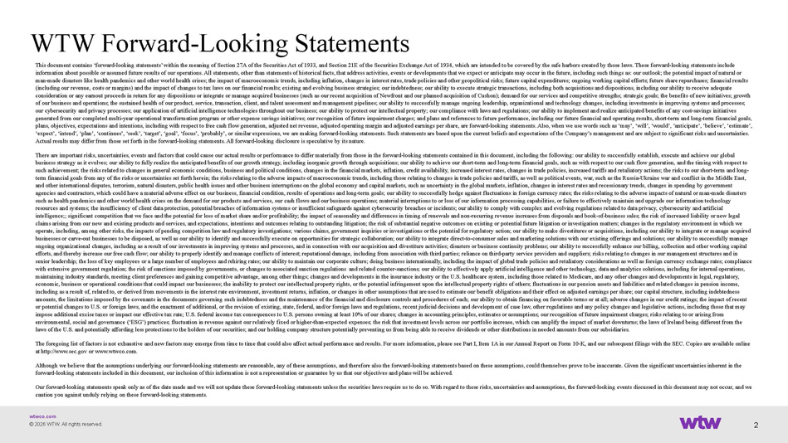
wtwco.com WTW Forward - Looking Statements This document contains ‘forward - looking statements’ within the meaning of Section 27A of the Securities Act of 1933, and Section 21E of the Securities Exchange Act of 1934, which are intended to be covered by the safe harbors created by those laws. These f orward - looking statements include information about possible or assumed future results of our operations. All statements, other than statements of historical f act s, that address activities, events or developments that we expect or anticipate may occur in the future, including such thing s a s: our outlook; the potential impact of natural or man - made disasters like health pandemics and other world health crises; the impact of macroeconomic trends, including inflation, changes in interest rates, trade policies and other geopolitical risks; future capital expenditures; ongoing working capital ef forts; future share repurchases; financial results (including our revenue, costs or margins) and the impact of changes to tax laws on our financial results; existing and evolvi ng business strategies; our indebtedness; our ability to execute strategic transactions, including both acquisitions and disposi tio ns, including our ability to receive adequate consideration or any earnout proceeds in return for any dispositions or integrate or manage acquired businesses (such as our rec ent acquisition of Newfront and our planned acquisition of Cushon); demand for our services and competitive strengths; strate gic goals; the benefits of new initiatives; growth of our business and operations; the sustained health of our product, service, transaction, client, and talent assessment and man agement pipelines; our ability to successfully manage ongoing leadership, organizational and technology changes, including in ves tments in improving systems and processes; our cybersecurity and privacy processes; our application of artificial intelligence technologies throughout our business; our ab ility to protect our intellectual property; our compliance with laws and regulations; our ability to implement and realize an tic ipated benefits of any cost - savings initiatives generated from our completed multi - year operational transformation program or other expense savings initiatives; our recognition of future impairment charges; and plans and references to future performance, including our future financial and operating re su lts, short - term and long - term financial goals, plans, objectives, expectations and intentions, including with respect to free cash flow generation, adjusted net revenue, ad jus ted operating margin and adjusted earnings per share, are forward - looking statements. Also, when we use words such as ‘may’, ‘wi ll’, ‘would’, ‘anticipate’, ‘believe’, ‘estimate’, ‘expect’, ‘intend’, ‘plan’, ‘continues’, ‘seek’, ‘target’, ‘goal’, ‘focus’, ‘probably’, or similar expressions, we are making fo rward - looking statements. Such statements are based upon the current beliefs and expectations of the Company’s management and ar e subject to significant risks and uncertainties. Actual results may differ from those set forth in the forward - looking statements. All forward - looking disclosure is speculative by its nature. There are important risks, uncertainties, events and factors that could cause our actual results or performance to differ mat eri ally from those in the forward - looking statements contained in this document, including the following: our ability to successful ly establish, execute and achieve our global business strategy as it evolves; our ability to fully realize the anticipated benefits of our growth strategy, including inor gan ic growth through acquisitions; our ability to achieve our short - term and long - term financial goals, such as with respect to our cash flow generation, and the timing with respect to such achievement; the risks related to changes in general economic conditions, business and political conditions, changes in the financial markets, inflation, credit availability, increased interest rates, changes in trade policies, increased tariffs and r etaliatory actions; the risks to our short - term and long - term financial goals from any of the risks or uncertainties set forth herein; the risks relating to the adverse impacts of ma cro economic trends, including those relating to changes in trade policies and tariffs, as well as political events, war, such as th e Russia - Ukraine war and conflict in the Middle East, and other international disputes, terrorism, natural disasters, public health issues and other business interruptions on the glo bal economy and capital markets, such as uncertainty in the global markets, inflation, changes in interest rates and recessio nar y trends, changes in spending by government agencies and contractors, which could have a material adverse effect on our business, financial condition, results of operati ons and long - term goals; our ability to successfully hedge against fluctuations in foreign currency rates; the risks relating to th e adverse impacts of natural or man - made disasters such as health pandemics and other world health crises on the demand for our products and services, our cash flows and our bu sin ess operations; material interruptions to or loss of our information processing capabilities, or failure to effectively maint ain and upgrade our information technology resources and systems; the insufficiency of client data protection, potential breaches of information systems or insufficient sa feguards against cybersecurity breaches or incidents; our ability to comply with complex and evolving regulations related to dat a privacy, cybersecurity and artificial intelligence;; significant competition that we face and the potential for loss of market share and/or profitability; the impa ct of seasonality and differences in timing of renewals and non - recurring revenue increases from disposals and book - of - business sal es; the risk of increased liability or new legal claims arising from our new and existing products and services, and expectations, intentions and outcomes relating to outstan din g litigation; the risk of substantial negative outcomes on existing or potential future litigation or investigation matters; cha nges in the regulatory environment in which we operate, including, among other risks, the impacts of pending competition law and regulatory investigations; various claims, gov ernment inquiries or investigations or the potential for regulatory action; our ability to make divestitures or acquisitions, in cluding our ability to integrate or manage acquired businesses or carve - out businesses to be disposed, as well as our ability to identify and successfully execute on opportunities for strategic collaboration; our ability to integrate direct - to - consumer sales and marketing solutions with our existing offerin gs and solutions; our ability to successfully manage ongoing organizational changes, including as a result of our investments in improving systems and processes, and in connectio n w ith our acquisition and divestiture activities; disasters or business continuity problems; our ability to successfully enhanc e o ur billing, collection and other working capital efforts, and thereby increase our free cash flow; our ability to properly identify and manage conflicts of interest; reputati ona l damage, including from association with third parties; reliance on third - party service providers and suppliers; risks relating to changes in our management structures and in senior leadership; the loss of key employees or a large number of employees and rehiring rates; our ability to maintain our c orp orate culture; doing business internationally, including the impact of global trade policies and retaliatory considerations a s w ell as foreign currency exchange rates; compliance with extensive government regulation; the risk of sanctions imposed by governments, or changes to associated sanction regulat ion s and related counter - sanctions; our ability to effectively apply artificial intelligence and other technology, data and analyt ics solutions, including for internal operations, maintaining industry standards, meeting client preferences and gaining competitive advantage, among other things; changes and de velopments in the insurance industry or the U.S. healthcare system, including those related to Medicare, and any other change s a nd developments in legal, regulatory, economic, business or operational conditions that could impact our businesses; the inability to protect our intellectual prop ert y rights, or the potential infringement upon the intellectual property rights of others; fluctuations in our pension assets a nd liabilities and related changes in pension income, including as a result of, related to, or derived from movements in the interest rate environment, investment returns, inflati on, or changes in other assumptions that are used to estimate our benefit obligations and their effect on adjusted earnings per s ha re; our capital structure, including indebtedness amounts, the limitations imposed by the covenants in the documents governing such indebtedness and the maintenance of the fin anc ial and disclosure controls and procedures of each; our ability to obtain financing on favorable terms or at all; adverse cha nge s in our credit ratings; the impact of recent or potential changes to U.S. or foreign laws, and the enactment of additional, or the revision of existing, state, federal, a nd/ or foreign laws and regulations, recent judicial decisions and development of case law, other regulations and any policy chan ges and legislative actions, including those that may impose additional excise taxes or impact our effective tax rate; U.S. federal income tax consequences to U.S. persons owning at least 10% of our shares; changes in accounting principles, estimates or assumptions; our recognition of future impairment cha rge s; risks relating to or arising from environmental, social and governance (‘ESG’) practices; fluctuation in revenue against our relatively fixed or higher - than - expec ted expenses; the risk that investment levels across our portfolio increase, which can amplify the impact of market downturns ; t he laws of Ireland being different from the laws of the U.S. and potentially affording less protections to the holders of our securities; and our holding company structu re potentially preventing us from being able to receive dividends or other distributions in needed amounts from our subsidiaries . The foregoing list of factors is not exhaustive and new factors may emerge from time to time that could also affect actual pe rfo rmance and results. For more information, please see Part I, Item 1A in our Annual Report on Form 10 - K, and our subsequent filin gs with the SEC. Copies are available online at http://www.sec.gov or www.wtwco.com. Although we believe that the assumptions underlying our forward - looking statements are reasonable, any of these assumptions, and therefore also the forward - looking statements based on these assumptions, could themselves prove to be inaccurate. Given the si gnificant uncertainties inherent in the forward - looking statements included in this document, our inclusion of this information is not a representation or guarantee by us that our objectives and plans will be achieved. Our forward - looking statements speak only as of the date made and we will not update these forward - looking statements unless the securities laws require us to do so. With regard to these risks, uncertainties and assumptions, the forward - looking events disc ussed in this document may not occur, and we caution you against unduly relying on these forward - looking statements. 2 © 2026 WTW. All rights reserved.

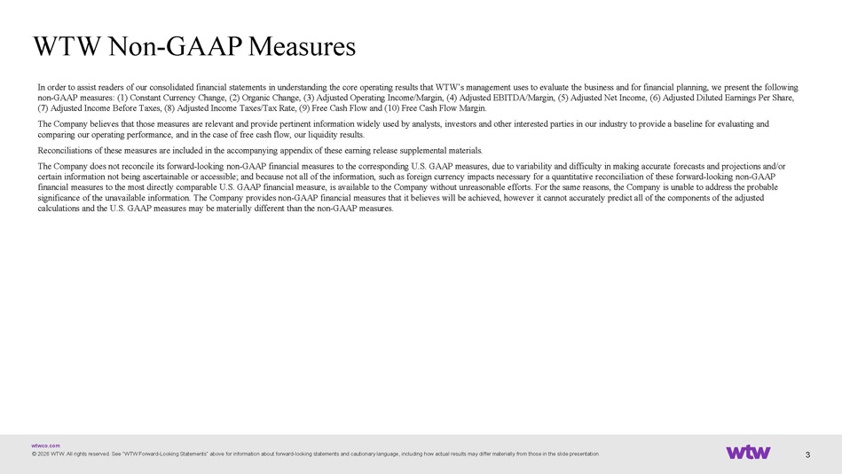
wtwco.com © 2026 WTW. All rights reserved. See “WTW Forward - Looking Statements“ above for information about forward - looking statements and cautionary language, including how actual results may differ materially from those in the slide presentation. WTW Non - GAAP Measures In order to assist readers of our consolidated financial statements in understanding the core operating results that WTW’s ma nag ement uses to evaluate the business and for financial planning, we present the following non - GAAP measures: (1) Constant Currency Change, (2) Organic Change, (3) Adjusted Operating Income/Margin, (4) Adjusted EBITDA/M argin, (5) Adjusted Net Income, (6) Adjusted Diluted Earnings Per Share, (7) Adjusted Income Before Taxes, (8) Adjusted Income Taxes/Tax Rate, (9) Free Cash Flow and (10) Free Cash Flow Margin. The Company believes that those measures are relevant and provide pertinent information widely used by analysts, investors an d o ther interested parties in our industry to provide a baseline for evaluating and comparing our operating performance, and in the case of free cash flow, our liquidity results. Reconciliations of these measures are included in the accompanying appendix of these earning release supplemental materials. The Company does not reconcile its forward - looking non - GAAP financial measures to the corresponding U.S. GAAP measures, due to v ariability and difficulty in making accurate forecasts and projections and/or certain information not being ascertainable or accessible; and because not all of the information, such as foreign currency i mpa cts necessary for a quantitative reconciliation of these forward - looking non - GAAP financial measures to the most directly comparable U.S. GAAP financial measure, is available to the Company without unreasona ble efforts. For the same reasons, the Company is unable to address the probable significance of the unavailable information. The Company provides non - GAAP financial measures that it believes will be achieved, however it cannot accurately predict all of the components of the adjusted calculations and the U.S. GAAP measures may be materially different than the non - GAAP measures. 3

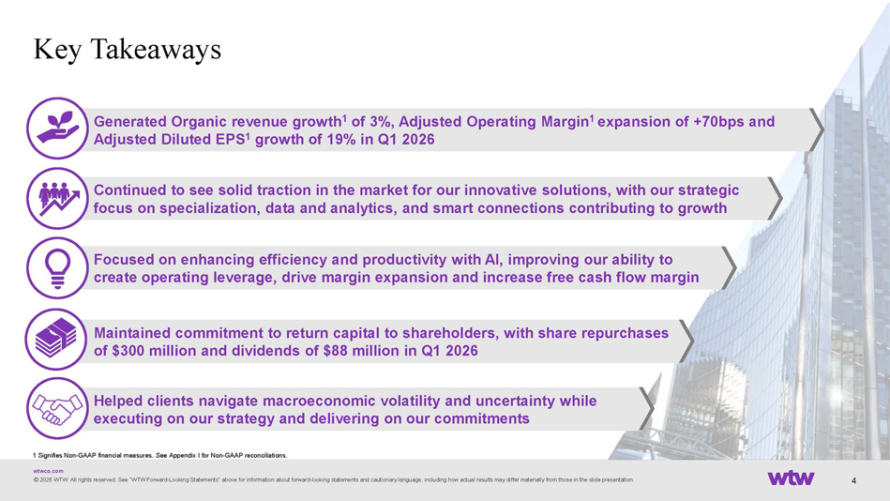
wtwco.com Helped clients navigate macroeconomic volatility and uncertainty while executing on our strategy and delivering on our commitments Maintained commitment to return capital to shareholders, with share repurchases of $300 million and dividends of $88 million in Q1 2026 Generated Organic revenue growth 1 of 3%, Adjusted Operating Margin 1 expansion of +70bps and Adjusted Diluted EPS 1 growth of 19% in Q1 2026 Continued to see solid traction in the market for our innovative solutions, with our strategic focus on specialization, data and analytics, and smart connections contributing to growth © 2026 WTW. All rights reserved. See “WTW Forward - Looking Statements“ above for information about forward - looking statements and cautionary language, including how actual results may differ materially from those in the slide presentation. Key Takeaways Focused on enhancing efficiency and productivity with AI, improving our ability to create operating leverage, drive margin expansion and increase free cash flow margin 4 1 Signifies Non - GAAP financial measures. See Appendix I for Non - GAAP reconciliations.

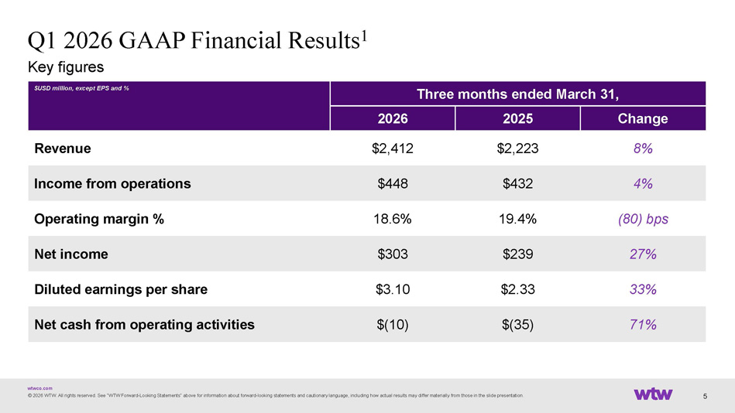
wtwco.com Key figures © 2026 WTW. All rights reserved. See “WTW Forward - Looking Statements“ above for information about forward - looking statements and cautionary language, including how actual results may differ materially from those in the slide presentation. Q1 2026 GAAP Financial Results 1 5 Three months ended March 31, $USD million, except EPS and % Change 2025 2026 8% $2,223 $2,412 Revenue 4% $432 $448 Income from operations (80) bps 19.4% 18.6% Operating margin % 27% $239 $303 Net income 33% $2.33 $3.10 Diluted earnings per share 71% $(35) $(10) Net cash from operating activities

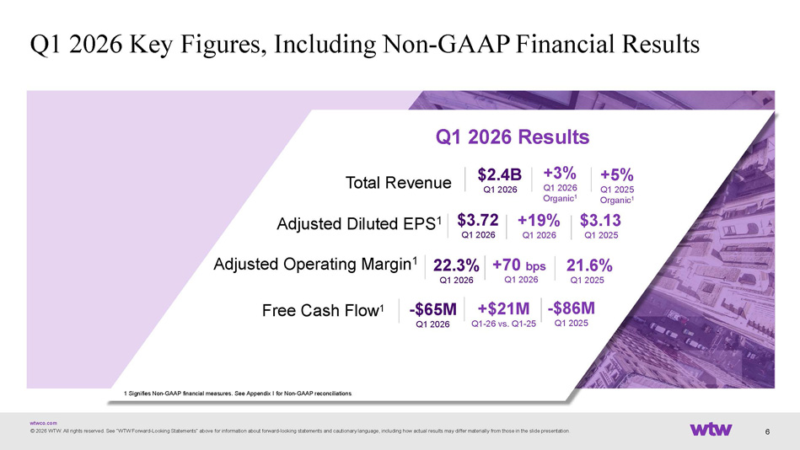
wtwco.com © 2026 WTW. All rights reserved. See “WTW Forward - Looking Statements“ above for information about forward - looking statements and cautionary language, including how actual results may differ materially from those in the slide presentation. Q1 2026 Key Figures, Including Non - GAAP Financial Results Total Revenue +3% Q1 2026 Organic 1 +5 % Q1 2025 Organic 1 Adjusted Diluted EPS 1 Q1 2026 Results Adjusted Operating Margin 1 Free Cash Flow 1 $2.4 B Q1 2026 $ 3.72 Q1 2026 $ 3.13 Q1 2025 - $65M Q1 2026 +19% Q1 2026 22.3% Q1 2026 +70 bps Q1 2026 21.6 % Q1 2025 +$21M Q1 - 26 vs. Q1 - 25 - $86M Q1 2025 6 1 Signifies Non - GAAP financial measures. See Appendix I for Non - GAAP reconciliations .

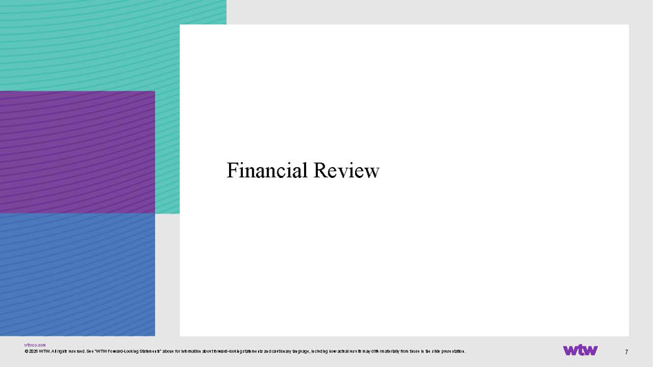
wtwco.com 7 Financial Review © 2026 WTW. All rights reserved. See “WTW Forward - Looking Statements“ above for information about forward - looking statements and cautionary language, including how actual results may differ materially from those in the slide presentation.

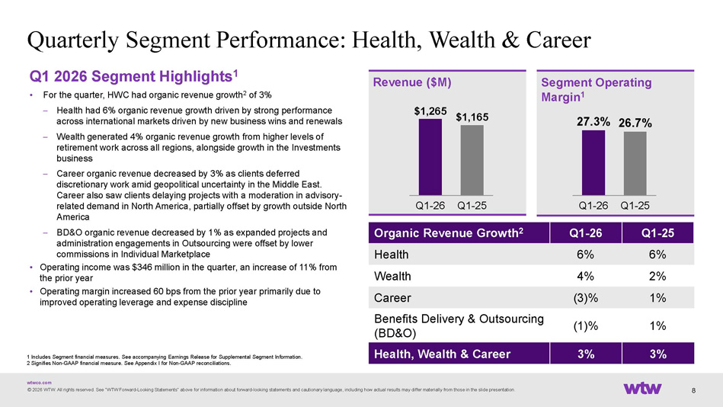
wtwco.com Q1 2026 Segment Highlights 1 • For the quarter, HWC had organic revenue growth 2 of 3% – Health had 6% organic revenue growth driven by strong performance across international markets driven by new business wins and renewals – Wealth generated 4% organic revenue growth from higher levels of retirement work across all regions, alongside growth in the Investments business – Career organic revenue decreased by 3% as clients deferred discretionary work amid geopolitical uncertainty in the Middle East. Career also saw clients delaying projects with a moderation in advisory - related demand in North America, partially offset by growth outside North America – BD&O organic revenue decreased by 1% as expanded projects and administration engagements in Outsourcing were offset by lower commissions in Individual Marketplace • Operating income was $346 million in the quarter, an increase of 11% from the prior year • Operating margin increased 60 bps from the prior year primarily due to improved operating leverage and expense discipline Quarterly Segment Performance: Health, Wealth & Career © 2026 WTW. All rights reserved. See “WTW Forward - Looking Statements“ above for information about forward - looking statements and cautionary language, including how actual results may differ materially from those in the slide presentation. $1,265 $1,165 Q1 - 26 Q1 - 25 Revenue ($M) Segment Operating Margin 1 Q1 - 25 Q1 - 26 Organic Revenue Growth 2 6% 6% Health 2% 4% Wealth 1% (3)% Career 1% (1)% Benefits Delivery & Outsourcing (BD&O) 3% 3% Health, Wealth & Career 27.3% 26.7% Q1 - 26 Q1 - 25 1 Includes Segment financial measures. See accompanying Earnings Release for Supplemental Segment Information. 2 Signifies Non - GAAP financial measure. See Appendix I for Non - GAAP reconciliations . 8

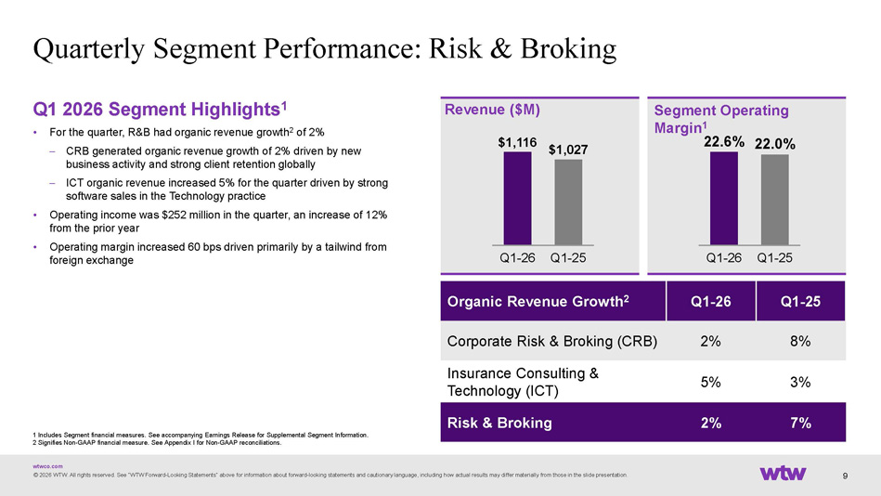
wtwco.com Q1 2026 Segment Highlights 1 • For the quarter, R&B had organic revenue growth 2 of 2% – CRB generated organic revenue growth of 2% driven by new business activity and strong client retention globally – ICT organic revenue increased 5% for the quarter driven by strong software sales in the Technology practice • Operating income was $252 million in the quarter, an increase of 12% from the prior year • Operating margin increased 60 bps driven primarily by a tailwind from foreign exchange Quarterly Segment Performance: Risk & Broking © 2026 WTW. All rights reserved. See “WTW Forward - Looking Statements“ above for information about forward - looking statements and cautionary language, including how actual results may differ materially from those in the slide presentation. $1,116 $1,027 Q1 - 26 Q1 - 25 Revenue ($M) Segment Operating Margin 1 Q1 - 25 Q1 - 26 Organic Revenue Growth 2 8% 2% Corporate Risk & Broking (CRB) 3% 5% Insurance Consulting & Technology (ICT) 7% 2% Risk & Broking 22.6% 22.0% Q1 - 26 Q1 - 25 9 1 Includes Segment financial measures. See accompanying Earnings Release for Supplemental Segment Information. 2 Signifies Non - GAAP financial measure. See Appendix I for Non - GAAP reconciliations .

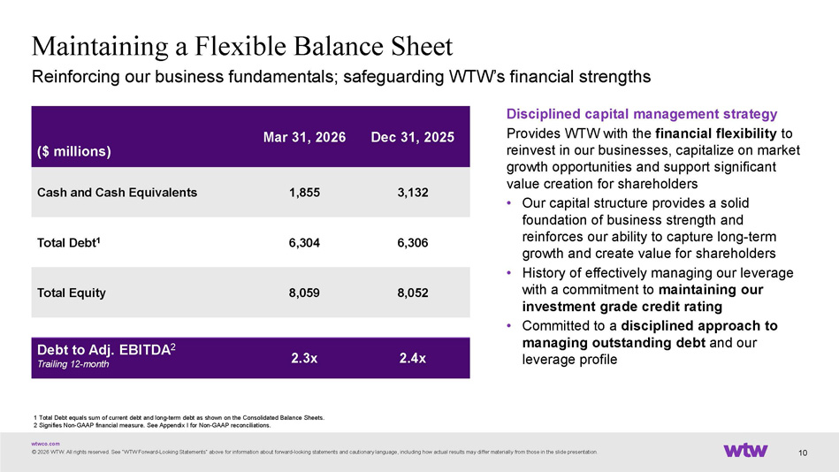
wtwco.com Maintaining a Flexible Balance Sheet © 2026 WTW. All rights reserved. See “WTW Forward - Looking Statements“ above for information about forward - looking statements and cautionary language, including how actual results may differ materially from those in the slide presentation. 1 Total Debt equals sum of current debt and long - term debt as shown on the Consolidated Balance Sheets. 2 Signifies Non - GAAP financial measure. See Appendix I for Non - GAAP reconciliations. Reinforcing our business fundamentals; safeguarding WTW’s financial strengths Dec 31, 2025 Mar 31, 2026 ($ millions) 3,132 1,855 Cash and Cash Equivalents 6,306 6,304 Total Debt 1 8,052 8,059 Total Equity 2.4x 2.3x Debt to Adj. EBITDA 2 Trailing 12 - month Disciplined capital management strategy Provides WTW with the financial flexibility to reinvest in our businesses, capitalize on market growth opportunities and support significant value creation for shareholders • Our capital structure provides a solid foundation of business strength and reinforces our ability to capture long - term growth and create value for shareholders • History of effectively managing our leverage with a commitment to maintaining our investment grade credit rating • Committed to a disciplined approach to managing outstanding debt and our leverage profile 10

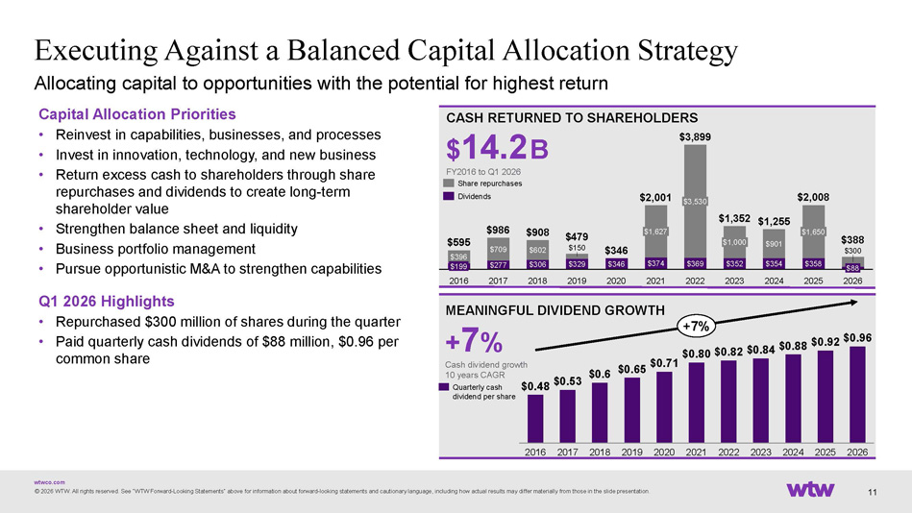
wtwco.com © 2026 WTW. All rights reserved. See “WTW Forward - Looking Statements“ above for information about forward - looking statements and cautionary language, including how actual results may differ materially from those in the slide presentation. Executing Against a Balanced Capital Allocation Strategy CASH RETURNED TO SHAREHOLDERS $ 14.2 B FY2016 to Q1 2026 MEANINGFUL DIVIDEND GROWTH + 7 % Cash dividend growth 10 years CAGR 2016 2017 2018 2019 2020 2021 2022 2023 2024 2025 2026 $ 0.48 $ 0.53 $ 0.6 $ 0.65 $ 0.71 $0.80 $ 0.82 $ 0.84 $ 0.88 $ 0.92 $ 0.96 +7% Quarterly cash dividend per share Capital Allocation Priorities • Reinvest in capabilities, businesses, and processes • Invest in innovation, technology, and new business • Return excess cash to shareholders through share repurchases and dividends to create long - term shareholder value • Strengthen balance sheet and liquidity • Business portfolio management • Pursue opportunistic M&A to strengthen capabilities Q1 2026 Highlights • Repurchased $300 million of shares during the quarter • Paid quarterly cash dividends of $88 million, $0.96 per common share 11 Allocating capital to opportunities with the potential for highest return $277 $306 $329 $346 $374 $369 $352 $354 $358 $396 $709 $602 $150 $901 $300 $199 2016 2017 2018 2019 2020 $1,627 2021 $3,530 2022 $1,000 2023 2024 $1,650 2025 $88 2026 $595 $986 $908 $479 $346 $2,001 $3,899 $1,352 $1,255 $2,008 $388 Share repurchases Dividends

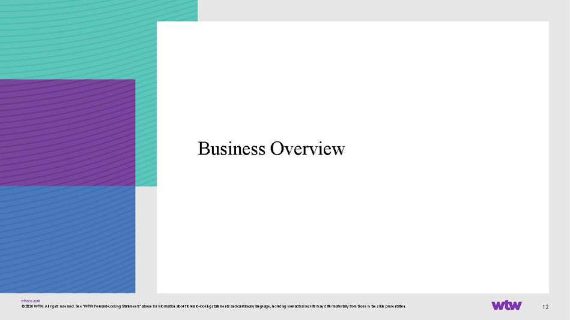
wtwco.com 12 Business Overview © 2026 WTW. All rights reserved. See “WTW Forward - Looking Statements“ above for information about forward - looking statements and cautionary language, including how actual results may differ materially from those in the slide presentation.

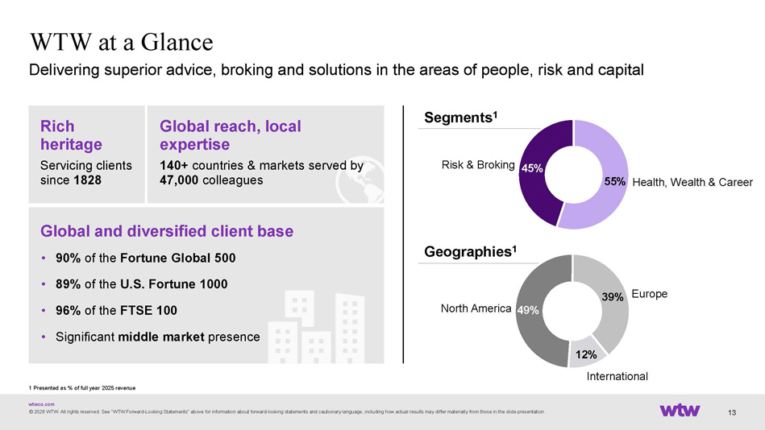
wtwco.com © 2026 WTW. All rights reserved. See “WTW Forward - Looking Statements“ above for information about forward - looking statements and cautionary language, including how actual results may differ materially from those in the slide presentation. 13 WTW at a Glance Delivering superior advice, broking and solutions in the areas of people, risk and capital Segments 1 Geographies 1 Rich heritage Servicing clients since 1828 Global and diversified client base • 90% of the Fortune Global 500 • 89% of the U.S. Fortune 1000 • 96% of the FTSE 100 • Significant middle market presence Global reach, local expertise 140+ countries & markets served by 47,000 colleagues 1 Presented as % of full year 2025 revenue 55% 45% Health, Wealth & Career Risk & Broking 49% 39% 12% North America Europe International

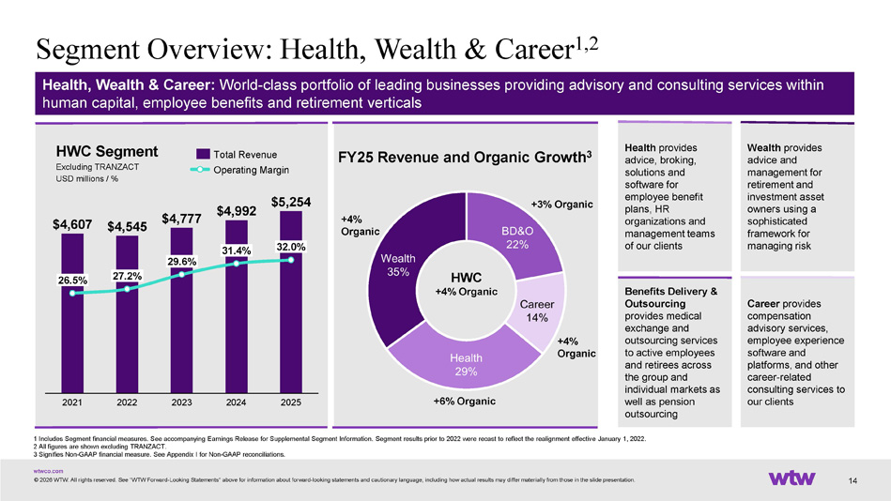
wtwco.com +4% Organic Segment Overview: Health, Wealth & Career 1,2 © 2026 WTW. All rights reserved. See “WTW Forward - Looking Statements“ above for information about forward - looking statements and cautionary language, including how actual results may differ materially from those in the slide presentation. Health, Wealth & Career: World - class portfolio of leading businesses providing advisory and consulting services within human capital, employee benefits and retirement verticals Benefits Delivery & Outsourcing provides medical exchange and outsourcing services to active employees and retirees across the group and individual markets as well as pension outsourcing Health provides advice, broking, solutions and software for employee benefit plans, HR organizations and management teams of our clients Wealth provides advice and management for retirement and investment asset owners using a sophisticated framework for managing risk Career provides compensation advisory services, employee experience software and platforms, and other career - related consulting services to our clients 14 FY25 Revenue and Organic Growth 3 1 Includes Segment financial measures. See accompanying Earnings Release for Supplemental Segment Information. Segment results pr ior to 2022 were recast to reflect the realignment effective January 1, 2022. 2 All figures are shown excluding TRANZACT. 3 Signifies Non - GAAP financial measure. See Appendix I for Non - GAAP reconciliations. HWC Segment Excluding TRANZACT USD millions / % $4,607 $4,545 $4,777 $4,992 $5,254 26.5% 2021 27.2% 2022 29.6% 2023 31.4% 2024 2025 32.0% Total Revenue Operating Margin +3% Organic +4% Organic HWC +4% Organic +6% Organic

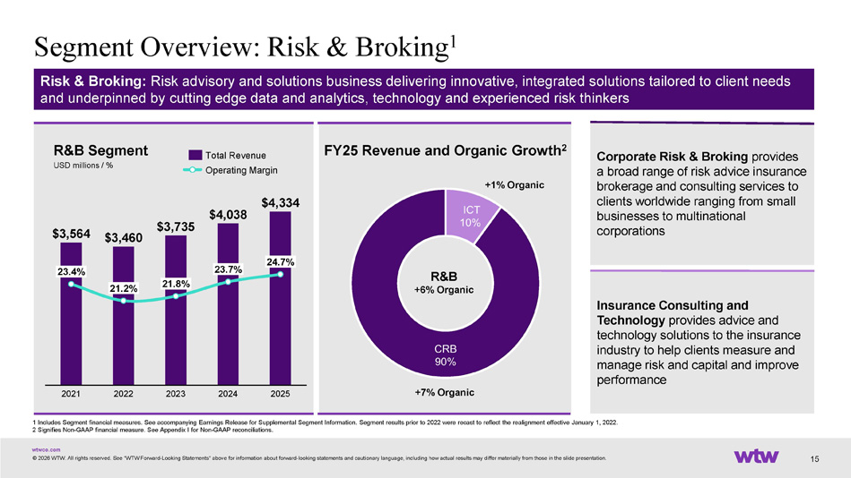
wtwco.com Insurance Consulting and Technology provides advice and technology solutions to the insurance industry to help clients measure and manage risk and capital and improve performance +7% Organic Segment Overview: Risk & Broking 1 © 2026 WTW. All rights reserved. See “WTW Forward - Looking Statements“ above for information about forward - looking statements and cautionary language, including how actual results may differ materially from those in the slide presentation. Risk & Broking: Risk advisory and solutions business delivering innovative, integrated solutions tailored to client needs and underpinned by cutting edge data and analytics, technology and experienced risk thinkers Corporate Risk & Broking provides a broad range of risk advice insurance brokerage and consulting services to clients worldwide ranging from small businesses to multinational corporations 15 FY25 Revenue and Organic Growth 2 1 Includes Segment financial measures. See accompanying Earnings Release for Supplemental Segment Information. Segment results pr ior to 2022 were recast to reflect the realignment effective January 1, 2022. 2 Signifies Non - GAAP financial measure. See Appendix I for Non - GAAP reconciliations. +1% Organic R&B Segment USD millions / % $3,564 $3,460 $3,735 $4,038 $4,334 23.4% 2021 21.2% 2022 21.8% 2023 23.7% 2024 2025 24.7% Total Revenue Operating Margin R&B +6% Organic

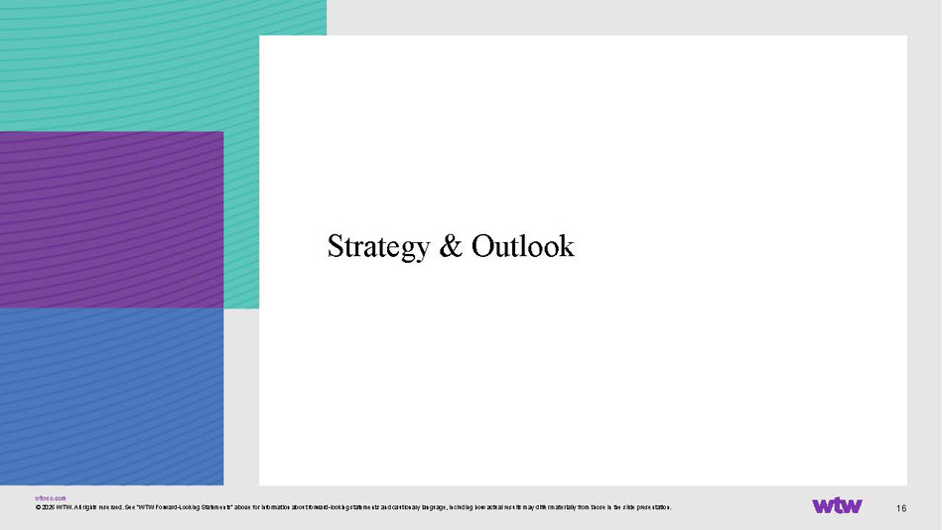
wtwco.com 16 Strategy & Outlook © 2026 WTW. All rights reserved. See “WTW Forward - Looking Statements“ above for information about forward - looking statements and cautionary language, including how actual results may differ materially from those in the slide presentation.

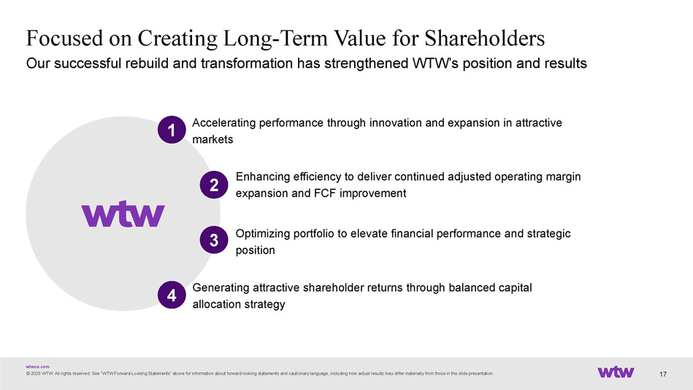
wtwco.com Focused on Creating Long - Term Value for Shareholders © 2026 WTW. All rights reserved. See “WTW Forward - Looking Statements“ above for information about forward - looking statements and cautionary language, including how actual results may differ materially from those in the slide presentation. Our successful rebuild and transformation has strengthened WTW’s position and results 17 Accelerating performance through innovation and expansion in attractive markets 1 Enhancing efficiency to deliver continued adjusted operating margin expansion and FCF improvement Optimizing portfolio to elevate financial performance and strategic position Generating attractive shareholder returns through balanced capital allocation strategy 2 4 3

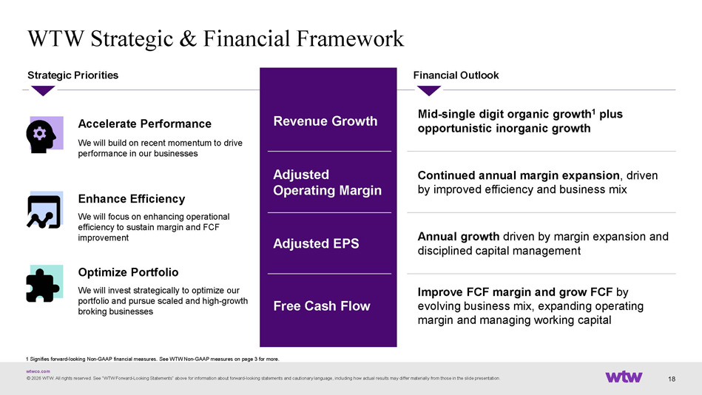
wtwco.com 18 WTW Strategic & Financial Framework Accelerate Performance We will build on recent momentum to drive performance in our businesses Strategic Priorities Enhance Efficiency We will focus on enhancing operational efficiency to sustain margin and FCF improvement Optimize Portfolio We will invest strategically to optimize our portfolio and pursue scaled and high - growth broking businesses Financial Outlook Mid - single digit organic growth 1 plus opportunistic inorganic growth Revenue Growth Continued annual margin expansion , driven by improved efficiency and business mix Adjusted Operating Margin Annual growth driven by margin expansion and disciplined capital management Adjusted EPS Improve FCF margin and grow FCF by evolving business mix, expanding operating margin and managing working capital Free Cash Flow © 2026 WTW. All rights reserved. See “WTW Forward - Looking Statements“ above for information about forward - looking statements and cautionary language, including how actual results may differ materially from those in the slide presentation. 1 Signifies forward - looking Non - GAAP financial measures. See WTW Non - GAAP measures on page 3 for more.

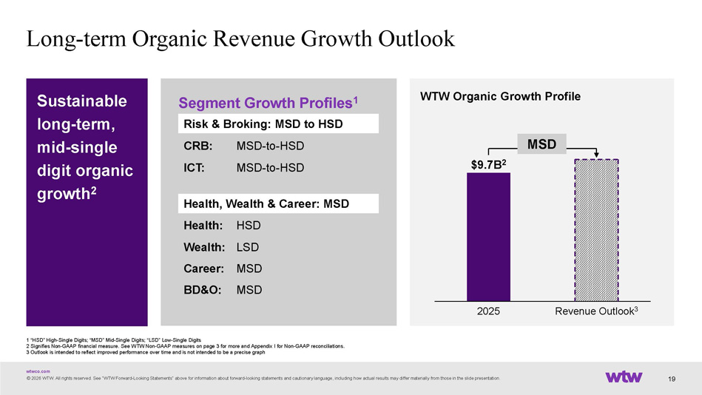
wtwco.com WTW Organic Growth Profile 19 Segment Growth Profiles 1 Risk & Broking: MSD to HSD CRB: MSD - to - HSD ICT: MSD - to - HSD Health, Wealth & Career: MSD Health: HSD Wealth: LSD Career: MSD BD&O: MSD 1 “HSD” High - Single Digits; “MSD” Mid - Single Digits; “LSD” Low - Single Digits 2 Signifies Non - GAAP financial measure. See WTW Non - GAAP measures on page 3 for more and Appendix I for Non - GAAP reconciliations. 3 Outlook is intended to reflect improved performance over time and is not intended to be a precise graph Sustainable long - term, mid - single digit organic growth 2 © 2026 WTW. All rights reserved. See “WTW Forward - Looking Statements“ above for information about forward - looking statements and cautionary language, including how actual results may differ materially from those in the slide presentation. 2025 Revenue Outlook 3 $ 9.7 B 2 MSD Long - term Organic Revenue Growth Outlook

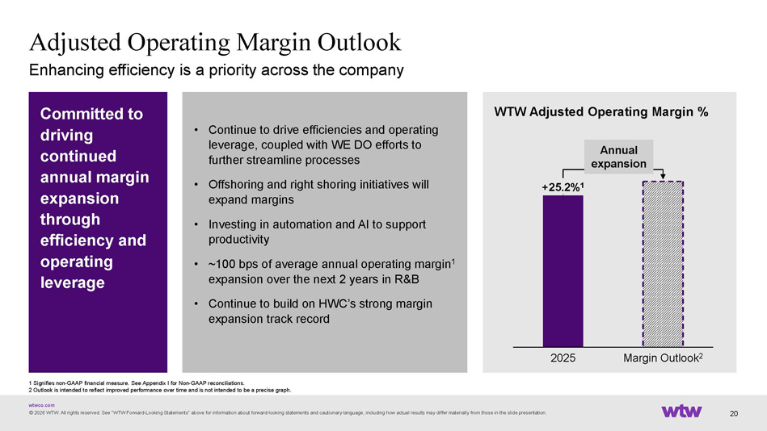
wtwco.com 20 Enhancing efficiency is a priority across the company Adjusted Operating Margin Outlook • Continue to drive efficiencies and operating leverage, coupled with WE DO efforts to further streamline processes • Offshoring and right shoring initiatives will expand margins • Investing in automation and AI to support productivity • ~100 bps of average annual operating margin 1 expansion over the next 2 years in R&B • Continue to build on HWC’s strong margin expansion track record Committed to driving continued annual margin expansion through efficiency and operating leverage WTW Adjusted Operating Margin % +25.2% 1 2025 Margin Outlook 2 Annual expansion © 2026 WTW. All rights reserved. See “WTW Forward - Looking Statements“ above for information about forward - looking statements and cautionary language, including how actual results may differ materially from those in the slide presentation. 1 Signifies non - GAAP financial measure. See Appendix I for Non - GAAP reconciliations. 2 Outlook is intended to reflect improved performance over time and is not intended to be a precise graph.

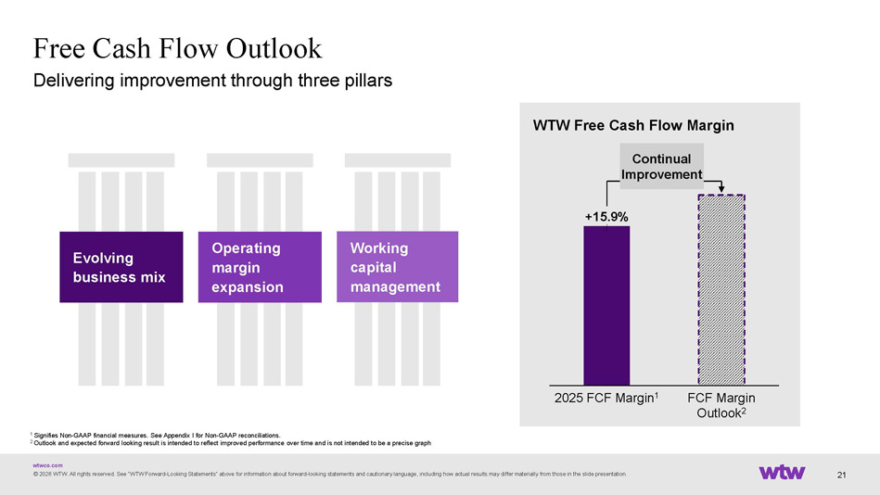
wtwco.com 21 Free Cash Flow Outlook Evolving business mix Operating margin expansion Working capital management 1 Signifies Non - GAAP financial measures. See Appendix I for Non - GAAP reconciliations. 2 Outlook and expected forward looking result is intended to reflect improved performance over time and is not intended to be a pr ecise graph © 2026 WTW. All rights reserved. See “WTW Forward - Looking Statements“ above for information about forward - looking statements and cautionary language, including how actual results may differ materially from those in the slide presentation. Delivering improvement through three pillars WTW Free Cash Flow Margin +15.9% 2025 FCF Margin 1 FCF Margin Outlook 2 Continual Improvement

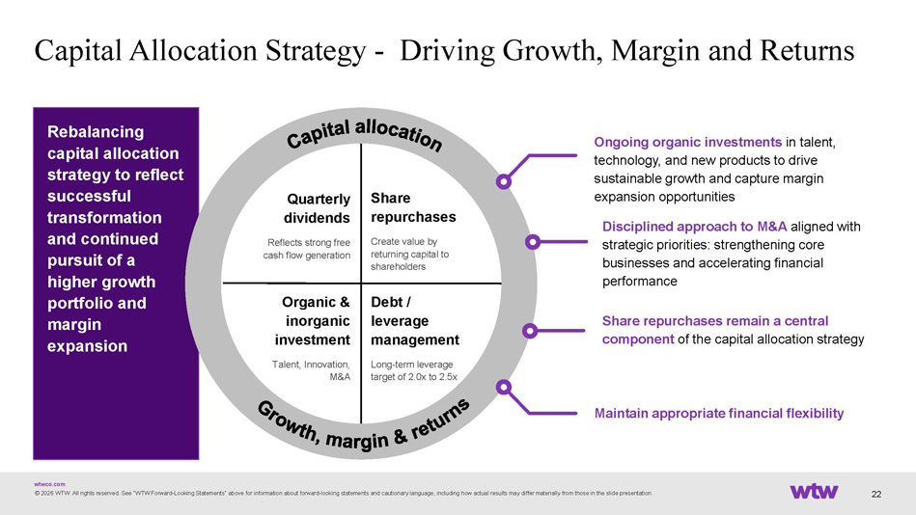
wtwco.com Rebalancing capital allocation strategy to reflect successful transformation and continued pursuit of a higher growth portfolio and margin expansion 22 Capital Allocation Strategy - Driving Growth, Margin and Returns Ongoing organic investments in talent, technology, and new products to drive sustainable growth and capture margin expansion opportunities Disciplined approach to M&A aligned with strategic priorities: strengthening core businesses and accelerating financial performance Share repurchases remain a central component of the capital allocation strategy Maintain appropriate financial flexibility Share repurchases Create value by returning capital to shareholders Quarterly dividends Reflects strong free cash flow generation Debt / leverage management Long - term leverage target of 2.0x to 2.5x Organic & inorganic investment Talent, Innovation, M&A © 2026 WTW. All rights reserved. See “WTW Forward - Looking Statements“ above for information about forward - looking statements and cautionary language, including how actual results may differ materially from those in the slide presentation.

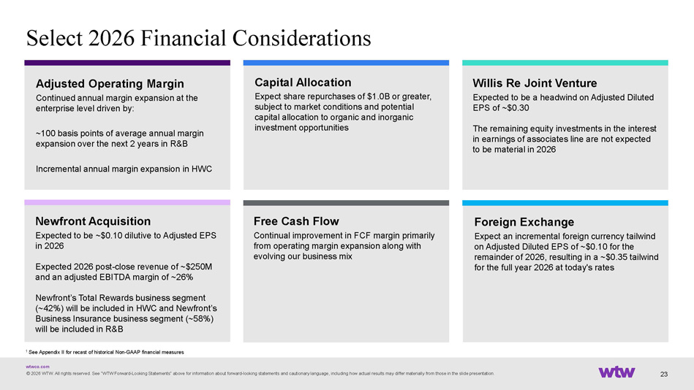
wtwco.com 23 Select 2026 Financial Considerations © 2026 WTW. All rights reserved. See “WTW Forward - Looking Statements“ above for information about forward - looking statements and cautionary language, including how actual results may differ materially from those in the slide presentation. Willis Re Joint Venture Expected to be a headwind on Adjusted Diluted EPS of ~$0.30 The remaining equity investments in the interest in earnings of associates line are not expected to be material in 2026 Capital Allocation Expect share repurchases of $1.0B or greater, subject to market conditions and potential capital allocation to organic and inorganic investment opportunities Foreign Exchange Expect an incremental foreign currency tailwind on Adjusted Diluted EPS of ~$0.10 for the remainder of 2026, resulting in a ~$0.35 tailwind for the full year 2026 at today's rates ﻿ Adjusted Operating Margin Continued annual margin expansion at the enterprise level driven by: ~100 basis points of average annual margin expansion over the next 2 years in R&B Incremental annual margin expansion in HWC 1 See Appendix II for recast of historical Non - GAAP financial measures Free Cash Flow Continual improvement in FCF margin primarily from operating margin expansion along with evolving our business mix Newfront Acquisition Expected to be ~$0.10 dilutive to Adjusted EPS in 2026 Expected 2026 post - close revenue of ~$250M and an adjusted EBITDA margin of ~26% Newfront’s Total Rewards business segment (~42%) will be included in HWC and Newfront’s Business Insurance business segment (~58%) will be included in R&B

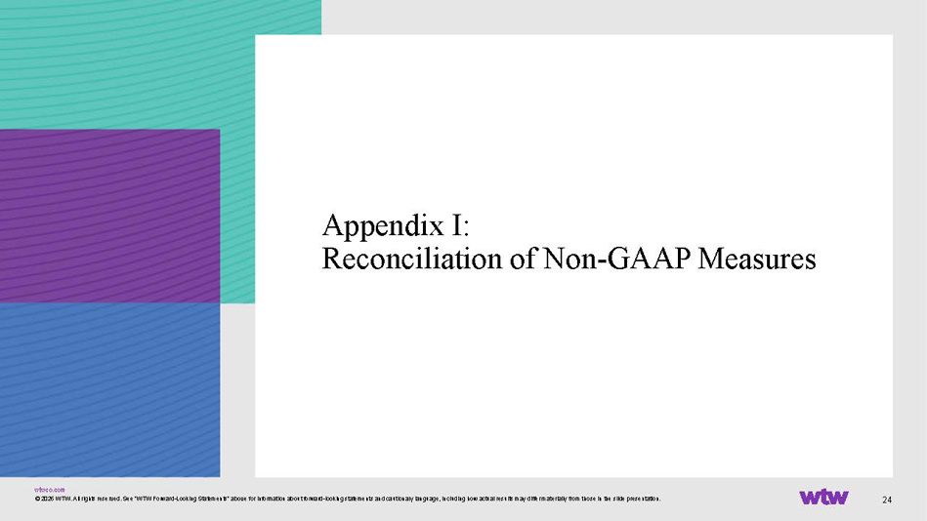
wtwco.com 24 Appendix I: Reconciliation of Non - GAAP Measures © 2026 WTW. All rights reserved. See “WTW Forward - Looking Statements“ above for information about forward - looking statements and cautionary language, including how actual results may differ materially from those in the slide presentation.

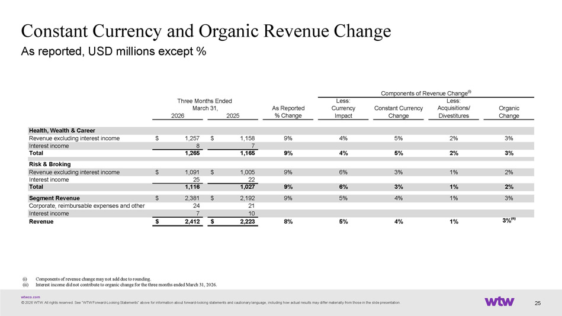
wtwco.com Constant Currency and Organic Revenue Change © 2026 WTW. All rights reserved. See “WTW Forward - Looking Statements“ above for information about forward - looking statements and cautionary language, including how actual results may differ materially from those in the slide presentation. As reported, USD millions except % 25 (i) Components of revenue change may not add due to rounding. (ii) Interest income did not contribute to organic change for the three months ended March 31, 2026. Less: Less: As Reported Currency Constant Currency Acquisitions/ Organic 2026 2025 % Change Impact Change Divestitures Change Health, Wealth & Career Revenue excluding interest income 1,257$ 1,158$ 9% 4% 5% 2% 3% Interest income 8 7 Total 1,265 1,165 9% 4% 5% 2% 3% Risk & Broking Revenue excluding interest income 1,091$ 1,005$ 9% 6% 3% 1% 2% Interest income 25 22 Total 1,116 1,027 9% 6% 3% 1% 2% Segment Revenue 2,381$ 2,192$ 9% 5% 4% 1% 3% Corporate, reimbursable expenses and other 24 21 Interest income 7 10 Revenue 2,412$ 2,223$ 8% 5% 4% 1% 3% (ii) Components of Revenue Change (i) March 31, Three Months Ended

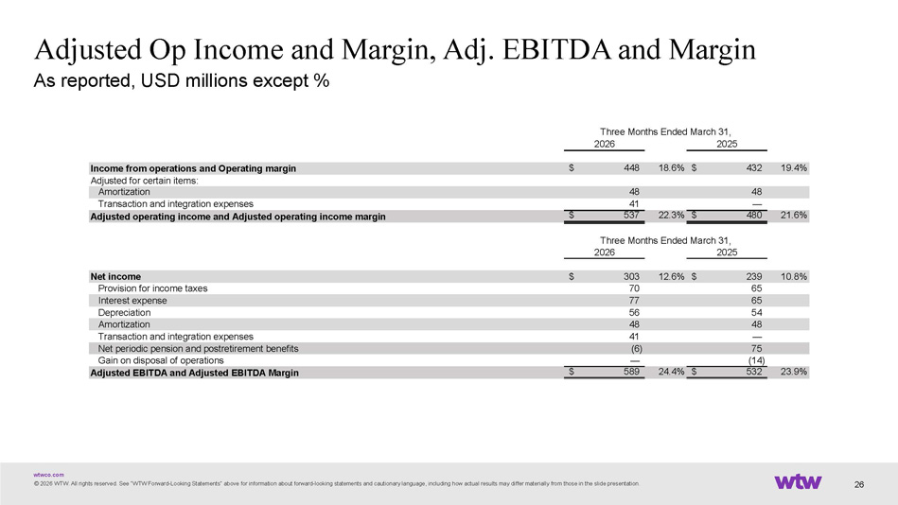
wtwco.com © 2026 WTW. All rights reserved. See “WTW Forward - Looking Statements“ above for information about forward - looking statements and cautionary language, including how actual results may differ materially from those in the slide presentation. Adjusted Op Income and Margin, Adj. EBITDA and Margin As reported, USD millions except % 26 2026 2025 Income from operations and Operating margin 448$ 18.6% 432$ 19.4% Adjusted for certain items: Amortization 48 48 Transaction and integration expenses 41 — Adjusted operating income and Adjusted operating income margin 537$ 22.3% 480$ 21.6% 2026 2025 Net income 303$ 12.6% 239$ 10.8% Provision for income taxes 70 65 Interest expense 77 65 Depreciation 56 54 Amortization 48 48 Transaction and integration expenses 41 — Net periodic pension and postretirement benefits (6) 75 Gain on disposal of operations — (14) Adjusted EBITDA and Adjusted EBITDA Margin 589$ 24.4% 532$ 23.9% Three Months Ended March 31, Three Months Ended March 31,

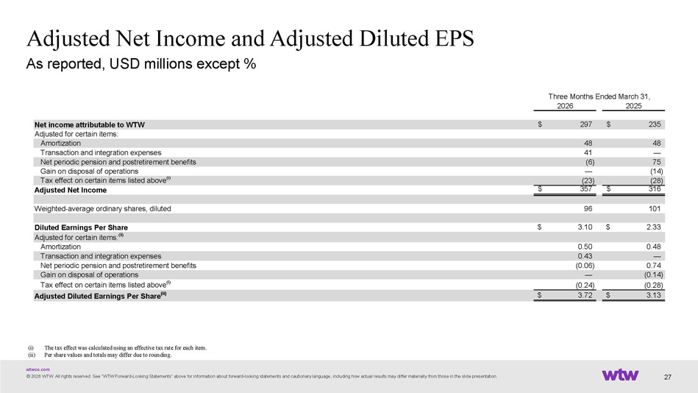
wtwco.com Adjusted Net Income and Adjusted Diluted EPS © 2026 WTW. All rights reserved. See “WTW Forward - Looking Statements“ above for information about forward - looking statements and cautionary language, including how actual results may differ materially from those in the slide presentation. As reported, USD millions except % 27 (i) The tax effect was calculated using an effective tax rate for each item. (ii) Per share values and totals may differ due to rounding. 2026 2025 Net income attributable to WTW 297$ 235$ Adjusted for certain items: Amortization 48 48 Transaction and integration expenses 41 — Net periodic pension and postretirement benefits (6) 75 Gain on disposal of operations — (14) Tax effect on certain items listed above (i) (23) (28) Adjusted Net Income 357$ 316$ Weighted-average ordinary shares, diluted 96 101 Diluted Earnings Per Share 3.10$ 2.33$ Adjusted for certain items: (ii) Amortization 0.50 0.48 Transaction and integration expenses 0.43 — Net periodic pension and postretirement benefits (0.06) 0.74 Gain on disposal of operations — (0.14) Tax effect on certain items listed above (i) (0.24) (0.28) Adjusted Diluted Earnings Per Share (ii) 3.72$ 3.13$ Three Months Ended March 31,

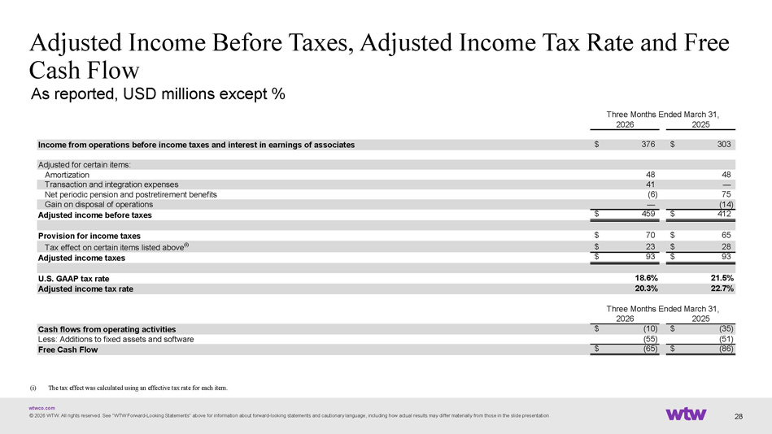
wtwco.com Adjusted Income Before Taxes, Adjusted Income Tax Rate and Free Cash Flow As reported, USD millions except % © 2026 WTW. All rights reserved. See “WTW Forward - Looking Statements“ above for information about forward - looking statements and cautionary language, including how actual results may differ materially from those in the slide presentation. 28 (i) ? ﻿ The tax effect was calculated using an effective tax rate for each item. 2026 2025 Cash flows from operating activities (10)$ (35)$ Less: Additions to fixed assets and software (55) (51) Free Cash Flow (65)$ (86)$ Three Months Ended March 31, 2026 2025 Income from operations before income taxes and interest in earnings of associates 376$ 303$ Adjusted for certain items: Amortization 48 48 Transaction and integration expenses 41 — Net periodic pension and postretirement benefits (6) 75 Gain on disposal of operations — (14) Adjusted income before taxes 459$ 412$ Provision for income taxes 70$ 65$ Tax effect on certain items listed above (i) 23$ 28$ Adjusted income taxes 93$ 93$ U.S. GAAP tax rate 18.6% 21.5% Adjusted income tax rate 20.3% 22.7% Three Months Ended March 31,

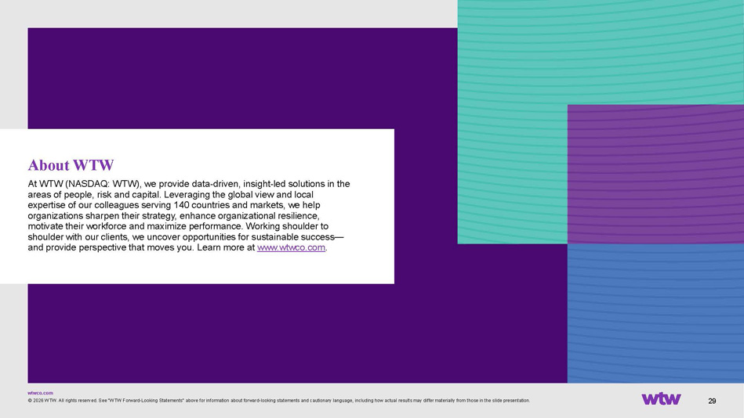
wtwco.com 29 About WTW At WTW (NASDAQ: WTW), we provide data - driven, insight - led solutions in the areas of people, risk and capital. Leveraging the global view and local expertise of our colleagues serving 140 countries and markets, we help organizations sharpen their strategy, enhance organizational resilience, motivate their workforce and maximize performance. Working shoulder to shoulder with our clients, we uncover opportunities for sustainable success

— and provide perspective that moves you. Learn more at www.wtwco.com . © 2026 WTW. All rights reserved. See “WTW Forward - Looking Statements“ above for information about forward - looking statements and cautionary language, including how actual results may differ materially from those in the slide presentation.

