UNITED STATES
SECURITIES AND EXCHANGE COMMISSION
Washington, D.C. 20549

FORM 8-K

CURRENT REPORT
Pursuant to Section 13 or 15(d)
of the Securities Exchange Act of 1934

Date of Report (Date of earliest event reported): June 30, 2026

Willis Towers Watson Public Limited Company
(Exact name of registrant as specified in its charter)

Ireland |  | 001-16503 |  | 98-0352587
(State or other jurisdiction  of incorporation) |  | (Commission  File Number) |  | (IRS Employer  Identification No.)

c/o Willis Group Limited, 51 Lime Street, London, EC3M 7DQ, England
(Address, including Zip Code, of Principal Executive Offices)

Registrant’s telephone number, including area code: (011) (44)-(20)-3124-6000

Not Applicable
(Former name or former address, if changed since last report)

Check the appropriate box below if the Form 8-K filing is intended to simultaneously satisfy the filing obligation of the registrant under any of the following provisions:

 | ☐ | Written communications pursuant to Rule 425 under the Securities Act (17 CFR 230.425)

 | ☐ | Soliciting material pursuant to Rule 14a-12 under the Exchange Act (17 CFR 240.14a-12)

 | ☐ | Pre-commencement communications pursuant to Rule 14d-2(b) under the Exchange Act (17 CFR 240.14d-2(b))

 | ☐ | Pre-commencement communications pursuant to Rule 13e-4(c) under the Exchange Act (17 CFR 240.13e-4(c))

Securities registered pursuant to Section 12(b) of the Act:

Title of each class |  | Trading  Symbol(s) |  | Name of each exchange on which registered
Ordinary Shares, nominal value $0.000304635 per share |  | WTW |  | NASDAQ Global Select Market

Indicate by check mark whether the registrant is an emerging growth company as defined in Rule 405 of the Securities Act of 1933 (17 CFR §230.405) or Rule 12b-2 of the Securities Exchange Act of 1934 (17 CFR §240.12b-2).

Emerging growth company ☐

If an emerging growth company, indicate by check mark if the registrant has elected not to use the extended transition period for complying with any new or revised financial accounting standards provided pursuant to Section 13(a) of the Exchange Act. ☐

Item 2.02 |  | Results of Operations and Financial Condition.

On July 30, 2026, Willis Towers Watson Public Limited Company (“WTW”) issued a press release announcing its financial results for the period ended June 30, 2026.

A copy of WTW’s press release is attached hereto as Exhibit 99.1 to this Current Report on Form 8-K and is incorporated by reference herein. A reconciliation between certain non-GAAP financial measures and reported financial results is provided as an attachment to the press release.

Item 7.01 |  | Regulation FD.

WTW also posted to the investor relations section of its website a slide presentation which it may refer to during its conference call to discuss the results. The slide presentation is attached hereto as Exhibit 99.2 to this Current Report on Form 8-K and is incorporated by reference herein.

The information contained in Item 2.02 and Item 7.01 of this Current Report on Form 8-K (including Exhibits 99.1 and 99.2) is being furnished and shall not be deemed “filed” for the purposes of Section 18 of the Securities Exchange Act of 1934, as amended (the “Exchange Act”), or otherwise subject to the liabilities of that section. Such information shall not be incorporated by reference into any registration statement or other document pursuant to the Securities Act of 1933, as amended, or the Exchange Act, except as shall be expressly set forth by specific reference in any such filing.

Item 9.01 |  | Financial Statements and Exhibits.

(d) | Exhibits

The following exhibits are furnished herewith:

Exhibit  No. |  | Description
99.1 |  | Press release, dated July 30, 2026, announcing the financial results for the period ended June 30, 2026, for WTW.
99.2 |  | Slide Presentation, supplementing the above press release.
104 |  | Cover Page Interactive Data File (embedded within the Inline XBRL document).

SIGNATURES
Pursuant to the requirements of the Securities Exchange Act of 1934, the registrant has duly caused this report to be signed on its behalf by the undersigned hereunto duly authorized.
WILLIS TOWERS WATSON
PUBLIC LIMITED COMPANY
Date: July 30, 2026 | By: /s/ Andrew Krasner  Name: Andrew Krasner  Title: Chief Financial Officer

EXHIBIT 99.1
WTW Reports Second Quarter 2026 Earnings
- Revenue1 increased 9% from prior year to $2.5 billion for the quarter
- Organic Revenue growth of 5% for the quarter
- Diluted Earnings per Share was $2.43 for the quarter, down 27% over prior year
- Adjusted Diluted Earnings per Share was $3.35 for the quarter, up 17% over prior year
- Operating Margin was 14.8% for the quarter, down 150 basis points from prior year
- Adjusted Operating Margin was 19.5% for the quarter, up 100 basis points from prior year
- Announced Propel, WTW's AI Acceleration Plan, to further scale AI and automation across WTW, targeting approximately 30% Adjusted Operating Margin2 in 2028 while positioning the Company for future growth
- Increased existing share repurchase authority by $1.5 billion
LONDON, July 30, 2026 (GLOBE NEWSWIRE) -- WTW (NASDAQ: WTW) (the “Company”), a leading global advisory, broking and solutions company, today announced financial results for the second quarter ended June 30, 2026.
“WTW delivered solid second quarter results, reflecting business momentum and disciplined execution,” said Carl Hess, WTW’s Chief Executive Officer. “This performance underscores the meaningful progress we've made embedding AI and automation across our business, enabling us to deliver higher-value client solutions and a more compelling colleague experience. Propel, WTW's AI Acceleration Plan announced today, builds on that foundation and is intended to further accelerate performance and enhance efficiency, creating value for shareholders and further strengthening WTW's differentiated position in the market. We remain confident in delivering on our full-year 2026 guidance and achieving our new 2028 margin target.”
Consolidated Results
As reported, USD millions, except %
Key Metrics | Q2-26 | Q2-25 | Y/Y Change
Revenue1 | $2,466 | $2,261 | Reported 9% | CC 8% | Organic 5%
Income from Operations | $364 | $368 | (1)%
Operating Margin % | 14.8% | 16.3% | (150) bps
Adjusted Operating Income | $480 | $419 | 15%
Adjusted Operating Margin % | 19.5% | 18.5% | 100 bps
Net Income | $231 | $332 | (30)%
Adjusted Net Income | $316 | $285 | 11%
Diluted EPS | $2.43 | $3.32 | (27)%
Adjusted Diluted EPS | $3.35 | $2.86 | 17%

1 | The revenue amounts included in this release are presented on a U.S. GAAP basis except where stated otherwise. The segment discussion is on an organic basis.
2 | See “WTW Non-GAAP Measures” below with respect to forward-looking non-GAAP measures.
Revenue was $2.47 billion for the second quarter of 2026, an increase of 9% compared to $2.26 billion for the same period in the prior year. Excluding the impact of foreign currency, revenue increased 8%. On an organic basis, revenue increased 5%. See Supplemental Segment Information for additional detail on book-of-business settlements and interest income included in revenue.
Net Income for the second quarter of 2026 was $231 million compared to $332 million in the prior-year second quarter. Adjusted EBITDA for the second quarter was $529 million, or 21.5% of revenue, an increase of 13%, compared to Adjusted EBITDA of $470 million, or 20.8% of revenue, in the prior-year second quarter. The U.S. GAAP tax rate for the second quarter was 19.8%, and the adjusted income tax rate for the second quarter used in calculating adjusted diluted earnings per share was 19.6%.
Cash Flow and Capital Allocation
Cash flows from operating activities were $474 million for the six months ended June 30, 2026, compared to $326 million in the prior year. Free cash flow for the six months ended June 30, 2026 and 2025 was $360 million and $217 million, respectively, an increase of $143 million. The increase was primarily driven by operating margin expansion. During the quarter ended June 30, 2026, the Company repurchased 1,733,574 of its outstanding shares for $450 million.
Second Quarter 2026 Segment Highlights
Health, Wealth & Career (“HWC”)
As reported, USD millions, except %
Health, Wealth & Career | Q2-26 | Q2-25 | Y/Y Change
Total Revenue | $1,270 | $1,180 | Reported 8% | CC 7% | Organic 4%
Operating Income | $306 | $280 | 9%
Operating Margin % | 24.1% | 23.8% | 30 bps
The HWC segment had revenue of $1.27 billion in the second quarter of 2026, an increase of 8% (7% increase constant currency and organic growth of 4%) from $1.18 billion in the prior year. Health delivered organic revenue growth with positive contributions from all regions. Wealth generated organic revenue growth supported by higher levels of retirement work across all regions. Career revenue was flat on an organic basis as increased levels of communications project work and broad-based pay work were offset by constrained revenue in the Middle East due to the ongoing conflict. Benefits Delivery & Outsourcing (BD&O) revenue increased organically as expanded project work, new client wins and regulatory driven work in Outsourcing were partially offset by lower commissions in Individual Marketplace.
Operating margin in the HWC segment increased 30 basis points from the prior-year second quarter to 24.1%. The increase was primarily driven by improved operating leverage and expense discipline.
Risk & Broking (“R&B”)
As reported, USD millions, except %
Risk & Broking | Q2-26 | Q2-25 | Y/Y Change
Total Revenue | $1,164 | $1,047 | Reported 11% | CC 10% | Organic 7%
Operating Income | $258 | $222 | 16%
Operating Margin % | 22.2% | 21.2% | 100 bps
The R&B segment had revenue of $1.16 billion in the second quarter of 2026, an increase of 11% (10% increase constant currency and organic growth of 7%) from $1.05 billion in the prior year. Corporate Risk & Broking (CRB) had organic revenue growth driven by new business activity and strong client retention globally. Insurance Consulting and Technology (ICT) delivered organic revenue growth primarily from strong software sales in the Technology practice.
Operating margin in the R&B segment increased 100 basis points from the prior-year second quarter to 22.2%. The increase was primarily driven by operating leverage.
Share Repurchase Program
Today, the Company announced that its Board of Directors approved an increase to the existing share repurchase authority in the amount of $1.5 billion. The $1.5 billion increase is in addition to the approximately $500 million remaining on the current open-ended repurchase authority. The Company is authorized to repurchase shares, by way of redemption or otherwise, and will consider whether to do so from time to time, based on many factors, including market and economic conditions, applicable legal requirements and other business considerations.
Propel
Concurrent with its second quarter results, WTW announced Propel to embed artificial intelligence and automation across the enterprise, expected to be completed by the end of 2028. Supported by the Company's ongoing investments in AI, data and technology, including the acquisition of Newfront, Propel is expected to enhance client service and create additional opportunities for growth as well as streamline core operating processes. WTW expects these efforts to accelerate performance and enhance efficiency, reinforcing WTW's strengths.
The Company expects to invest approximately $625 million of cash and incur approximately $25 million in non-cash charges to generate approximately $400 million in run-rate savings, delivering a cash-cost-to-achieve ratio of approximately 1.6 times. After reinvesting approximately $50 million to support growth, the Company expects to deliver approximately $350 million in net run-rate savings and approximately 30% adjusted operating margin in 2028. The Company’s full-year 2026 guidance remains unchanged. Please refer to the most recent supplemental slides in the Investor Relations section of the Company's website for further details.
Select 2026 Financial Considerations
Adjusted operating margin:
- Continued annual margin expansion at the enterprise level driven by:
  - ~100 basis points of annual margin expansion in R&B
  - Incremental annual margin expansion in HWC
Segment organic revenue:
- Health, Wealth & Career: Mid-single digits (MSD)
  - Health: High-single digits (HSD)
  - Wealth: Low-single digits (LSD)
  - Career: LSD to MSD
  - BD&O: LSD
- Risk & Broking: MSD
  - CRB: MSD
  - ICT: LSD to MSD
Willis Re joint venture:
- Expected to be a headwind on Adjusted Diluted EPS of ~$0.30
- The remaining equity investments in the interest in earnings of associates line are not expected to be material in 2026
Newfront acquisition:
- Expected to be ~$0.10 dilutive to Adjusted EPS in 2026
- Expected 2026 post-close revenue of ~$250M and an adjusted EBITDA margin of ~26%
- Newfront’s Total Rewards business segment (~42%) will be included in HWC and Newfront’s Business Insurance business segment (~58%) will be included in R&B
Capital allocation:
- Expect share repurchases of $1.0B or greater, subject to market conditions and potential capital allocation to organic and inorganic investment opportunities
Free cash flow:
- Continual improvement in FCF margin primarily from operating margin expansion along with evolving our business mix
Foreign exchange:
- Expect an incremental foreign currency tailwind on Adjusted Diluted EPS of ~$0.05 for the remainder of 2026, resulting in a ~$0.35 tailwind for the full year 2026 at today's rates
The 2026 Financial Considerations above include Non-GAAP financial measures. We do not reconcile forward-looking Non-GAAP measures for reasons explained under "WTW Non-GAAP Measures" below.
Conference Call
The Company will host a conference call to discuss the financial results for the second quarter 2026, including an update on strategic priorities. It will be held on Thursday, July 30, 2026, beginning at 9:00 a.m. Eastern Time. A live, listen-only webcast of the conference call will be available on WTW’s website. Analysts and institutional investors may participate in the conference call’s question-and-answer session by registering in advance here. An online replay will be available at investors.wtwco.com shortly after the call concludes.
About WTW
At WTW (NASDAQ: WTW), we provide data-driven, insight-led solutions in the areas of people, risk and capital. Leveraging the global view and local expertise of our colleagues serving 140 countries and markets, we help organizations sharpen their strategy, enhance organizational resilience, motivate their workforce and maximize performance. Working shoulder to shoulder with our clients, we uncover opportunities for sustainable success—and provide perspective that moves you. Learn more at www.wtwco.com.
WTW Non-GAAP Measures
In order to assist readers of our consolidated financial statements in understanding the core operating results that WTW’s management uses to evaluate the business and for financial planning, we present the following non-GAAP measures: (1) Constant Currency Change, (2) Organic Change, (3) Adjusted Operating Income/Margin, (4) Adjusted EBITDA/Margin, (5) Adjusted Net Income, (6) Adjusted Diluted Earnings Per Share, (7) Adjusted Income Before Taxes, (8) Adjusted Income Taxes/Tax Rate, (9) Free Cash Flow and (10) Free Cash Flow Margin.
We believe that those measures are relevant and provide pertinent information widely used by analysts, investors and other interested parties in our industry to provide a baseline for evaluating and comparing our operating performance, and in the case of free cash flow, our liquidity results.
Within the measures referred to as ‘adjusted’, we adjust for significant items which will not be settled in cash, or which we believe to be items that are not core to our current or future operations. Some of these items may not be applicable for the current quarter, however they may be part of our full-year results. Additionally, we have historically adjusted for certain items which are not described below, but for which we may adjust in a future period when applicable. Items applicable to the quarter or full year results, or the comparable periods, include the following:
- Transaction and integration expenses – Management believes it is appropriate to adjust for significant acquisition-related transaction and integration expenses including changes in significant estimated acquisition earnouts payable and acquisition-related compensation charges. We believe the adjustment is necessary to present how the Company is performing, both now and in the future when the incurrence of these costs will have concluded.
- Gains and losses on disposals of operations – Adjustment to remove the gains or losses resulting from disposed operations that have not been classified as discontinued operations.
- Net periodic pension and postretirement benefits – Adjustment to remove the recognition of net periodic pension and postretirement benefits (including pension settlements), other than service costs.
We evaluate our revenue on an as reported (U.S. GAAP), constant currency and organic basis. We believe presenting constant currency and organic information provides valuable supplemental information regarding our comparable results, consistent with how we evaluate our performance internally.
We consider Constant Currency Change, Organic Change, Adjusted Operating Income/Margin, Adjusted EBITDA/Margin, Adjusted Net Income, Adjusted Diluted Earnings Per Share, Adjusted Income Before Taxes, Adjusted Income Taxes/Tax Rate and Free Cash Flow to be important financial measures, which are used to internally evaluate and assess our core operations and to benchmark our operating and liquidity results against our competitors. These non-GAAP measures are important in illustrating what our comparable operating and liquidity results would have been had we not incurred transaction-related and non-recurring items. Reconciliations of these measures are included in the accompanying tables with the following exception: The Company does not reconcile its forward-looking non-GAAP financial measures to the corresponding U.S. GAAP measures, due to variability and difficulty in making accurate forecasts and projections and/or certain information not being ascertainable or accessible; and because not all of the information, such as foreign currency impacts necessary for a quantitative reconciliation of these forward-looking non-GAAP financial measures to the most directly comparable U.S. GAAP financial measure, is available to the Company without unreasonable efforts. For the same reasons, the Company is unable to address the probable significance of the unavailable information. The Company provides non-GAAP financial measures that it believes will be achieved, however it cannot accurately predict all of the components of the adjusted calculations and the U.S. GAAP measures may be materially different than the non-GAAP measures.
Our non-GAAP measures and their accompanying definitions are presented as follows:
Constant Currency Change – Represents the year-over-year change in revenue excluding the impact of foreign currency fluctuations. To calculate this impact, the prior-year local currency results are first translated using the current year monthly average exchange rates. The change is calculated by comparing the prior year revenue, translated at the current year monthly average exchange rates, to the current year as reported revenue, for the same period. We believe constant currency measures provide useful information to investors because they provide transparency to performance by excluding the effects that foreign currency exchange rate fluctuations have on period-over-period comparability given volatility in foreign currency exchange markets.
Organic Change – Excludes the impact of fluctuations in foreign currency exchange rates, as described above and the period-over-period impact of acquisitions and divestitures on current-year revenue. We believe that excluding transaction-related items from our U.S. GAAP financial measures provides useful supplemental information to our investors, and it is important in illustrating what our core operating results would have been had we not included these transaction-related items, since the nature, size and number of these transaction-related items can vary from period to period.
Adjusted Operating Income/Margin – Income from operations adjusted for amortization, transaction and integration and non-recurring items that, in management’s judgment, significantly affect the period-over-period assessment of operating results. Adjusted operating income margin is calculated by dividing adjusted operating income by revenue. We consider adjusted operating income/margin to be important financial measures, which are used internally to evaluate and assess our core operations and to benchmark our operating results against our competitors.
Adjusted EBITDA/Margin – Net Income adjusted for provision for income taxes, interest expense, depreciation and amortization, transaction and integration, gains and losses on disposals of operations, net periodic pension and postretirement benefits, and non-recurring items that, in management’s judgment, significantly affect the period-over-period assessment of operating results. Adjusted EBITDA Margin is calculated by dividing adjusted EBITDA by revenue. We consider adjusted EBITDA/margin to be important financial measures, which are used internally to evaluate and assess our core operations, to benchmark our operating results against our competitors and to evaluate and measure our performance-based compensation plans.
Adjusted Net Income – Net Income Attributable to WTW adjusted for amortization, transaction and integration, gains and losses on disposals of operations, net periodic pension and postretirement benefits, and non-recurring items that, in management’s judgment, significantly affect the period-over-period assessment of operating results and the related tax effect of those adjustments and the tax effects of significant adjustments. This measure is used solely for the purpose of calculating adjusted diluted earnings per share.
Adjusted Diluted Earnings Per Share – Adjusted Net Income divided by the weighted-average number of ordinary shares, diluted. Adjusted diluted earnings per share is used to internally evaluate and assess our core operations and to benchmark our operating results against our competitors.
Adjusted Income Before Taxes – Income from operations before income taxes and interest in earnings of associates adjusted for amortization, transaction and integration, gains and losses on disposals of operations, net periodic pension and postretirement benefits, and non-recurring items that, in management’s judgment, significantly affect the period-over-period assessment of operating results. Adjusted income before taxes is used solely for the purpose of calculating the adjusted income tax rate.
Adjusted Income Taxes/Tax Rate – Provision for income taxes adjusted for taxes on certain items of amortization, transaction and integration, gains and losses on disposals of operations, net periodic pension and postretirement benefits, the tax effects of significant adjustments and non-recurring items that, in management’s judgment, significantly affect the period-over-period assessment of operating results, divided by adjusted income before taxes. Adjusted income taxes is used solely for the purpose of calculating the adjusted income tax rate. Management believes that the adjusted income tax rate presents a rate that is more closely aligned to the rate that we would incur if not for the reduction of pre-tax income for the adjusted items and the tax effects of significant adjustments, which are not core to our current and future operations.
Free Cash Flow – Cash flows from operating activities less cash used to purchase fixed assets and software. Management believes that free cash flow presents the core operating performance and cash-generating capabilities of our business operations.
Free Cash Flow Margin – Free Cash Flow as a percentage of revenue, which represents how much of revenue would be realized on a cash basis. We consider this measure to be a meaningful metric for tracking cash conversion on a year-over-year basis due to the non-cash nature of our pension income, which is included in our GAAP and Non-GAAP earnings metrics presented herein.
These non-GAAP measures are not defined in the same manner by all companies and may not be comparable to other similarly titled measures of other companies. Non-GAAP measures should be considered in addition to, and not as a substitute for, the information contained within our condensed consolidated financial statements.
WTW Forward-Looking Statements
We have included in this document ‘forward-looking statements’ within the meaning of Section 27A of the Securities Act of 1933, and Section 21E of the Securities Exchange Act of 1934, which are intended to be covered by the safe harbors created by those laws. These forward-looking statements include information about possible or assumed future results of our operations or certain considerations relating to our future results. All statements, other than statements of historical facts, that address activities, events or developments that we expect or anticipate may occur in the future, including such things as: our outlook; the potential impact of natural or man-made disasters like health pandemics and other world health crises; the impact of macroeconomic trends, including inflation, changes in interest rates, trade policies and other geopolitical risks; future capital expenditures; ongoing working capital efforts; future share repurchases; financial results (including our revenue, costs or margins) and the impact of changes to tax laws on our financial results; existing and evolving business strategies; our indebtedness; our ability to execute strategic transactions, including both acquisitions and dispositions, including our ability to receive adequate consideration or any earnout proceeds in return for any dispositions or integrate or manage acquired businesses (such as our recent acquisitions of Newfront Insurance Holdings, Inc. and Cushon) or effect internal reorganizations; demand for our services and competitive strengths; strategic goals; the benefits of new initiatives or investments in technology; growth of our business and operations; the sustained health of our product, service, transaction, client, and talent assessment and management pipelines; our ability to successfully manage ongoing leadership, organizational and technology changes, including investments in improving systems and processes; our ability to implement and realize anticipated benefits of any cost-savings or investment initiatives including our newly launched artificial intelligence acceleration plan (the ‘Plan’); our cybersecurity and privacy processes; our application of artificial intelligence technologies throughout our business and our ability to compete with artificial intelligence technologies offered by new or existing competitors; our ability to protect our intellectual property; our compliance with laws and regulations; risks associated with being an Irish-incorporated company; our recognition of future impairment charges; and plans and references to future successes, including our future financial and operating results, short-term and long-term financial goals, plans, objectives, expectations and intentions, including with respect to free cash flow generation, adjusted net income, adjusted operating margin and adjusted earnings per share, are forward-looking statements. Also, when we use words such as ‘may’, ‘will’, ‘would’, ‘anticipate’, ‘believe’, ‘estimate’, ‘expect’, ‘intend’, ‘plan’, ‘continues’, ‘seek’, ‘target’, ‘goal’, ‘focus’, ‘probably’, or similar expressions, we are making forward-looking statements. Such statements are based upon the current beliefs and expectations of the Company’s management and are subject to significant risks and uncertainties. Actual results may differ from those set forth in the forward-looking statements. All forward-looking disclosure is speculative by its nature.
There are important risks, uncertainties, events and factors that could cause our actual results or performance to differ materially from those in the forward-looking statements contained in this document, including the following: our ability to successfully establish, execute and achieve our global business strategy as it evolves; our ability to fully realize the anticipated benefits of our growth strategy, including inorganic growth through acquisitions; our ability to achieve our short-term and long-term financial goals, such as with respect to our cash flow generation, and the timing with respect to such achievement; the risks related to changes in general economic conditions, business and political conditions, changes in the financial markets, inflation, credit availability, increased interest rates, changes in trade policies, increased tariffs and retaliatory actions; the risks to our short-term and long-term financial goals from any of the risks or uncertainties set forth herein; the risks relating to the adverse impacts of macroeconomic trends, including those relating to changes in trade policies and tariffs, as well as political events, war, such as the Russia-Ukraine war and conflict in the Middle East, and other international disputes, terrorism, natural disasters, public health issues and other business interruptions on the global economy and capital markets, such as uncertainty in the global markets, inflation, changes in interest rates and recessionary trends, changes in spending by government agencies and contractors, which could have a material adverse effect on our business, financial condition, results of operations and long-term goals; our ability to successfully hedge against fluctuations in foreign currency rates; the risks relating to the adverse impacts of natural or man-made disasters such as health pandemics and other world health crises on the demand for our products and services, our cash flows and our business operations; material interruptions to or loss of our information processing capabilities, or failure to effectively maintain and upgrade our information technology resources and systems; the insufficiency of client data protection, potential breaches of information systems or insufficient safeguards against cybersecurity breaches or incidents; our ability to comply with complex and evolving regulations related to data privacy, cybersecurity and artificial intelligence; significant competition that we face and the potential for loss of market share and/or profitability; the impact of seasonality and differences in timing of renewals and non-recurring revenue increases from disposals and book-of-business sales; the risk of increased liability or new legal claims arising from our new and existing products and services, and expectations, intentions and outcomes relating to outstanding litigation; the risk of substantial negative outcomes on existing or potential future litigation or investigation matters; changes in the regulatory environment in which we operate, including, among other risks, the impacts of pending competition law and regulatory investigations; various claims, government inquiries or investigations or the potential for regulatory action; our ability to make divestitures or acquisitions, including our ability to integrate or manage acquired businesses or carve-out businesses to be disposed, as well as our ability to identify and successfully execute on opportunities for strategic collaboration; our ability to integrate direct-to-consumer sales and marketing solutions with our existing offerings and solutions; our ability to successfully manage ongoing organizational changes, including as a result of our investments in improving systems and processes or other initiatives, and in connection with our acquisition and divestiture activities; the risks relating to the implementation of the Plan; disasters or business continuity problems; our ability to successfully enhance our billing, collection and other working capital efforts, and thereby increase our free cash flow; our ability to properly identify and manage conflicts of interest; reputational damage, including from association with third parties; reliance on third-party service providers and suppliers; risks relating to changes in our management structures and in senior leadership; the loss of key employees or a large number of employees and rehiring rates; our ability to maintain our corporate culture; doing business internationally, including the impact of global trade policies and retaliatory considerations as well as foreign currency exchange rates; compliance with extensive government regulation; the risk of sanctions imposed by governments, or changes to associated sanction regulations and related counter-sanctions; our ability to effectively apply technology, data and analytics solutions, including through the use of artificial intelligence, for internal operations, maintaining industry standards, meeting client preferences and gaining competitive advantage, among other things; changes and developments in the insurance industry or the U.S. healthcare system, including those related to Medicare, and any other changes and developments in legal, regulatory, economic, business or operational conditions that could impact our businesses; the inability to protect our intellectual property rights, or the potential infringement upon the intellectual property rights of others; fluctuations in our pension assets and liabilities and related changes in pension income, including as a result of, related to, or derived from movements in the interest rate environment, investment returns, inflation, or changes in other assumptions that are used to estimate our benefit obligations and their effect on adjusted earnings per share; our capital structure, including indebtedness amounts, the limitations imposed by the covenants in the documents governing such indebtedness and the maintenance of the financial and disclosure controls and procedures of each; our ability to obtain financing on favorable terms or at all; adverse changes in our credit ratings; the impact of recent or potential changes to applicable U.S. state, federal and/or foreign laws, rules and regulations, recent judicial decisions and case law developments, and any other relevant policy changes and legislative actions, including the ‘Act to provide for reconciliation pursuant to title II of H. Con. Res. 14’ (‘H.R. 1’) signed into law on July 4, 2025, on our business, operations or results; the impact of recent or potential changes in state, federal, and/or foreign tax laws and regulations, including those that may impose additional excise taxes or impact our effective tax rate, including H.R. 1; U.S. federal income tax consequences to U.S. persons owning at least 10% of our shares; changes in accounting principles, estimates or assumptions; our recognition of future impairment charges; risks relating to or arising from environmental, social and governance (‘ESG’) practices; fluctuation in revenue against our relatively fixed or higher-than-expected expenses; the risk that investment levels across our portfolio increase, which can amplify the impact of market downturns; the laws of Ireland being different from the laws of the U.S. and potentially affording less protections to the holders of our securities; and our holding company structure potentially preventing us from being able to receive dividends or other distributions in needed amounts from our subsidiaries.
The foregoing list of factors is not exhaustive and new factors may emerge from time to time that could also affect actual performance and results. For more information, please see Part I, Item 1A in our Annual Report on Form 10-K, and our subsequent filings with the SEC. Copies are available online at http://www.sec.gov or www.wtwco.com.
Although we believe that the assumptions underlying our forward-looking statements are reasonable, any of these assumptions, and therefore also the forward-looking statements based on these assumptions, could themselves prove to be inaccurate. Given the significant uncertainties inherent in the forward-looking statements included in this document, our inclusion of this information is not a representation or guarantee by us that our objectives and plans will be achieved.
Our forward-looking statements speak only as of the date made and we will not update these forward-looking statements unless the securities laws require us to do so. With regard to these risks, uncertainties and assumptions, the forward-looking events discussed in this document may not occur, and we caution you against unduly relying on these forward-looking statements.
Contact
INVESTORS
Claudia De La Hoz | Claudia.Delahoz@wtwco.com
WTW
Supplemental Segment Information
(In millions of U.S. dollars)
(Unaudited)
REVENUE
 |  |  |  |  |  |  |  |  |  |  |  | Components of Revenue Change(i)
 |  |  |  |  |  |  |  |  |  |  |  | Less: |  |  |  | Less:
 |  | Three Months Ended  June 30, |  |  |  |  |  |  |  | As Reported |  | Currency |  | Constant Currency |  | Acquisitions/ |  | Organic
 |  | 2026 |  |  |  | 2025 |  |  |  | % Change |  | Impact |  | Change |  | Divestitures |  | Change
Health, Wealth & Career
Revenue excluding interest income |  | $ | 1,263 |  |  | $ | 1,173 |  |  | 8% |  | 1% |  | 7% |  | 3% |  | 4%
Interest income |  |  | 7 |  |  |  | 7
Total |  |  | 1,270 |  |  |  | 1,180 |  |  | 8% |  | 1% |  | 7% |  | 3% |  | 4%
Risk & Broking
Revenue excluding interest income |  | $ | 1,140 |  |  | $ | 1,024 |  |  | 11% |  | 1% |  | 10% |  | 3% |  | 7%
Interest income |  |  | 24 |  |  |  | 23
Total |  |  | 1,164 |  |  |  | 1,047 |  |  | 11% |  | 1% |  | 10% |  | 3% |  | 7%
Segment Revenue |  | $ | 2,434 |  |  | $ | 2,227 |  |  | 9% |  | 1% |  | 8% |  | 3% |  | 5%
Corporate, reimbursable expenses and other |  |  | 30 |  |  |  | 24
Interest income |  |  | 2 |  |  |  | 10
Revenue |  | $ | 2,466 |  |  | $ | 2,261 |  |  | 9% |  | 1% |  | 8% |  | 3% |  | 5%(ii)

 |  |  |  |  |  |  |  |  |  |  |  | Components of Revenue Change(i)
 |  |  |  |  |  |  |  |  |  |  |  | Less: |  |  |  | Less:
 |  | Six Months Ended  June 30, |  |  |  |  |  |  |  | As Reported |  | Currency |  | Constant Currency |  | Acquisitions/ |  | Organic
 |  | 2026 |  |  |  | 2025 |  |  |  | % Change |  | Impact |  | Change |  | Divestitures |  | Change
Health, Wealth & Career
Revenue excluding interest income |  | $ | 2,520 |  |  | $ | 2,331 |  |  | 8% |  | 2% |  | 6% |  | 2% |  | 3%
Interest income |  |  | 15 |  |  |  | 14
Total |  |  | 2,535 |  |  |  | 2,345 |  |  | 8% |  | 2% |  | 6% |  | 2% |  | 3%
Risk & Broking
Revenue excluding interest income |  | $ | 2,231 |  |  | $ | 2,029 |  |  | 10% |  | 4% |  | 6% |  | 2% |  | 4%
Interest income |  |  | 49 |  |  |  | 45
Total |  |  | 2,280 |  |  |  | 2,074 |  |  | 10% |  | 4% |  | 6% |  | 2% |  | 4%
Segment Revenue |  | $ | 4,815 |  |  | $ | 4,419 |  |  | 9% |  | 3% |  | 6% |  | 2% |  | 4%
Corporate, reimbursable expenses and other |  |  | 54 |  |  |  | 45
Interest income |  |  | 9 |  |  |  | 20
Revenue |  | $ | 4,878 |  |  | $ | 4,484 |  |  | 9% |  | 3% |  | 6% |  | 2% |  | 4%(ii)
(i) Components of revenue change may not add due to rounding.
(ii) Interest income did not contribute to organic change for the three and six months ended June 30, 2026.
BOOK-OF-BUSINESS SETTLEMENTS AND INTEREST INCOME
 |  | Three Months Ended June 30,
 |  | HWC |  |  |  |  |  |  |  | R&B |  |  |  |  |  |  |  | Corporate |  |  |  |  |  |  |  | Total
 |  | 2026 |  |  |  | 2025 |  |  |  | 2026 |  |  |  | 2025 |  |  |  | 2026 |  |  |  | 2025 |  |  |  | 2026 |  |  |  | 2025
Book-of-business settlements |  | $ | 1 |  |  | $ | — |  |  | $ | 3 |  |  | $ | 3 |  |  | $ | — |  |  | $ | — |  |  | $ | 4 |  |  | $ | 3
Interest income |  |  | 7 |  |  |  | 7 |  |  |  | 24 |  |  |  | 23 |  |  |  | 2 |  |  |  | 10 |  |  |  | 33 |  |  |  | 40
Total |  | $ | 8 |  |  | $ | 7 |  |  | $ | 27 |  |  | $ | 26 |  |  | $ | 2 |  |  | $ | 10 |  |  | $ | 37 |  |  | $ | 43

 |  | Six Months Ended June 30,
 |  | HWC |  |  |  |  |  |  |  | R&B |  |  |  |  |  |  |  | Corporate |  |  |  |  |  |  |  | Total
 |  | 2026 |  |  |  | 2025 |  |  |  | 2026 |  |  |  | 2025 |  |  |  | 2026 |  |  |  | 2025 |  |  |  | 2026 |  |  |  | 2025
Book-of-business settlements |  | $ | 2 |  |  | $ | 2 |  |  | $ | 10 |  |  | $ | 3 |  |  | $ | — |  |  | $ | — |  |  | $ | 12 |  |  | $ | 5
Interest income |  |  | 15 |  |  |  | 14 |  |  |  | 49 |  |  |  | 45 |  |  |  | 9 |  |  |  | 20 |  |  |  | 73 |  |  |  | 79
Total |  | $ | 17 |  |  | $ | 16 |  |  | $ | 59 |  |  | $ | 48 |  |  | $ | 9 |  |  | $ | 20 |  |  | $ | 85 |  |  | $ | 84
SEGMENT OPERATING INCOME (i)
Three Months Ended
June 30,
 |  | 2026 |  |  |  | 2025
Health, Wealth & Career |  | $ | 306 |  |  | $ | 280
Risk & Broking |  |  | 258 |  |  |  | 222
Segment Operating Income |  | $ | 564 |  |  | $ | 502

Six Months Ended
June 30,
 |  | 2026 |  |  |  | 2025
Health, Wealth & Career |  | $ | 652 |  |  | $ | 591
Risk & Broking |  |  | 510 |  |  |  | 448
Segment Operating Income |  | $ | 1,162 |  |  | $ | 1,039
(i) Segment operating income excludes certain costs, including amortization of intangibles, transaction and integration expenses, and to the extent that the actual expense based upon which allocations are made differs from the forecast/budget amount, a reconciling item will be created between internally-allocated expenses and the actual expenses reported for U.S. GAAP purposes.
SEGMENT OPERATING MARGINS
 |  | Three Months Ended June 30,
 |  | 2026 |  | 2025
Health, Wealth & Career |  | 24.1% |  | 23.8%
Risk & Broking |  | 22.2% |  | 21.2%

 |  | Six Months Ended June 30,
 |  | 2026 |  | 2025
Health, Wealth & Career |  | 25.7% |  | 25.2%
Risk & Broking |  | 22.4% |  | 21.6%
RECONCILIATIONS OF SEGMENT OPERATING INCOME TO INCOME FROM OPERATIONS BEFORE INCOME TAXES AND INTEREST IN EARNINGS OF ASSOCIATES
 |  | Three Months Ended June 30,
 |  | 2026 |  |  |  | 2025
Segment Operating Income |  | $ | 564 |  |  | $ | 502
Amortization |  |  | (55 | ) |  |  | (49 | )
Transaction and integration expenses(i) |  |  | (61 | ) |  |  | (2 | )
Unallocated, net(ii) |  |  | (84 | ) |  |  | (83 | )
Income from Operations |  |  | 364 |  |  |  | 368
Interest expense |  |  | (78 | ) |  |  | (64 | )
Other income, net |  |  | 6 |  |  |  | 9
Income from operations before income taxes  and interest in earnings of associates |  | $ | 292 |  |  | $ | 313

 |  | Six Months Ended June 30,
 |  | 2026 |  |  |  | 2025
Segment Operating Income |  | $ | 1,162 |  |  | $ | 1,039
Amortization |  |  | (103 | ) |  |  | (97 | )
Transaction and integration expenses(i) |  |  | (102 | ) |  |  | (2 | )
Unallocated, net(ii) |  |  | (145 | ) |  |  | (140 | )
Income from Operations |  |  | 812 |  |  |  | 800
Interest expense |  |  | (155 | ) |  |  | (129 | )
Other income/(loss), net |  |  | 11 |  |  |  | (55 | )
Income from operations before income taxes  and interest in earnings of associates |  | $ | 668 |  |  | $ | 616
(i) Primarily includes share-based compensation and other transaction-related costs attributable to our Newfront acquisition.
(ii) Includes certain costs, primarily related to corporate functions which are not directly related to the segments, and certain differences between budgeted expenses determined at the beginning of the year and actual expenses that we report for U.S. GAAP purposes.
WTW
Reconciliations of Non-GAAP Measures
(In millions of U.S. dollars, except per share data)
(Unaudited)
RECONCILIATIONS OF NET INCOME ATTRIBUTABLE TO WTW TO ADJUSTED DILUTED EARNINGS PER SHARE
 |  | Three Months Ended June 30,
 |  | 2026 |  |  |  | 2025
Net income attributable to WTW |  | $ | 229 |  |  | $ | 331
Adjusted for certain items:
Amortization |  |  | 55 |  |  |  | 49
Transaction and integration expenses |  |  | 61 |  |  |  | 2
Net periodic pension and postretirement benefits |  |  | (8 | ) |  |  | (13 | )
Tax effect on certain items listed above(i) |  |  | (21 | ) |  |  | (10 | )
Tax effect of significant adjustments |  |  | — |  |  |  | (74 | )
Adjusted Net Income |  | $ | 316 |  |  | $ | 285
Weighted-average ordinary shares, diluted |  |  | 94 |  |  |  | 100
Diluted Earnings Per Share |  | $ | 2.43 |  |  | $ | 3.32
Adjusted for certain items:(ii)
Amortization |  |  | 0.58 |  |  |  | 0.49
Transaction and integration expenses |  |  | 0.65 |  |  |  | 0.02
Net periodic pension and postretirement benefits |  |  | (0.08 | ) |  |  | (0.13 | )
Tax effect on certain items listed above(i) |  |  | (0.22 | ) |  |  | (0.10 | )
Tax effect of significant adjustments |  |  | — |  |  |  | (0.74 | )
Adjusted Diluted Earnings Per Share(ii) |  | $ | 3.35 |  |  | $ | 2.86

 |  | Six Months Ended June 30,
 |  | 2026 |  |  |  | 2025
Net income attributable to WTW |  | $ | 526 |  |  | $ | 566
Adjusted for certain items:
Amortization |  |  | 103 |  |  |  | 97
Transaction and integration expenses |  |  | 102 |  |  |  | 2
Net periodic pension and postretirement benefits |  |  | (14 | ) |  |  | 62
Gain on disposal of operations |  |  | — |  |  |  | (14 | )
Tax effect on certain items listed above(i) |  |  | (44 | ) |  |  | (38 | )
Tax effect of significant adjustments |  |  | — |  |  |  | (74 | )
Adjusted Net Income |  | $ | 673 |  |  | $ | 601
Weighted-average ordinary shares, diluted |  |  | 95 |  |  |  | 100
Diluted Earnings Per Share |  | $ | 5.53 |  |  | $ | 5.64
Adjusted for certain items:(ii)
Amortization |  |  | 1.08 |  |  |  | 0.97
Transaction and integration expenses |  |  | 1.07 |  |  |  | 0.02
Net periodic pension and postretirement benefits |  |  | (0.15 | ) |  |  | 0.62
Gain on disposal of operations |  |  | — |  |  |  | (0.14 | )
Tax effect on certain items listed above(i) |  |  | (0.46 | ) |  |  | (0.38 | )
Tax effect of significant adjustments |  |  | — |  |  |  | (0.74 | )
Adjusted Diluted Earnings Per Share(ii) |  | $ | 7.07 |  |  | $ | 5.99
(i) The tax effect was calculated using an effective tax rate for each item.
(ii) Per share values and totals may differ due to rounding.
RECONCILIATIONS OF NET INCOME TO ADJUSTED EBITDA
 |  | Three Months Ended June 30,
 |  | 2026 |  |  |  | 2025
Net income |  | $ | 231 |  | 9.4% | $ | 332 |  | 14.7%
Provision for/(benefit from) income taxes |  |  | 57 |  |  |  | (21 | )
Interest expense |  |  | 78 |  |  |  | 64
Depreciation |  |  | 55 |  |  |  | 57
Amortization |  |  | 55 |  |  |  | 49
Transaction and integration expenses |  |  | 61 |  |  |  | 2
Net periodic pension and postretirement benefits |  |  | (8 | ) |  |  | (13 | )
Adjusted EBITDA and Adjusted EBITDA Margin |  | $ | 529 |  | 21.5% | $ | 470 |  | 20.8%

 |  | Six Months Ended June 30,
 |  | 2026 |  |  |  | 2025
Net income |  | $ | 534 |  | 10.9% | $ | 571 |  | 12.7%
Provision for income taxes |  |  | 127 |  |  |  | 44
Interest expense |  |  | 155 |  |  |  | 129
Depreciation |  |  | 111 |  |  |  | 111
Amortization |  |  | 103 |  |  |  | 97
Transaction and integration expenses |  |  | 102 |  |  |  | 2
Net periodic pension and postretirement benefits |  |  | (14 | ) |  |  | 62
Gain on disposal of operations |  |  | — |  |  |  | (14 | )
Adjusted EBITDA and Adjusted EBITDA Margin |  | $ | 1,118 |  | 22.9% | $ | 1,002 |  | 22.3%

RECONCILIATIONS OF INCOME FROM OPERATIONS TO ADJUSTED OPERATING INCOME
 |  | Three Months Ended June 30,
 |  | 2026 |  |  |  | 2025
Income from operations and Operating margin |  | $ | 364 |  | 14.8% | $ | 368 |  | 16.3%
Adjusted for certain items:
Amortization |  |  | 55 |  |  |  | 49
Transaction and integration expenses |  |  | 61 |  |  |  | 2
Adjusted operating income and Adjusted operating income margin |  | $ | 480 |  | 19.5% | $ | 419 |  | 18.5%

 |  | Six Months Ended June 30,
 |  | 2026 |  |  |  | 2025
Income from operations and Operating margin |  | $ | 812 |  | 16.6% | $ | 800 |  | 17.8%
Adjusted for certain items:
Amortization |  |  | 103 |  |  |  | 97
Transaction and integration expenses |  |  | 102 |  |  |  | 2
Adjusted operating income and Adjusted operating income margin |  | $ | 1,017 |  | 20.8% | $ | 899 |  | 20.0%

RECONCILIATIONS OF GAAP INCOME TAXES/TAX RATE TO ADJUSTED INCOME TAXES/TAX RATE
 |  | Three Months Ended June 30,
 |  | 2026 |  |  |  | 2025
Income from operations before income taxes and interest in earnings of associates |  | $ | 292 |  |  | $ | 313
Adjusted for certain items:
Amortization |  |  | 55 |  |  |  | 49
Transaction and integration expenses |  |  | 61 |  |  |  | 2
Net periodic pension and postretirement benefits |  |  | (8 | ) |  |  | (13 | )
Adjusted income before taxes |  | $ | 400 |  |  | $ | 351
Provision for/(benefit from) income taxes |  | $ | 57 |  |  | $ | (21 | )
Tax effect on certain items listed above(i) |  |  | 21 |  |  |  | 10
Tax effect of significant adjustments |  |  | — |  |  |  | 74
Adjusted income taxes |  | $ | 78 |  |  | $ | 63
U.S. GAAP tax rate |  |  | 19.8 | % |  |  | (6.8 | )%
Adjusted income tax rate |  |  | 19.6 | % |  |  | 18.0 | %

 |  | Six Months Ended June 30,
 |  | 2026 |  |  |  | 2025
Income from operations before income taxes and interest in earnings of associates |  | $ | 668 |  |  | $ | 616
Adjusted for certain items:
Amortization |  |  | 103 |  |  |  | 97
Transaction and integration expenses |  |  | 102 |  |  |  | 2
Net periodic pension and postretirement benefits |  |  | (14 | ) |  |  | 62
Gain on disposal of operations |  |  | — |  |  |  | (14 | )
Adjusted income before taxes |  | $ | 859 |  |  | $ | 763
Provision for income taxes |  | $ | 127 |  |  | $ | 44
Tax effect on certain items listed above(i) |  |  | 44 |  |  |  | 38
Tax effect of significant adjustments |  |  | — |  |  |  | 74
Adjusted income taxes |  | $ | 171 |  |  | $ | 156
U.S. GAAP tax rate |  |  | 19.1 | % |  |  | 7.1 | %
Adjusted income tax rate |  |  | 19.7 | % |  |  | 20.5 | %
(i) The tax effect was calculated using an effective tax rate for each item.
RECONCILIATION OF CASH FLOWS FROM OPERATING ACTIVITIES TO FREE CASH FLOW
 |  | Six Months Ended June 30,
 |  | 2026 |  |  |  | 2025
Cash flows from operating activities |  | $ | 474 |  |  | $ | 326
Less: Additions to fixed assets and software |  |  | (114 | ) |  |  | (109 | )
Free Cash Flow |  | $ | 360 |  |  | $ | 217

WILLIS TOWERS WATSON PUBLIC LIMITED COMPANY
Condensed Consolidated Statements of Income
(In millions of U.S. dollars, except per share data)
(Unaudited)
 |  | Three Months Ended  June 30, |  |  |  |  |  |  |  | Six Months Ended  June 30,
 |  | 2026 |  |  |  | 2025 |  |  |  | 2026 |  |  |  | 2025
Revenue |  | $ | 2,466 |  |  | $ | 2,261 |  |  | $ | 4,878 |  |  | $ | 4,484
Costs of providing services
Salaries and benefits |  |  | 1,551 |  |  |  | 1,449 |  |  |  | 2,985 |  |  |  | 2,773
Other operating expenses |  |  | 380 |  |  |  | 336 |  |  |  | 765 |  |  |  | 701
Depreciation |  |  | 55 |  |  |  | 57 |  |  |  | 111 |  |  |  | 111
Amortization |  |  | 55 |  |  |  | 49 |  |  |  | 103 |  |  |  | 97
Transaction and integration expenses |  |  | 61 |  |  |  | 2 |  |  |  | 102 |  |  |  | 2
Total costs of providing services |  |  | 2,102 |  |  |  | 1,893 |  |  |  | 4,066 |  |  |  | 3,684
Income from operations |  |  | 364 |  |  |  | 368 |  |  |  | 812 |  |  |  | 800
Interest expense |  |  | (78 | ) |  |  | (64 | ) |  |  | (155 | ) |  |  | (129 | )
Other income/(loss), net |  |  | 6 |  |  |  | 9 |  |  |  | 11 |  |  |  | (55 | )
INCOME FROM OPERATIONS BEFORE INCOME TAXES AND INTEREST IN EARNINGS OF ASSOCIATES |  |  | 292 |  |  |  | 313 |  |  |  | 668 |  |  |  | 616
(Provision for)/benefit from income taxes |  |  | (57 | ) |  |  | 21 |  |  |  | (127 | ) |  |  | (44 | )
INCOME FROM OPERATIONS BEFORE INTEREST IN EARNINGS OF ASSOCIATES |  |  | 235 |  |  |  | 334 |  |  |  | 541 |  |  |  | 572
Interest in earnings of associates, net of tax |  |  | (4 | ) |  |  | (2 | ) |  |  | (7 | ) |  |  | (1 | )
NET INCOME |  |  | 231 |  |  |  | 332 |  |  |  | 534 |  |  |  | 571
Income attributable to non-controlling interests |  |  | (2 | ) |  |  | (1 | ) |  |  | (8 | ) |  |  | (5 | )
NET INCOME ATTRIBUTABLE TO WTW |  | $ | 229 |  |  | $ | 331 |  |  | $ | 526 |  |  | $ | 566
EARNINGS PER SHARE
Basic earnings per share |  | $ | 2.43 |  |  | $ | 3.34 |  |  | $ | 5.55 |  |  | $ | 5.68
Diluted earnings per share |  | $ | 2.43 |  |  | $ | 3.32 |  |  | $ | 5.53 |  |  | $ | 5.64
Weighted-average ordinary shares, basic |  |  | 94 |  |  |  | 99 |  |  |  | 95 |  |  |  | 100
Weighted-average ordinary shares, diluted |  |  | 94 |  |  |  | 100 |  |  |  | 95 |  |  |  | 100

WILLIS TOWERS WATSON PUBLIC LIMITED COMPANY
Condensed Consolidated Balance Sheets
(In millions of U.S. dollars, except share data)
(Unaudited)
 |  | June 30, |  |  |  | December 31,
 |  | 2026 |  |  |  | 2025
ASSETS
Cash and cash equivalents |  | $ | 1,627 |  |  | $ | 3,132
Fiduciary assets |  |  | 11,846 |  |  |  | 10,445
Accounts receivable, net |  |  | 2,603 |  |  |  | 2,702
Prepaid and other current assets |  |  | 669 |  |  |  | 595
Total current assets |  |  | 16,745 |  |  |  | 16,874
Fixed assets, net |  |  | 675 |  |  |  | 695
Goodwill |  |  | 9,735 |  |  |  | 8,938
Other intangible assets, net |  |  | 1,444 |  |  |  | 1,141
Right-of-use assets |  |  | 474 |  |  |  | 487
Pension benefits assets |  |  | 558 |  |  |  | 529
Other non-current assets |  |  | 928 |  |  |  | 866
Total non-current assets |  |  | 13,814 |  |  |  | 12,656
TOTAL ASSETS |  | $ | 30,559 |  |  | $ | 29,530
LIABILITIES AND EQUITY
Fiduciary liabilities |  | $ | 11,846 |  |  | $ | 10,445
Deferred revenue and accrued expenses |  |  | 1,766 |  |  |  | 2,087
Current debt |  |  | 749 |  |  |  | 550
Current lease liabilities |  |  | 117 |  |  |  | 125
Other current liabilities |  |  | 767 |  |  |  | 797
Total current liabilities |  |  | 15,245 |  |  |  | 14,004
Long-term debt |  |  | 5,781 |  |  |  | 5,756
Liability for pension benefits |  |  | 610 |  |  |  | 660
Provision for liabilities |  |  | 359 |  |  |  | 340
Long-term lease liabilities |  |  | 454 |  |  |  | 472
Other non-current liabilities |  |  | 340 |  |  |  | 246
Total non-current liabilities |  |  | 7,544 |  |  |  | 7,474
TOTAL LIABILITIES |  |  | 22,789 |  |  |  | 21,478
COMMITMENTS AND CONTINGENCIES
EQUITY(i)
Additional paid-in capital |  |  | 11,236 |  |  |  | 11,106
Accumulated deficit |  |  | (699 | ) |  |  | (296 | )
Accumulated other comprehensive loss, net of tax |  |  | (2,849 | ) |  |  | (2,834 | )
Total WTW shareholders' equity |  |  | 7,688 |  |  |  | 7,976
Non-controlling interests |  |  | 82 |  |  |  | 76
Total Equity |  |  | 7,770 |  |  |  | 8,052
TOTAL LIABILITIES AND EQUITY |  | $ | 30,559 |  |  | $ | 29,530
______________
(i) Equity includes (a) Ordinary shares $0.000304635 nominal value; Authorized 1,510,003,775; Issued 93,003,869 (2026) and 95,079,835 (2025); Outstanding 93,003,869 (2026) and 95,079,835 (2025) and (b) Preference shares, $0.000115 nominal value; Authorized 1,000,000,000 and Issued none in 2026 and 2025.

WILLIS TOWERS WATSON PUBLIC LIMITED COMPANY
Condensed Consolidated Statements of Cash Flows
(In millions of U.S. dollars)
(Unaudited)
 |  | Six Months Ended June 30,
 |  | 2026 |  |  |  | 2025
CASH FLOWS FROM OPERATING ACTIVITIES
NET INCOME |  | $ | 534 |  |  | $ | 571
Adjustments to reconcile net income to total net cash from operating activities:
Depreciation |  |  | 111 |  |  |  | 111
Amortization |  |  | 103 |  |  |  | 97
Non-cash lease expense |  |  | 50 |  |  |  | 47
Net periodic cost of defined benefit pension plans |  |  | 14 |  |  |  | 94
Provision for doubtful receivables from clients |  |  | 10 |  |  |  | 7
Benefit from deferred income taxes |  |  | (42 | ) |  |  | (70 | )
Share-based compensation |  |  | 109 |  |  |  | 68
Gain on disposal of operations |  |  | — |  |  |  | (14 | )
Non-cash foreign exchange (gain)/loss |  |  | (16 | ) |  |  | 30
Other, net |  |  | 31 |  |  |  | 18
Changes in operating assets and liabilities, net of effects from purchase of subsidiaries:
Accounts receivable |  |  | 121 |  |  |  | 225
Other assets |  |  | (97 | ) |  |  | (99 | )
Other liabilities |  |  | (475 | ) |  |  | (778 | )
Provisions |  |  | 21 |  |  |  | 19
Net cash from operating activities |  |  | 474 |  |  |  | 326
CASH FLOWS (USED IN)/FROM INVESTING ACTIVITIES
Additions to fixed assets and software |  |  | (114 | ) |  |  | (109 | )
Acquisitions of operations, net of cash acquired |  |  | (1,039 | ) |  |  | (14 | )
Contributions to investments in associates |  |  | (23 | ) |  |  | (8 | )
Net proceeds from sale of operations |  |  | — |  |  |  | 836
Net purchases of held-to-maturity securities |  |  | — |  |  |  | (50 | )
Net purchases of available-for-sale securities |  |  | — |  |  |  | (43 | )
Net cash (used in)/from investing activities |  |  | (1,176 | ) |  |  | 612
CASH FLOWS USED IN FINANCING ACTIVITIES
Borrowing of other debt |  |  | 775 |  |  |  | —
Debt issuance costs |  |  | (4 | ) |  |  | —
Repayments of debt |  |  | (552 | ) |  |  | (2 | )
Repurchase of shares |  |  | (750 | ) |  |  | (700 | )
Net proceeds from fiduciary funds held for clients |  |  | 159 |  |  |  | 141
Payments of deferred and contingent consideration related to acquisitions |  |  | (2 | ) |  |  | (15 | )
Cash paid for employee taxes on withholding shares |  |  | (57 | ) |  |  | (43 | )
Dividends paid |  |  | (178 | ) |  |  | (179 | )
Acquisitions of and dividends paid to non-controlling interests |  |  | (2 | ) |  |  | (2 | )
Net cash used in financing activities |  |  | (611 | ) |  |  | (800 | )
(DECREASE)/INCREASE IN CASH, CASH EQUIVALENTS AND RESTRICTED  CASH |  |  | (1,313 | ) |  |  | 138
Effect of exchange rate changes on cash, cash equivalents and restricted cash |  |  | (34 | ) |  |  | 207
CASH, CASH EQUIVALENTS AND RESTRICTED CASH, BEGINNING OF  PERIOD(i) |  |  | 6,487 |  |  |  | 4,998
CASH, CASH EQUIVALENTS AND RESTRICTED CASH, END OF PERIOD(i) |  | $ | 5,140 |  |  | $ | 5,343
______________
(i) The amounts of cash, cash equivalents and restricted cash, their respective classification on the condensed consolidated balance sheets, as well as their respective portions of the increase or decrease in cash, cash equivalents and restricted cash for each of the periods presented have been included in the Supplemental Disclosure of Cash Flow Information section.

SUPPLEMENTAL DISCLOSURE OF CASH FLOW INFORMATION
(In millions of U.S. dollars)
 |  | Six Months Ended June 30,
 |  | 2026 |  |  |  | 2025
Supplemental disclosures of cash flow information:
Cash and cash equivalents |  | $ | 1,627 |  |  | $ | 1,963
Fiduciary funds (included in fiduciary assets) |  |  | 3,513 |  |  |  | 3,380
Total cash, cash equivalents and restricted cash |  | $ | 5,140 |  |  | $ | 5,343
Decrease in cash, cash equivalents and other restricted cash |  | $ | (1,487 | ) |  | $ | (3 | )
Increase in fiduciary funds |  |  | 174 |  |  |  | 141
Total(i) |  | $ | (1,313 | ) |  | $ | 138
(i) Does not include the effect of exchange rate changes on cash, cash equivalents and restricted cash.
EXHIBIT 99.2


wtwco.com WTW July 30, 2026 Earnings Release Supplemental Materials 2026 Second Quarter Financial Results © 2026 WTW. All rights reserved. See “WTW Forward - Looking Statements“ above for information about forward - looking statements and cautionary language, including how actual results may differ materially from those in the slide presentation.

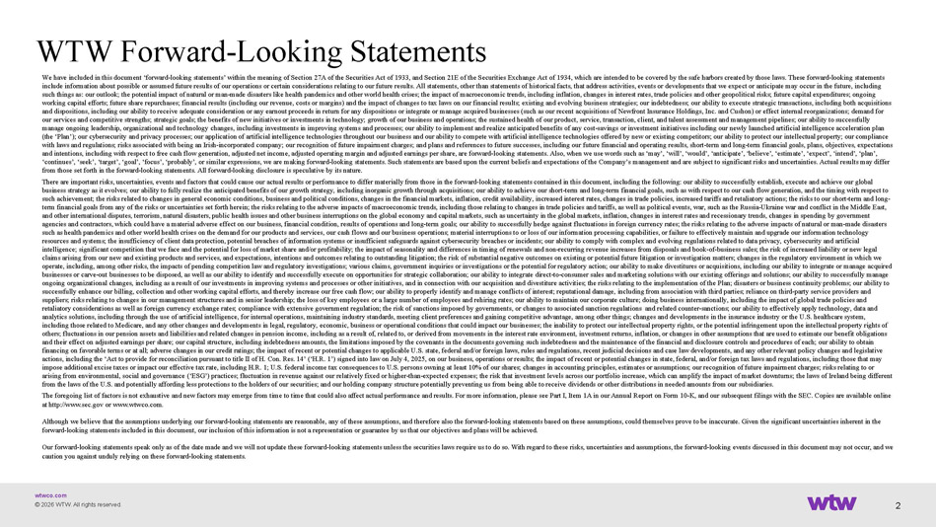
wtwco.com WTW Forward - Looking Statements We have included in this document ‘forward - looking statements’ within the meaning of Section 27A of the Securities Act of 1933, and Section 21E of the Securities Exchange Act of 1934, which are intended to be covered by the safe harbors created by those la ws. These forward - looking statements include information about possible or assumed future results of our operations or certain considerations relating to our futu re results. All statements, other than statements of historical facts, that address activities, events or developments that we e xpe ct or anticipate may occur in the future, including such things as: our outlook; the potential impact of natural or man - made disasters like health pandemics and other world health crises; the impact of macroeconomic trends, including inflation, changes in interest rates, trade policies and other geopolit ica l risks; future capital expenditures; ongoing working capital efforts; future share repurchases; financial results (including our revenue, costs or margins) and the impact of changes to tax laws on our financial results; existing and evolving business strategies; our indebtedness; our ability to exe cu te strategic transactions, including both acquisitions and dispositions, including our ability to receive adequate consideration or any earnout proceeds in return for any dispositi ons or integrate or manage acquired businesses (such as our recent acquisitions of Newfront Insurance Holdings, Inc. and Cushon) or effect internal reorganizations; demand for our services and competitive strengths; strategic goals; the benefits of new initiatives or investments in technology; growth of our business and operations; the sustained health of our product, service, transaction, client, and talent assessment and man ag ement pipelines; our ability to successfully manage ongoing leadership, organizational and technology changes, including investments in improving systems and processes; o ur ability to implement and realize anticipated benefits of any cost - savings or investment initiatives including our newly launched artificial intelligence acceleration plan (the ‘Plan’); our cybersecurity and privacy processes; our application of artificial intelligence technologies throughout our bu siness and our ability to compete with artificial intelligence technologies offered by new or existing competitors; our ability to protect our intellectual property; our compliance with laws and regulations; risks associated with being an Irish - incorporated company; our recognition of future impairment charg es; and plans and references to future successes, including our future financial and operating results, short - term and long - term financial goals, plans, objectives, expectations and intentions, including with respect to free cash flow generation, adjusted net income, adjusted operating margin and adjus ted earnings per share, are forward - looking statements. Also, when we use words such as ‘may’, ‘will’, ‘would’, ‘anticipate’, ‘beli eve’, ‘estimate’, ‘expect’, ‘intend’, ‘plan’, ‘continues’, ‘seek’, ‘target’, ‘goal’, ‘focus’, ‘probably’, or similar expressions, we are making forward - looking statements. Su ch statements are based upon the current beliefs and expectations of the Company’s management and are subject to significant ris ks and uncertainties. Actual results may differ from those set forth in the forward - looking statements. All forward - looking disclosure is speculative by its nature. There are important risks, uncertainties, events and factors that could cause our actual results or performance to differ mat eri ally from those in the forward - looking statements contained in this document, including the following: our ability to successful ly establish, execute and achieve our global business strategy as it evolves; our ability to fully realize the anticipated benefits of our growth strategy, including inor gan ic growth through acquisitions; our ability to achieve our short - term and long - term financial goals, such as with respect to our cash flow generation, and the timing with respect to such achievement; the risks related to changes in general economic conditions, business and political conditions, changes in the financial markets, inflation, credit availability, increased interest rates, changes in trade policies, increased tariffs and r etaliatory actions; the risks to our short - term and long - term financial goals from any of the risks or uncertainties set forth herein; the risks relating to the adverse impacts of ma cro economic trends, including those relating to changes in trade policies and tariffs, as well as political events, war, such as th e Russia - Ukraine war and conflict in the Middle East, and other international disputes, terrorism, natural disasters, public health issues and other business interruptions on the glo bal economy and capital markets, such as uncertainty in the global markets, inflation, changes in interest rates and recessio nar y trends, changes in spending by government agencies and contractors, which could have a material adverse effect on our business, financial condition, results of operati ons and long - term goals; our ability to successfully hedge against fluctuations in foreign currency rates; the risks relating to th e adverse impacts of natural or man - made disasters such as health pandemics and other world health crises on the demand for our products and services, our cash flows and our bu sin ess operations; material interruptions to or loss of our information processing capabilities, or failure to effectively maint ain and upgrade our information technology resources and systems; the insufficiency of client data protection, potential breaches of information systems or insufficient sa feguards against cybersecurity breaches or incidents; our ability to comply with complex and evolving regulations related to dat a privacy, cybersecurity and artificial intelligence; significant competition that we face and the potential for loss of market share and/or profitability; the impac t o f seasonality and differences in timing of renewals and non - recurring revenue increases from disposals and book - of - business sale s; the risk of increased liability or new legal claims arising from our new and existing products and services, and expectations, intentions and outcomes relating to outstan din g litigation; the risk of substantial negative outcomes on existing or potential future litigation or investigation matters; cha nges in the regulatory environment in which we operate, including, among other risks, the impacts of pending competition law and regulatory investigations; various claims, gov ernment inquiries or investigations or the potential for regulatory action; our ability to make divestitures or acquisitions, in cluding our ability to integrate or manage acquired businesses or carve - out businesses to be disposed, as well as our ability to identify and successfully execute on opportunities for strategic collaboration; our ability to integrate direct - to - consumer sales and marketing solutions with our existing offerin gs and solutions; our ability to successfully manage ongoing organizational changes, including as a result of our investments in improving systems and processes or other initiati ves , and in connection with our acquisition and divestiture activities; the risks relating to the implementation of the Plan; di sas ters or business continuity problems; our ability to successfully enhance our billing, collection and other working capital efforts, and thereby increase our free cash flow; our abi lity to properly identify and manage conflicts of interest; reputational damage, including from association with third partie s; reliance on third - party service providers and suppliers; risks relating to changes in our management structures and in senior leadership; the loss of key employees or a la rge number of employees and rehiring rates; our ability to maintain our corporate culture; doing business internationally, includ in g the impact of global trade policies and retaliatory considerations as well as foreign currency exchange rates; compliance with extensive government regulation; the r isk of sanctions imposed by governments, or changes to associated sanction regulations and related counter - sanctions; our ability to effectively apply technology, data and analytics solutions, including through the use of artificial intelligence, for internal operations, maintaining industry stan dar ds, meeting client preferences and gaining competitive advantage, among other things; changes and developments in the insuran ce industry or the U.S. healthcare system, including those related to Medicare, and any other changes and developments in legal, regulatory, economic, business or opera tio nal conditions that could impact our businesses; the inability to protect our intellectual property rights, or the potential inf ringement upon the intellectual property rights of others; fluctuations in our pension assets and liabilities and related changes in pension income, including as a result of, r ela ted to, or derived from movements in the interest rate environment, investment returns, inflation, or changes in other assump tio ns that are used to estimate our benefit obligations and their effect on adjusted earnings per share; our capital structure, including indebtedness amounts, the limitations impos ed by the covenants in the documents governing such indebtedness and the maintenance of the financial and disclosure controls an d p rocedures of each; our ability to obtain financing on favorable terms or at all; adverse changes in our credit ratings; the impact of recent or potential changes to a ppl icable U.S. state, federal and/or foreign laws, rules and regulations, recent judicial decisions and case law developments, a nd any other relevant policy changes and legislative actions, including the ‘Act to provide for reconciliation pursuant to title II of H. Con. Res. 14’ (‘H.R. 1’) signed into law on July 4, 2025, on our business, operations or results; the impact of recent or potential changes in state, federal, and/or for ei gn tax laws and regulations, including those that may impose additional excise taxes or impact our effective tax rate, including H.R. 1; U.S. federal income tax consequences to U. S. persons owning at least 10% of our shares; changes in accounting principles, estimates or assumptions; our recognition of fut ure impairment charges; risks relating to or arising from environmental, social and governance (‘ESG’) practices; fluctuation in revenue against our relatively fixed or h igh er - than - expected expenses; the risk that investment levels across our portfolio increase, which can amplify the impact of market downturns; the laws of Ireland being different from the laws of the U.S. and potentially affording less protections to the holders of our securities; and our holding compan y s tructure potentially preventing us from being able to receive dividends or other distributions in needed amounts from our sub sid iaries. The foregoing list of factors is not exhaustive and new factors may emerge from time to time that could also affect actual pe rfo rmance and results. For more information, please see Part I, Item 1A in our Annual Report on Form 10 - K, and our subsequent filin gs with the SEC. Copies are available online at http://www.sec.gov or www.wtwco.com. Although we believe that the assumptions underlying our forward - looking statements are reasonable, any of these assumptions, and therefore also the forward - looking statements based on these assumptions, could themselves prove to be inaccurate. Given the si gnificant uncertainties inherent in the forward - looking statements included in this document, our inclusion of this information is not a representation or guarantee by us that our objectives and plans will be achieved. Our forward - looking statements speak only as of the date made and we will not update these forward - looking statements unless the securities laws require us to do so. With regard to these risks, uncertainties and assumptions, the forward - looking events disc ussed in this document may not occur, and we caution you against unduly relying on these forward - looking statements. 2 © 2026 WTW. All rights reserved.

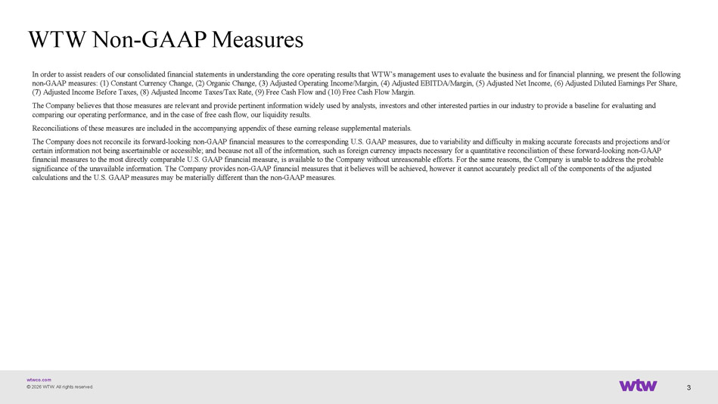
wtwco.com WTW Non - GAAP Measures In order to assist readers of our consolidated financial statements in understanding the core operating results that WTW’s ma nag ement uses to evaluate the business and for financial planning, we present the following non - GAAP measures: (1) Constant Currency Change, (2) Organic Change, (3) Adjusted Operating Income/Margin, (4) Adjusted EBITDA/M argin, (5) Adjusted Net Income, (6) Adjusted Diluted Earnings Per Share, (7) Adjusted Income Before Taxes, (8) Adjusted Income Taxes/Tax Rate, (9) Free Cash Flow and (10) Free Cash Flow Margin. The Company believes that those measures are relevant and provide pertinent information widely used by analysts, investors an d o ther interested parties in our industry to provide a baseline for evaluating and comparing our operating performance, and in the case of free cash flow, our liquidity results. Reconciliations of these measures are included in the accompanying appendix of these earning release supplemental materials. The Company does not reconcile its forward - looking non - GAAP financial measures to the corresponding U.S. GAAP measures, due to v ariability and difficulty in making accurate forecasts and projections and/or certain information not being ascertainable or accessible; and because not all of the information, such as foreign currency i mpa cts necessary for a quantitative reconciliation of these forward - looking non - GAAP financial measures to the most directly comparable U.S. GAAP financial measure, is available to the Company without unreasona ble efforts. For the same reasons, the Company is unable to address the probable significance of the unavailable information. The Company provides non - GAAP financial measures that it believes will be achieved, however it cannot accurately predict all of the components of the adjusted calculations and the U.S. GAAP measures may be materially different than the non - GAAP measures. 3 © 2026 WTW. All rights reserved.

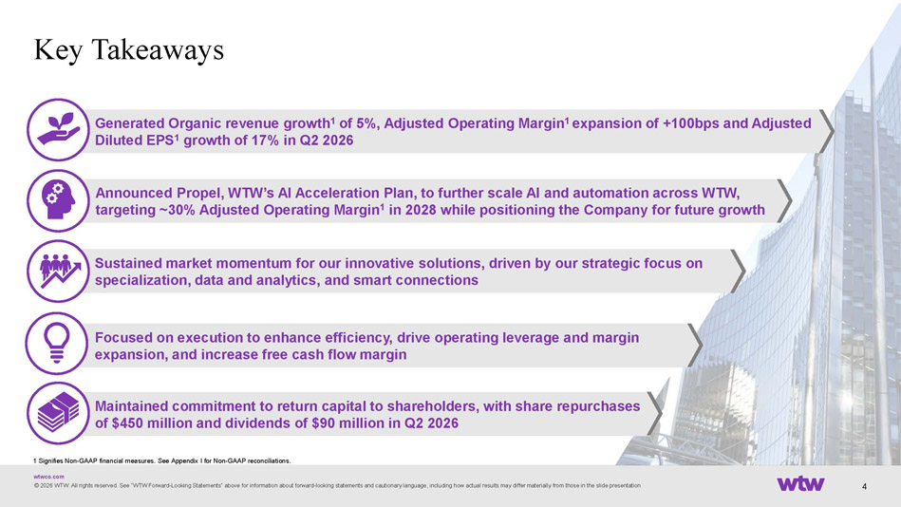
wtwco.com Maintained commitment to return capital to shareholders, with share repurchases of $450 million and dividends of $90 million in Q2 2026 Focused on execution to enhance efficiency, drive operating leverage and margin expansion, and increase free cash flow margin Generated Organic revenue growth 1 of 5%, Adjusted Operating Margin 1 expansion of +100bps and Adjusted Diluted EPS 1 growth of 17% in Q2 2026 Announced Propel, WTW’s AI Acceleration Plan, to further scale AI and automation across WTW, targeting ~30% Adjusted Operating Margin 1 in 2028 while positioning the Company for future growth © 2026 WTW. All rights reserved. See “WTW Forward - Looking Statements“ above for information about forward - looking statements and cautionary language, including how actual results may differ materially from those in the slide presentation. Key Takeaways Sustained market momentum for our innovative solutions, driven by our strategic focus on specialization, data and analytics, and smart connections 4 1 Signifies Non - GAAP financial measures. See Appendix I for Non - GAAP reconciliations.

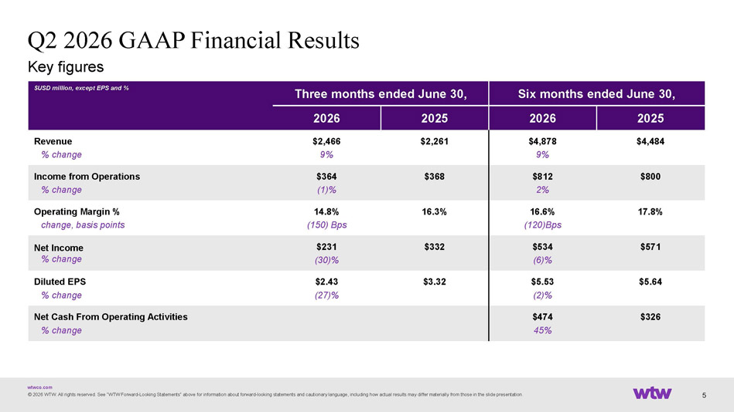
wtwco.com Key figures © 2026 WTW. All rights reserved. See “WTW Forward - Looking Statements“ above for information about forward - looking statements and cautionary language, including how actual results may differ materially from those in the slide presentation. Q2 2026 GAAP Financial Results Six months ended June 30, Three months ended June 30, $USD million, except EPS and % 2025 2026 2025 2026 $4,484 $4,878 9% $2,261 $2,466 9% Revenue % change $800 $812 2% $368 $364 (1)% Income from Operations % change 17.8% 16.6% (120)Bps 16.3% 14.8% (150) Bps Operating Margin % change, basis points $571 $534 (6)% $332 $231 (30)% Net Income % change $5.64 $5.53 (2)% $3.32 $2.43 (27)% Diluted EPS % change $326 $474 45% Net Cash From Operating Activities % change 5

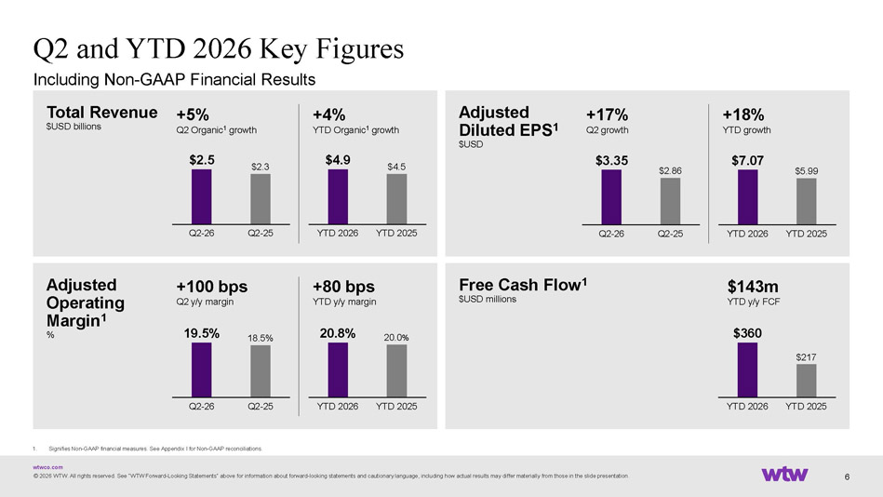
wtwco.com © 2026 WTW. All rights reserved. See “WTW Forward - Looking Statements“ above for information about forward - looking statements and cautionary language, including how actual results may differ materially from those in the slide presentation. Q2 and YTD 2026 Key Figures Total Revenue $USD billions Ad justed O perating Margin 1 % Free Cash Flow 1 $USD millions Adjusted Diluted EPS 1 $USD Including Non - GAAP Financial Results $4.9 $4.5 YTD 2026 YTD 2025 +4% YTD Organic 1 growth 1. Signifies Non - GAAP financial measures. See Appendix I for Non - GAAP reconciliations. $2.5 $2.3 Q2 - 26 Q2 - 25 +5% Q2 Organic 1 growth $7.07 $5.99 YTD 2026 YTD 2025 +18% YTD growth $3.35 $2.86 Q2 - 26 Q2 - 25 + 17 % Q2 growth YTD 2026 YTD 2025 20.8 % 20.0 % + 80 bps YTD y/y margin Q2 - 26 Q2 - 25 19.5 % 18.5 % +100 bps Q2 y/y margin $360 $217 YTD 2026 YTD 2025 $143m YTD y/y FCF 6

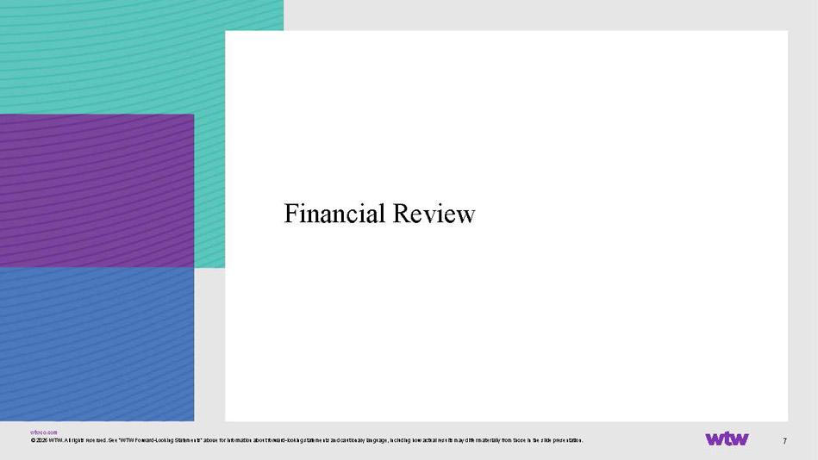
wtwco.com 7 Financial Review © 2026 WTW. All rights reserved. See “WTW Forward - Looking Statements“ above for information about forward - looking statements and cautionary language, including how actual results may differ materially from those in the slide presentation.

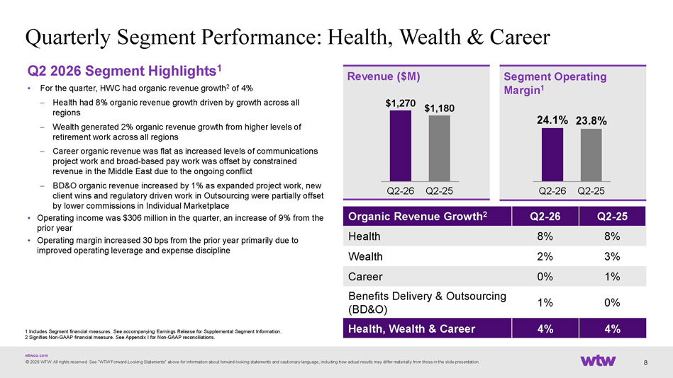
wtwco.com Q2 2026 Segment Highlights 1 • For the quarter, HWC had organic revenue growth 2 of 4% – Health had 8% organic revenue growth driven by growth across all regions – Wealth generated 2% organic revenue growth from higher levels of retirement work across all regions – Career organic revenue was flat as increased levels of communications project work and broad - based pay work was offset by constrained revenue in the Middle East due to the ongoing conflict – BD&O organic revenue increased by 1% as expanded project work, new client wins and regulatory driven work in Outsourcing were partially offset by lower commissions in Individual Marketplace • Operating income was $306 million in the quarter, an increase of 9% from the prior year • Operating margin increased 30 bps from the prior year primarily due to improved operating leverage and expense discipline Quarterly Segment Performance: Health, Wealth & Career © 2026 WTW. All rights reserved. See “WTW Forward - Looking Statements“ above for information about forward - looking statements and cautionary language, including how actual results may differ materially from those in the slide presentation. $1,270 $1,180 Q2 - 26 Q2 - 25 Revenue ($M) Segment Operating Margin 1 Q2 - 25 Q2 - 26 Organic Revenue Growth 2 8% 8% Health 3% 2% Wealth 1% 0% Career 0% 1% Benefits Delivery & Outsourcing (BD&O) 4% 4% Health, Wealth & Career 24.1% 23.8% Q2 - 26 Q2 - 25 1 Includes Segment financial measures. See accompanying Earnings Release for Supplemental Segment Information. 2 Signifies Non - GAAP financial measure. See Appendix I for Non - GAAP reconciliations . 8

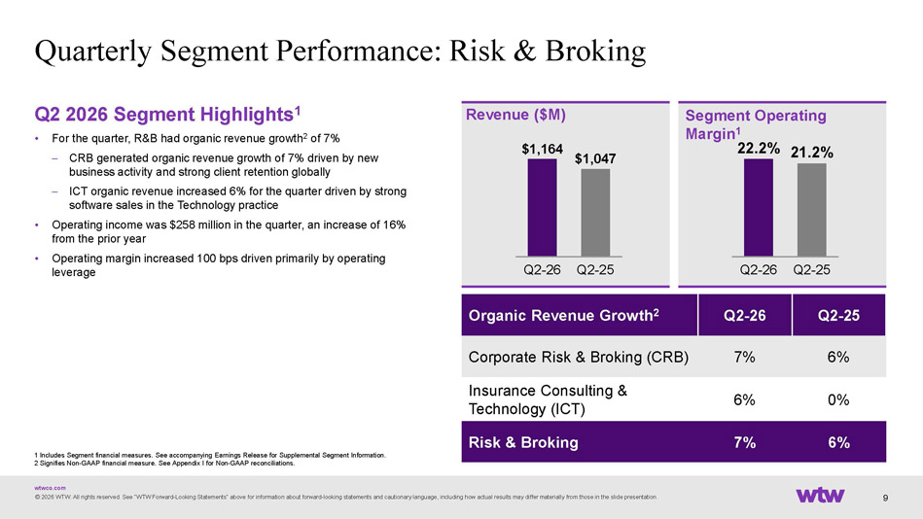
wtwco.com Q2 2026 Segment Highlights 1 • For the quarter, R&B had organic revenue growth 2 of 7% – CRB generated organic revenue growth of 7% driven by new business activity and strong client retention globally – ICT organic revenue increased 6% for the quarter driven by strong software sales in the Technology practice • Operating income was $258 million in the quarter, an increase of 16% from the prior year • Operating margin increased 100 bps driven primarily by operating leverage Quarterly Segment Performance: Risk & Broking © 2026 WTW. All rights reserved. See “WTW Forward - Looking Statements“ above for information about forward - looking statements and cautionary language, including how actual results may differ materially from those in the slide presentation. $1,164 $1,047 Q2 - 26 Q2 - 25 Revenue ($M) Segment Operating Margin 1 Q2 - 25 Q2 - 26 Organic Revenue Growth 2 6% 7% Corporate Risk & Broking (CRB) 0% 6% Insurance Consulting & Technology (ICT) 6% 7% Risk & Broking 22.2% 21.2% Q2 - 26 Q2 - 25 9 1 Includes Segment financial measures. See accompanying Earnings Release for Supplemental Segment Information. 2 Signifies Non - GAAP financial measure. See Appendix I for Non - GAAP reconciliations .

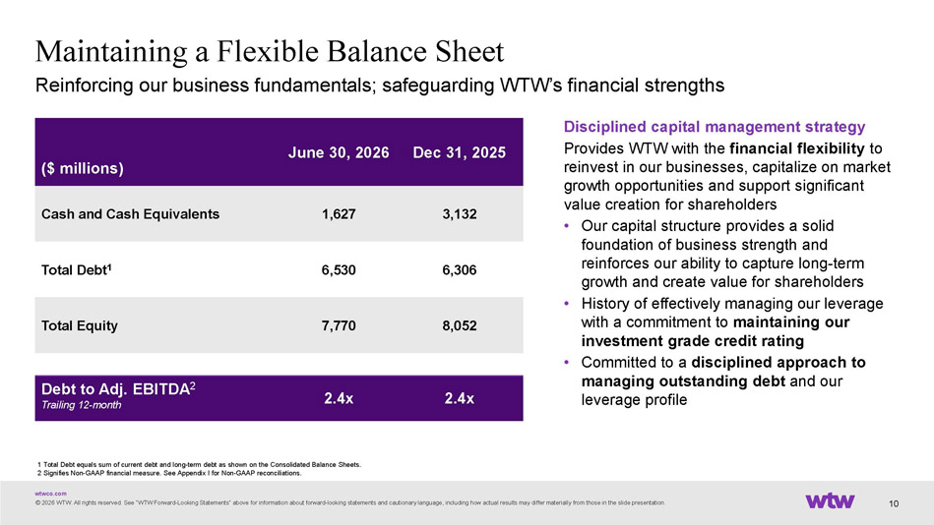
wtwco.com Maintaining a Flexible Balance Sheet © 2026 WTW. All rights reserved. See “WTW Forward - Looking Statements“ above for information about forward - looking statements and cautionary language, including how actual results may differ materially from those in the slide presentation. 1 Total Debt equals sum of current debt and long - term debt as shown on the Consolidated Balance Sheets. 2 Signifies Non - GAAP financial measure. See Appendix I for Non - GAAP reconciliations. Reinforcing our business fundamentals; safeguarding WTW’s financial strengths Dec 31, 2025 June 30, 2026 ($ millions) 3,132 1,627 Cash and Cash Equivalents 6,306 6,530 Total Debt 1 8,052 7,770 Total Equity 2.4x 2.4x Debt to Adj. EBITDA 2 Trailing 12 - month Disciplined capital management strategy Provides WTW with the financial flexibility to reinvest in our businesses, capitalize on market growth opportunities and support significant value creation for shareholders • Our capital structure provides a solid foundation of business strength and reinforces our ability to capture long - term growth and create value for shareholders • History of effectively managing our leverage with a commitment to maintaining our investment grade credit rating • Committed to a disciplined approach to managing outstanding debt and our leverage profile 10

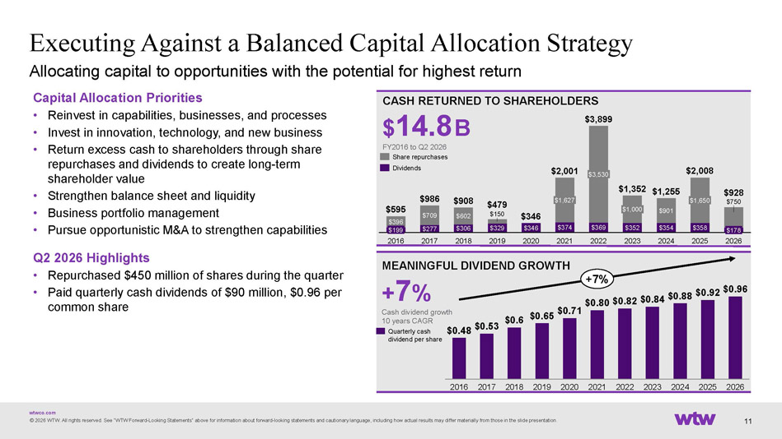
wtwco.com © 2026 WTW. All rights reserved. See “WTW Forward - Looking Statements“ above for information about forward - looking statements and cautionary language, including how actual results may differ materially from those in the slide presentation. Executing Against a Balanced Capital Allocation Strategy CASH RETURNED TO SHAREHOLDERS $ 14.8 B FY2016 to Q2 2026 MEANINGFUL DIVIDEND GROWTH + 7 % Cash dividend growth 10 years CAGR 2016 2017 2018 2019 2020 2021 2022 2023 2024 2025 2026 $ 0.48 $ 0.53 $ 0.6 $ 0.65 $ 0.71 $0.80 $ 0.82 $ 0.84 $ 0.88 $ 0.92 $ 0.96 +7% Quarterly cash dividend per share Capital Allocation Priorities • Reinvest in capabilities, businesses, and processes • Invest in innovation, technology, and new business • Return excess cash to shareholders through share repurchases and dividends to create long - term shareholder value • Strengthen balance sheet and liquidity • Business portfolio management • Pursue opportunistic M&A to strengthen capabilities Q2 2026 Highlights • Repurchased $450 million of shares during the quarter • Paid quarterly cash dividends of $90 million, $0.96 per common share 11 Allocating capital to opportunities with the potential for highest return $277 $306 $329 $346 $374 $369 $352 $354 $358 $396 $709 $602 $150 $901 $750 $199 2016 2017 2018 2019 2020 $1,627 2021 $3,530 2022 $1,000 2023 2024 $1,650 2025 $178 2026 $595 $986 $908 $479 $346 $2,001 $3,899 $1,352 $1,255 $2,008 $928 Share repurchases Dividends

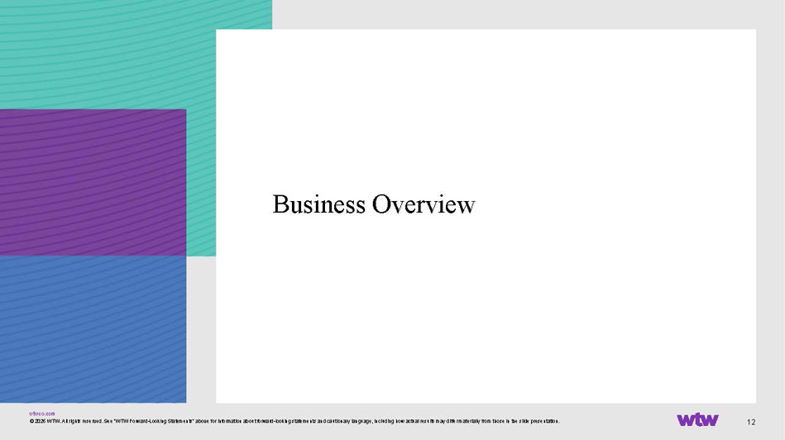
wtwco.com 12 Business Overview © 2026 WTW. All rights reserved. See “WTW Forward - Looking Statements“ above for information about forward - looking statements and cautionary language, including how actual results may differ materially from those in the slide presentation.

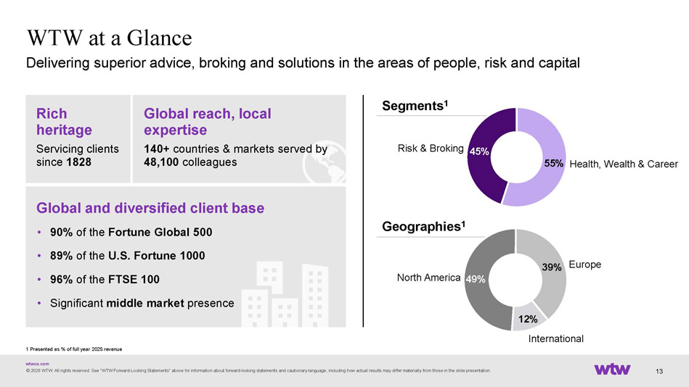
wtwco.com © 2026 WTW. All rights reserved. See “WTW Forward - Looking Statements“ above for information about forward - looking statements and cautionary language, including how actual results may differ materially from those in the slide presentation. 13 WTW at a Glance Delivering superior advice, broking and solutions in the areas of people, risk and capital Segments 1 Geographies 1 Rich heritage Servicing clients since 1828 Global and diversified client base • 90% of the Fortune Global 500 • 89% of the U.S. Fortune 1000 • 96% of the FTSE 100 • Significant middle market presence Global reach, local expertise 140+ countries & markets served by 48,100 colleagues 1 Presented as % of full year 2025 revenue 55% 45% Health, Wealth & Career Risk & Broking 49% 39% 12% North America Europe International

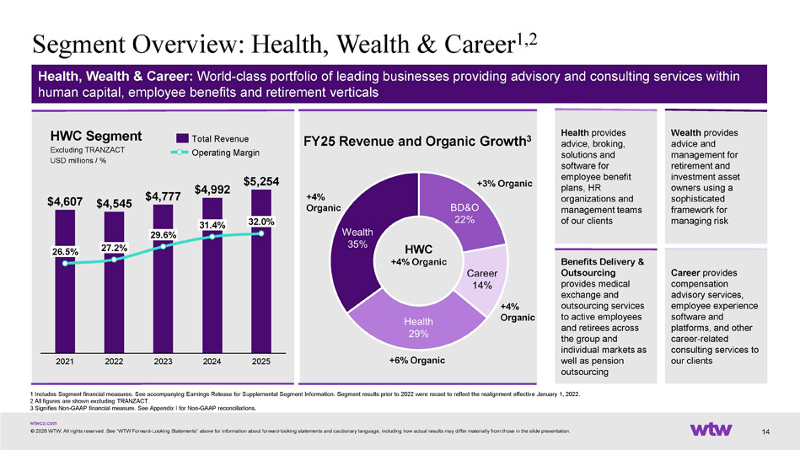
wtwco.com +4% Organic Segment Overview: Health, Wealth & Career 1,2 © 2026 WTW. All rights reserved. See “WTW Forward - Looking Statements“ above for information about forward - looking statements and cautionary language, including how actual results may differ materially from those in the slide presentation. Health, Wealth & Career: World - class portfolio of leading businesses providing advisory and consulting services within human capital, employee benefits and retirement verticals Benefits Delivery & Outsourcing provides medical exchange and outsourcing services to active employees and retirees across the group and individual markets as well as pension outsourcing Health provides advice, broking, solutions and software for employee benefit plans, HR organizations and management teams of our clients Wealth provides advice and management for retirement and investment asset owners using a sophisticated framework for managing risk Career provides compensation advisory services, employee experience software and platforms, and other career - related consulting services to our clients 14 FY25 Revenue and Organic Growth 3 1 Includes Segment financial measures. See accompanying Earnings Release for Supplemental Segment Information. Segment results pr ior to 2022 were recast to reflect the realignment effective January 1, 2022. 2 All figures are shown excluding TRANZACT. 3 Signifies Non - GAAP financial measure. See Appendix I for Non - GAAP reconciliations. HWC Segment Excluding TRANZACT USD millions / % $4,607 $4,545 $4,777 $4,992 $5,254 26.5% 2021 27.2% 2022 29.6% 2023 31.4% 2024 2025 32.0% Total Revenue Operating Margin +3% Organic +4% Organic HWC +4% Organic +6% Organic

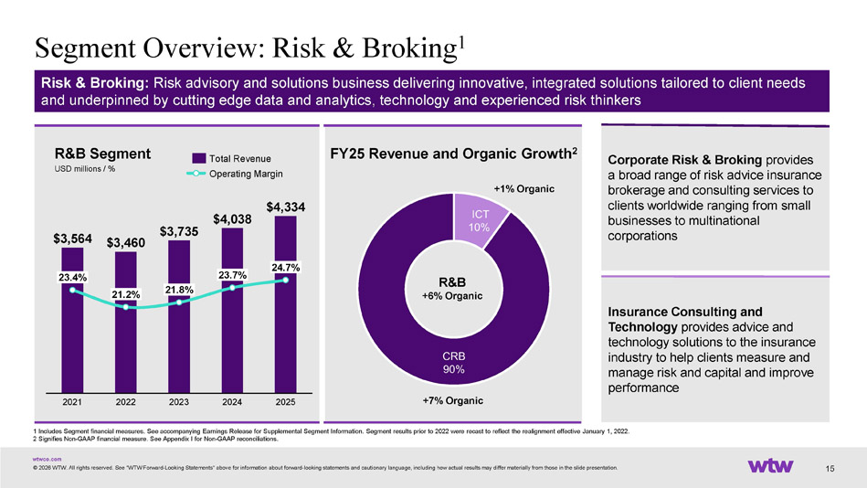
wtwco.com Insurance Consulting and Technology provides advice and technology solutions to the insurance industry to help clients measure and manage risk and capital and improve performance +7% Organic Segment Overview: Risk & Broking 1 © 2026 WTW. All rights reserved. See “WTW Forward - Looking Statements“ above for information about forward - looking statements and cautionary language, including how actual results may differ materially from those in the slide presentation. Risk & Broking: Risk advisory and solutions business delivering innovative, integrated solutions tailored to client needs and underpinned by cutting edge data and analytics, technology and experienced risk thinkers Corporate Risk & Broking provides a broad range of risk advice insurance brokerage and consulting services to clients worldwide ranging from small businesses to multinational corporations 15 FY25 Revenue and Organic Growth 2 1 Includes Segment financial measures. See accompanying Earnings Release for Supplemental Segment Information. Segment results pr ior to 2022 were recast to reflect the realignment effective January 1, 2022. 2 Signifies Non - GAAP financial measure. See Appendix I for Non - GAAP reconciliations. +1% Organic R&B Segment USD millions / % $3,564 $3,460 $3,735 $4,038 $4,334 23.4% 2021 21.2% 2022 21.8% 2023 23.7% 2024 2025 24.7% Total Revenue Operating Margin R&B +6% Organic

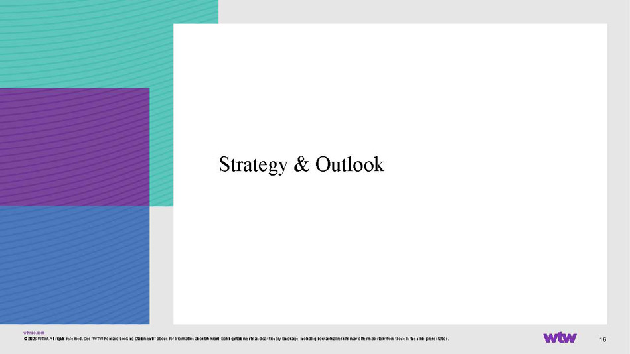
wtwco.com 16 Strategy & Outlook © 2026 WTW. All rights reserved. See “WTW Forward - Looking Statements“ above for information about forward - looking statements and cautionary language, including how actual results may differ materially from those in the slide presentation.

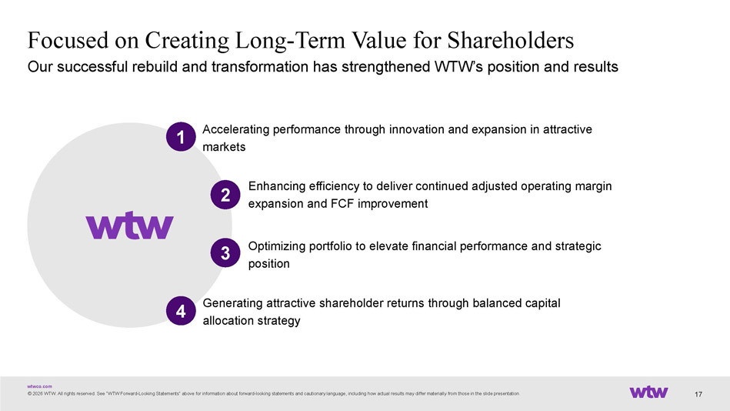
wtwco.com Focused on Creating Long - Term Value for Shareholders © 2026 WTW. All rights reserved. See “WTW Forward - Looking Statements“ above for information about forward - looking statements and cautionary language, including how actual results may differ materially from those in the slide presentation. Our successful rebuild and transformation has strengthened WTW’s position and results 17 Accelerating performance through innovation and expansion in attractive markets 1 Enhancing efficiency to deliver continued adjusted operating margin expansion and FCF improvement Optimizing portfolio to elevate financial performance and strategic position Generating attractive shareholder returns through balanced capital allocation strategy 2 4 3

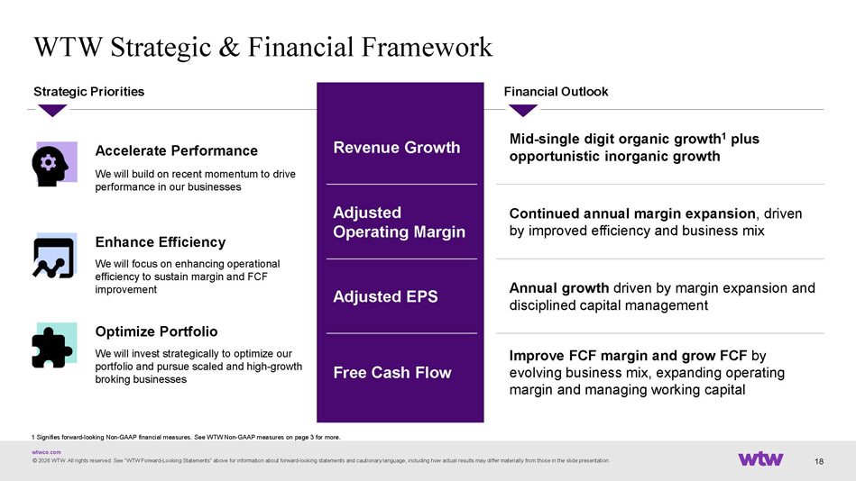
wtwco.com 18 WTW Strategic & Financial Framework Accelerate Performance We will build on recent momentum to drive performance in our businesses Strategic Priorities Enhance Efficiency We will focus on enhancing operational efficiency to sustain margin and FCF improvement Optimize Portfolio We will invest strategically to optimize our portfolio and pursue scaled and high - growth broking businesses Financial Outlook Mid - single digit organic growth 1 plus opportunistic inorganic growth Revenue Growth Continued annual margin expansion , driven by improved efficiency and business mix Adjusted Operating Margin Annual growth driven by margin expansion and disciplined capital management Adjusted EPS Improve FCF margin and grow FCF by evolving business mix, expanding operating margin and managing working capital Free Cash Flow © 2026 WTW. All rights reserved. See “WTW Forward - Looking Statements“ above for information about forward - looking statements and cautionary language, including how actual results may differ materially from those in the slide presentation. 1 Signifies forward - looking Non - GAAP financial measures. See WTW Non - GAAP measures on page 3 for more.

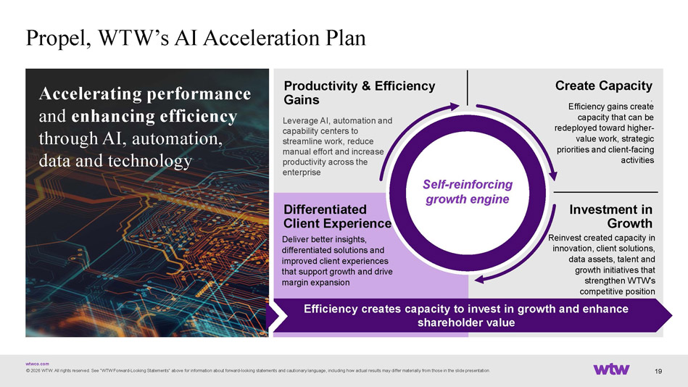
wtwco.com Propel, WTW’s AI Acceleration Plan 19 © 2026 WTW. All rights reserved. See “WTW Forward - Looking Statements“ above for information about forward - looking statements and cautionary language, including how actual results may differ materially from those in the slide presentation. Accelerating performance and enhancing efficiency through AI, automation, data and technology Investment in Growth . Differentiated Client Experience Productivity & Efficiency Gains Create Capacity . Efficiency creates capacity to invest in growth and enhance shareholder value Reinvest created capacity in innovation, client solutions, data assets, talent and growth initiatives that strengthen WTW's competitive position Deliver better insights, differentiated solutions and improved client experiences that support growth and drive margin expansion Leverage AI, automation and capability centers to streamline work, reduce manual effort and increase productivity across the enterprise Efficiency gains create capacity that can be redeployed toward higher - value work, strategic priorities and client - facing activities Self - reinforcing growth engine

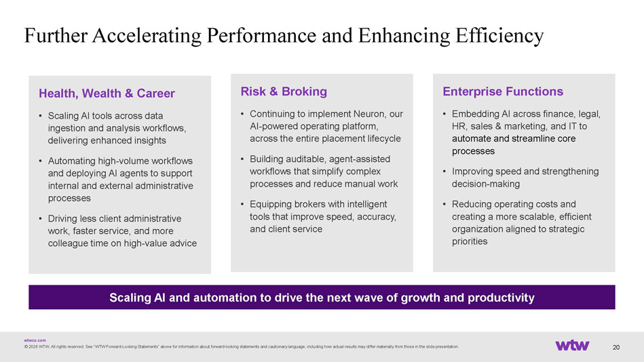
wtwco.com Further Accelerating Performance and Enhancing Efficiency © 2026 WTW. All rights reserved. See “WTW Forward - Looking Statements“ above for information about forward - looking statements and cautionary language, including how actual results may differ materially from those in the slide presentation. 20 Health, Wealth & Career • Scaling AI tools across data ingestion and analysis workflows, delivering enhanced insights • Automating high - volume workflows and deploying AI agents to support internal and external administrative processes • Driving less client administrative work, faster service, and more colleague time on high - value advice Risk & Broking • Continuing to implement Neuron, our AI - powered operating platform, across the entire placement lifecycle • Building auditable, agent - assisted workflows that simplify complex processes and reduce manual work • Equipping brokers with intelligent tools that improve speed, accuracy, and client service Enterprise Functions • Embedding AI across finance, legal, HR, sales & marketing, and IT to automate and streamline core processes • Improving speed and strengthening decision - making • Reducing operating costs and creating a more scalable, efficient organization aligned to strategic priorities Scaling AI and automation to drive the next wave of growth and productivity

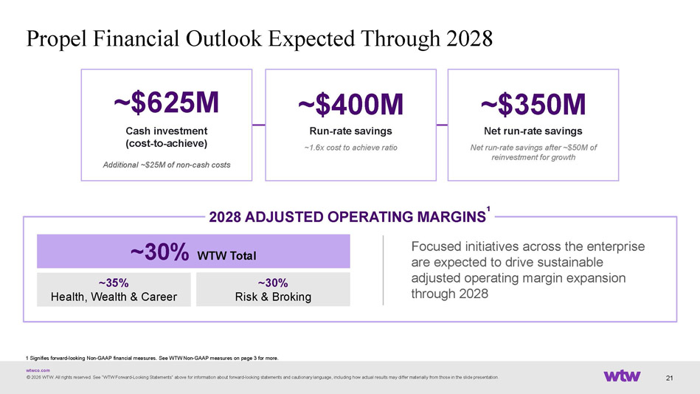
wtwco.com Propel Financial Outlook Expected Through 2028 © 2026 WTW. All rights reserved. See “WTW Forward - Looking Statements“ above for information about forward - looking statements and cautionary language, including how actual results may differ materially from those in the slide presentation. 21 1 Signifies forward - looking Non - GAAP financial measures. See WTW Non - GAAP measures on page 3 for more. ~$625M Cash investment (cost - to - achieve) Additional ~$25M of non - cash costs ~$400M Run - rate savings ~ 1.6x cost to achieve ratio ~$350M Net run - rate savings Net run - rate savings after ~$50M of reinvestment for growth Focused initiatives across the enterprise are expected to drive sustainable adjusted operating margin expansion through 2028 2028 ADJUSTED OPERATING MARGINS ¹ ~30% WTW Total ~35% Health, Wealth & Career ~30% Risk & Broking

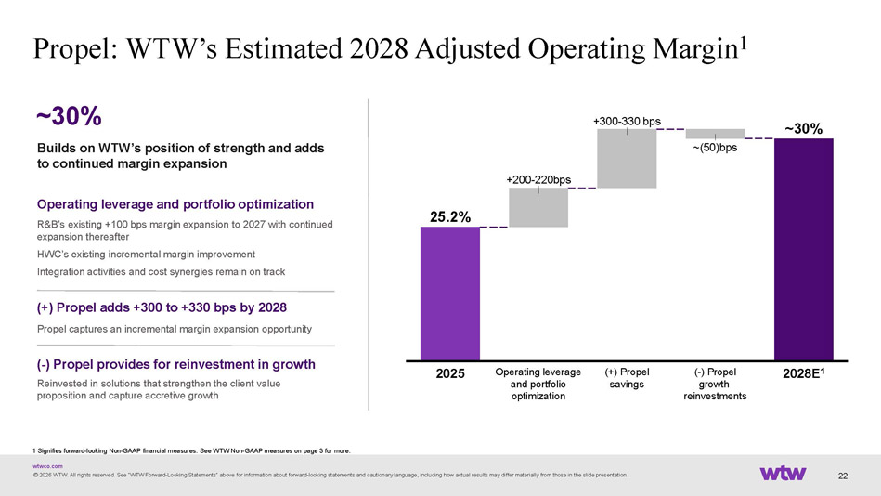
wtwco.com 22 2025 +200 - 220bps Operating leverage and portfolio optimization +300 - 330 bps (+) Propel savings ~(50)bps ( - ) Propel growth reinvestments 2028E 1 25.2% ~30% Propel: WTW’s Estimated 2028 Adjusted Operating Margin 1 Builds on WTW’s position of strength and adds to continued margin expansion Operating leverage and portfolio optimization R&B’s existing +100 bps margin expansion to 2027 with continued expansion thereafter HWC’s existing incremental margin improvement Integration activities and cost synergies remain on track (+) Propel adds +300 to +330 bps by 2028 Propel captures an incremental margin expansion opportunity ( - ) Propel provides for reinvestment in growth Reinvested in solutions that strengthen the client value proposition and capture accretive growth ~30% 1 Signifies forward - looking Non - GAAP financial measures. See WTW Non - GAAP measures on page 3 for more. © 2026 WTW. All rights reserved. See “WTW Forward - Looking Statements“ above for information about forward - looking statements and cautionary language, including how actual results may differ materially from those in the slide presentation.

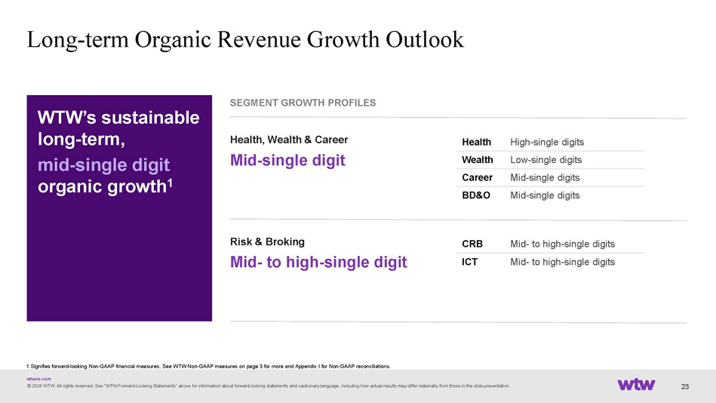
wtwco.com 23 Long - term Organic Revenue Growth Outlook 1 Signifies forward - looking Non - GAAP financial measures. See WTW Non - GAAP measures on page 3 for more and Appendix I for Non - GAAP reconciliations. © 2026 WTW. All rights reserved. See “WTW Forward - Looking Statements“ above for information about forward - looking statements and cautionary language, including how actual results may differ materially from those in the slide presentation. WTW’s sustainable long - term, mid - single digit organic growth 1 SEGMENT GROWTH PROFILES Health, Wealth & Career Mid - single digit Mid - to high - single digits CRB Mid - to high - single digits ICT High - single digits Health Low - single digits Wealth Mid - single digits Career Mid - single digits BD&O Risk & Broking Mid - to high - single digit

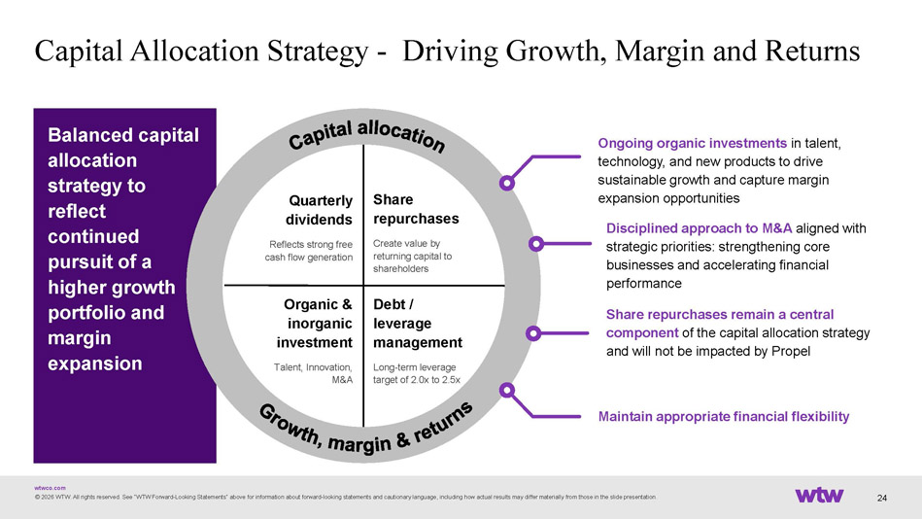
wtwco.com Balanced capital allocation strategy to reflect continued pursuit of a higher growth portfolio and margin expansion 24 Capital Allocation Strategy - Driving Growth, Margin and Returns Ongoing organic investments in talent, technology, and new products to drive sustainable growth and capture margin expansion opportunities Disciplined approach to M&A aligned with strategic priorities: strengthening core businesses and accelerating financial performance Share repurchases remain a central component of the capital allocation strategy and will not be impacted by Propel Maintain appropriate financial flexibility Share repurchases Create value by returning capital to shareholders Quarterly dividends Reflects strong free cash flow generation Debt / leverage management Long - term leverage target of 2.0x to 2.5x Organic & inorganic investment Talent, Innovation, M&A © 2026 WTW. All rights reserved. See “WTW Forward - Looking Statements“ above for information about forward - looking statements and cautionary language, including how actual results may differ materially from those in the slide presentation.CD1

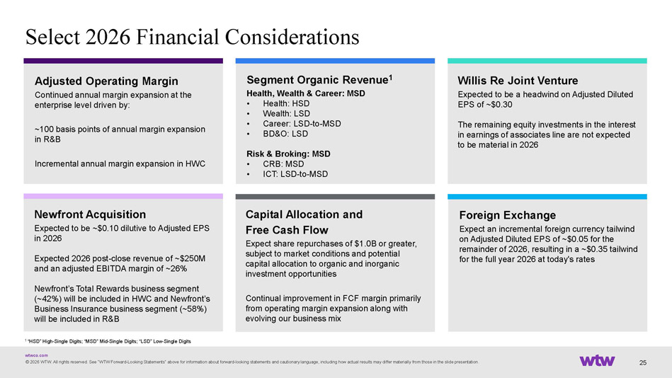
wtwco.com 25 Select 2026 Financial Considerations © 2026 WTW. All rights reserved. See “WTW Forward - Looking Statements“ above for information about forward - looking statements and cautionary language, including how actual results may differ materially from those in the slide presentation. Willis Re Joint Venture Expected to be a headwind on Adjusted Diluted EPS of ~$0.30 The remaining equity investments in the interest in earnings of associates line are not expected to be material in 2026 Segment Organic Revenue 1 Health, Wealth & Career: MSD • Health: HSD • Wealth: LSD • Career: LSD - to - MSD • BD&O: LSD Risk & Broking: MSD • CRB: MSD • ICT: LSD - to - MSD Foreign Exchange Expect an incremental foreign currency tailwind on Adjusted Diluted EPS of ~$0.05 for the remainder of 2026, resulting in a ~$0.35 tailwind for the full year 2026 at today's rates Adjusted Operating Margin Continued annual margin expansion at the enterprise level driven by: ~100 basis points of annual margin expansion in R&B Incremental annual margin expansion in HWC 1 “HSD” High - Single Digits; “MSD” Mid - Single Digits; “LSD” Low - Single Digits Capital Allocation and Free Cash Flow Expect share repurchases of $1.0B or greater, subject to market conditions and potential capital allocation to organic and inorganic investment opportunities Continual improvement in FCF margin primarily from operating margin expansion along with evolving our business mix Newfront Acquisition Expected to be ~$0.10 dilutive to Adjusted EPS in 2026 Expected 2026 post - close revenue of ~$250M and an adjusted EBITDA margin of ~26% Newfront’s Total Rewards business segment (~42%) will be included in HWC and Newfront’s Business Insurance business segment (~58%) will be included in R&B

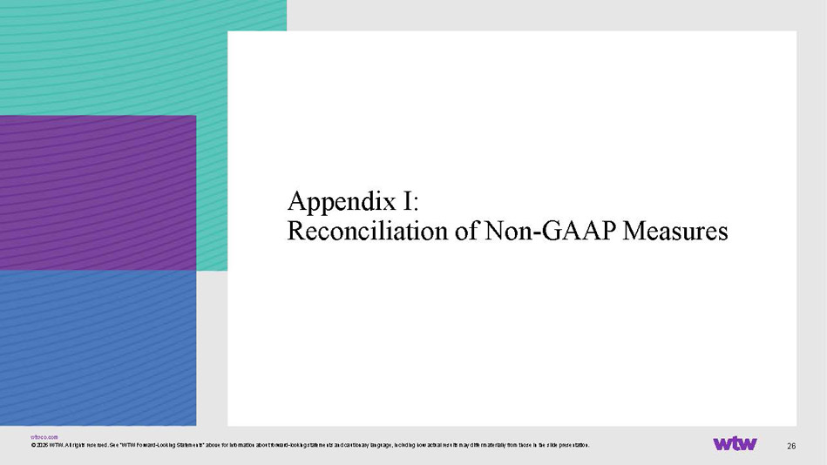
wtwco.com 26 Appendix I: Reconciliation of Non - GAAP Measures © 2026 WTW. All rights reserved. See “WTW Forward - Looking Statements“ above for information about forward - looking statements and cautionary language, including how actual results may differ materially from those in the slide presentation.

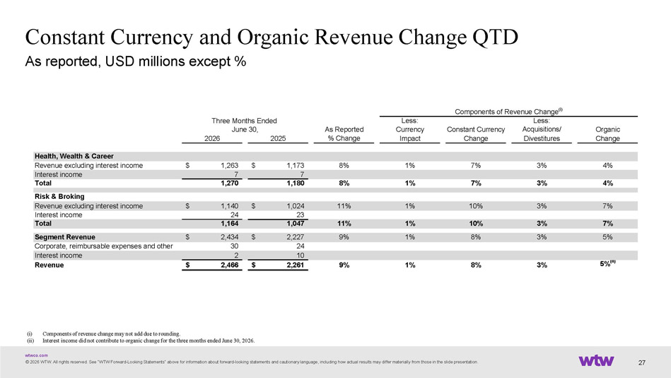
wtwco.com Constant Currency and Organic Revenue Change QTD © 2026 WTW. All rights reserved. See “WTW Forward - Looking Statements“ above for information about forward - looking statements and cautionary language, including how actual results may differ materially from those in the slide presentation. As reported, USD millions except % 27 (i) Components of revenue change may not add due to rounding. (ii) Interest income did not contribute to organic change for the three months ended June 30, 2026. Less: Less: As Reported Currency Constant Currency Acquisitions/ Organic 2026 2025 % Change Impact Change Divestitures Change Health, Wealth & Career Revenue excluding interest income 1,263$ 1,173$ 8% 1% 7% 3% 4% Interest income 7 7 Total 1,270 1,180 8% 1% 7% 3% 4% Risk & Broking Revenue excluding interest income 1,140$ 1,024$ 11% 1% 10% 3% 7% Interest income 24 23 Total 1,164 1,047 11% 1% 10% 3% 7% Segment Revenue 2,434$ 2,227$ 9% 1% 8% 3% 5% Corporate, reimbursable expenses and other 30 24 Interest income 2 10 Revenue 2,466$ 2,261$ 9% 1% 8% 3% 5% (ii) Components of Revenue Change (i) June 30, Three Months Ended

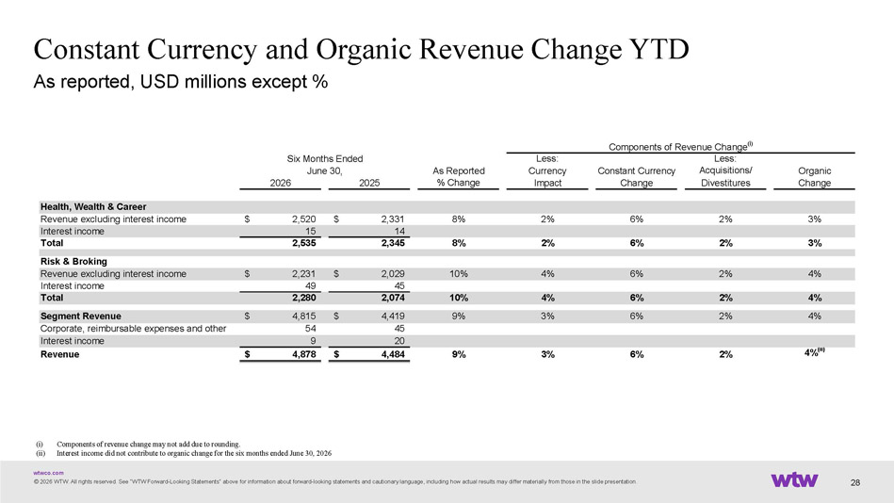
wtwco.com Constant Currency and Organic Revenue Change YTD © 2026 WTW. All rights reserved. See “WTW Forward - Looking Statements“ above for information about forward - looking statements and cautionary language, including how actual results may differ materially from those in the slide presentation. As reported, USD millions except % 28 (i) Components of revenue change may not add due to rounding. (ii) Interest income did not contribute to organic change for the six months ended June 30, 2026 Less: Less: As Reported Currency Constant Currency Acquisitions/ Organic 2026 2025 % Change Impact Change Divestitures Change Health, Wealth & Career Revenue excluding interest income 2,520$ 2,331$ 8% 2% 6% 2% 3% Interest income 15 14 Total 2,535 2,345 8% 2% 6% 2% 3% Risk & Broking Revenue excluding interest income 2,231$ 2,029$ 10% 4% 6% 2% 4% Interest income 49 45 Total 2,280 2,074 10% 4% 6% 2% 4% Segment Revenue 4,815$ 4,419$ 9% 3% 6% 2% 4% Corporate, reimbursable expenses and other 54 45 Interest income 9 20 Revenue 4,878$ 4,484$ 9% 3% 6% 2% 4% (ii) June 30, Components of Revenue Change (i) Six Months Ended

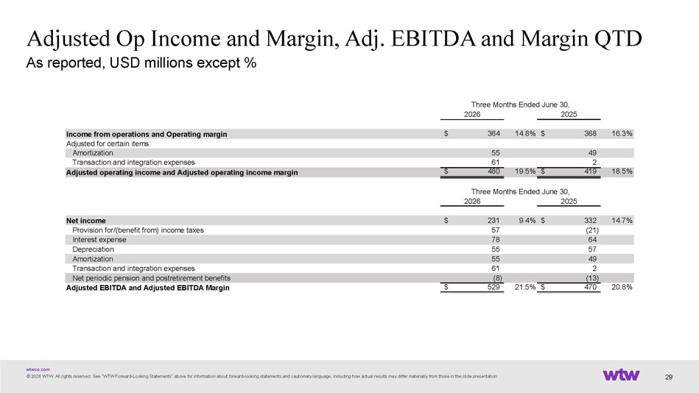
wtwco.com © 2026 WTW. All rights reserved. See “WTW Forward - Looking Statements“ above for information about forward - looking statements and cautionary language, including how actual results may differ materially from those in the slide presentation. Adjusted Op Income and Margin, Adj. EBITDA and Margin QTD As reported, USD millions except % 29 2026 2025 Income from operations and Operating margin 364$ 14.8% 368$ 16.3% Adjusted for certain items: Amortization 55 49 Transaction and integration expenses 61 2 Adjusted operating income and Adjusted operating income margin 480$ 19.5% 419$ 18.5% 2026 2025 Net income 231$ 9.4% 332$ 14.7% Provision for/(benefit from) income taxes 57 (21) Interest expense 78 64 Depreciation 55 57 Amortization 55 49 Transaction and integration expenses 61 2 Net periodic pension and postretirement benefits (8) (13) Adjusted EBITDA and Adjusted EBITDA Margin 529$ 21.5% 470$ 20.8% Three Months Ended June 30, Three Months Ended June 30,

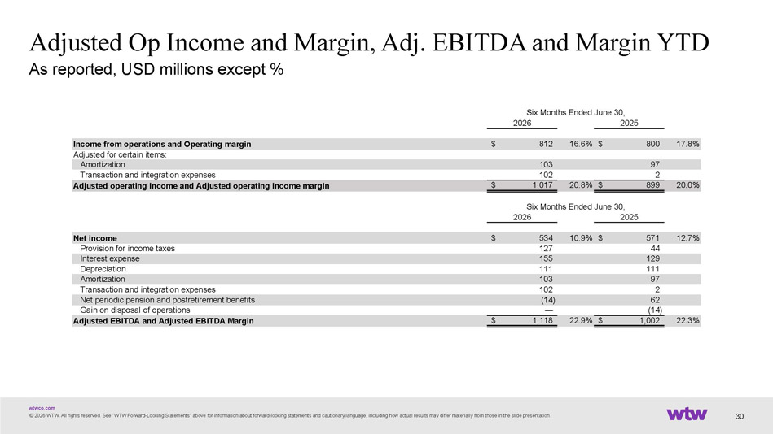
wtwco.com © 2026 WTW. All rights reserved. See “WTW Forward - Looking Statements“ above for information about forward - looking statements and cautionary language, including how actual results may differ materially from those in the slide presentation. Adjusted Op Income and Margin, Adj. EBITDA and Margin YTD As reported, USD millions except % 30 2026 2025 Income from operations and Operating margin 812$ 16.6% 800$ 17.8% Adjusted for certain items: Amortization 103 97 Transaction and integration expenses 102 2 Adjusted operating income and Adjusted operating income margin 1,017$ 20.8% 899$ 20.0% 2026 2025 Net income 534$ 10.9% 571$ 12.7% Provision for income taxes 127 44 Interest expense 155 129 Depreciation 111 111 Amortization 103 97 Transaction and integration expenses 102 2 Net periodic pension and postretirement benefits (14) 62 Gain on disposal of operations — (14) Adjusted EBITDA and Adjusted EBITDA Margin 1,118$ 22.9% 1,002$ 22.3% Six Months Ended June 30, Six Months Ended June 30,

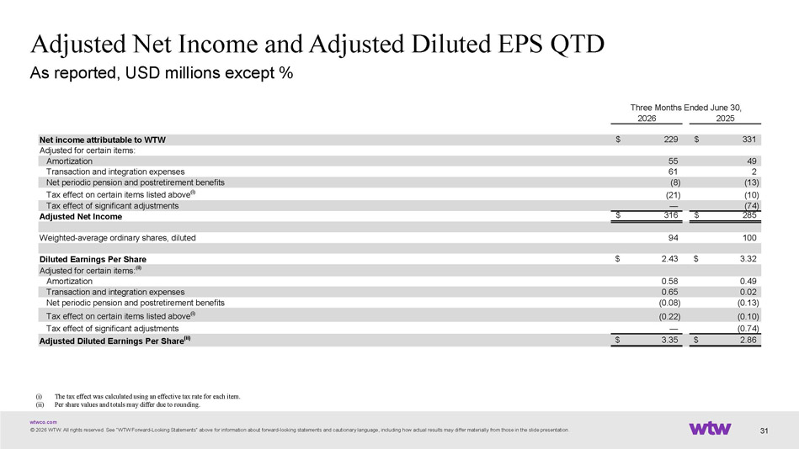
wtwco.com Adjusted Net Income and Adjusted Diluted EPS QTD © 2026 WTW. All rights reserved. See “WTW Forward - Looking Statements“ above for information about forward - looking statements and cautionary language, including how actual results may differ materially from those in the slide presentation. As reported, USD millions except % 31 (i) The tax effect was calculated using an effective tax rate for each item. (ii) Per share values and totals may differ due to rounding. 2026 2025 Net income attributable to WTW 229$ 331$ Adjusted for certain items: Amortization 55 49 Transaction and integration expenses 61 2 Net periodic pension and postretirement benefits (8) (13) Tax effect on certain items listed above (i) (21) (10) Tax effect of significant adjustments — (74) Adjusted Net Income 316$ 285$ Weighted-average ordinary shares, diluted 94 100 Diluted Earnings Per Share 2.43$ 3.32$ Adjusted for certain items: (ii) Amortization 0.58 0.49 Transaction and integration expenses 0.65 0.02 Net periodic pension and postretirement benefits (0.08) (0.13) Tax effect on certain items listed above (i) (0.22) (0.10) Tax effect of significant adjustments — (0.74) Adjusted Diluted Earnings Per Share (ii) 3.35$ 2.86$ Three Months Ended June 30,

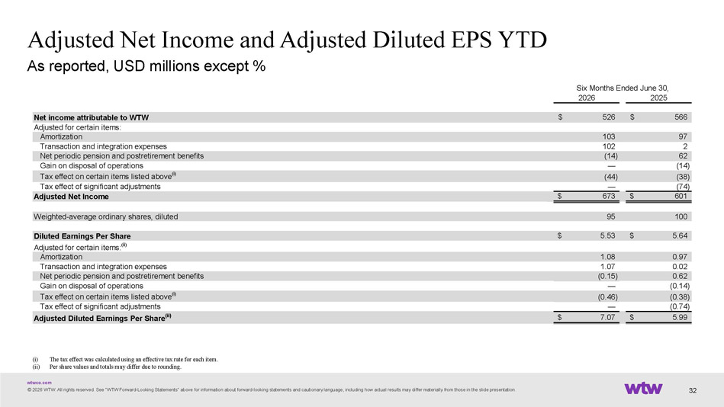
wtwco.com Adjusted Net Income and Adjusted Diluted EPS YTD © 2026 WTW. All rights reserved. See “WTW Forward - Looking Statements“ above for information about forward - looking statements and cautionary language, including how actual results may differ materially from those in the slide presentation. As reported, USD millions except % 32 2026 2025 Net income attributable to WTW 526$ 566$ Adjusted for certain items: Amortization 103 97 Transaction and integration expenses 102 2 Net periodic pension and postretirement benefits (14) 62 Gain on disposal of operations — (14) Tax effect on certain items listed above (i) (44) (38) Tax effect of significant adjustments — (74) Adjusted Net Income 673$ 601$ Weighted-average ordinary shares, diluted 95 100 Diluted Earnings Per Share 5.53$ 5.64$ Adjusted for certain items: (ii) Amortization 1.08 0.97 Transaction and integration expenses 1.07 0.02 Net periodic pension and postretirement benefits (0.15) 0.62 Gain on disposal of operations — (0.14) Tax effect on certain items listed above (i) (0.46) (0.38) Tax effect of significant adjustments — (0.74) Adjusted Diluted Earnings Per Share (ii) 7.07$ 5.99$ Six Months Ended June 30, (i) The tax effect was calculated using an effective tax rate for each item. (ii) Per share values and totals may differ due to rounding.

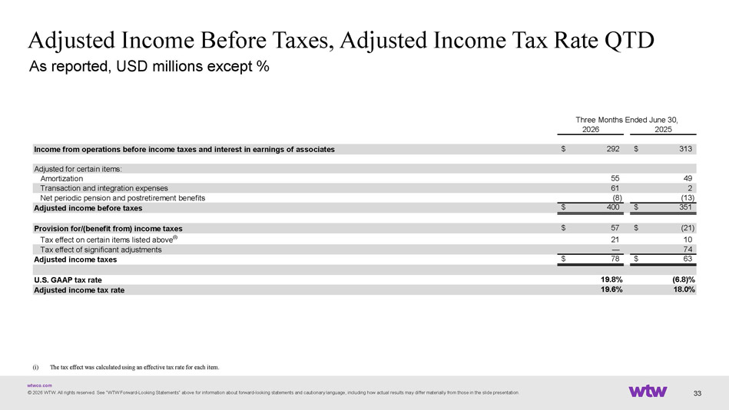
wtwco.com Adjusted Income Before Taxes, Adjusted Income Tax Rate QTD As reported, USD millions except % © 2026 WTW. All rights reserved. See “WTW Forward - Looking Statements“ above for information about forward - looking statements and cautionary language, including how actual results may differ materially from those in the slide presentation. 33 2026 2025 Income from operations before income taxes and interest in earnings of associates 292$ 313$ Adjusted for certain items: Amortization 55 49 Transaction and integration expenses 61 2 Net periodic pension and postretirement benefits (8) (13) Adjusted income before taxes 400$ 351$ Provision for/(benefit from) income taxes 57$ (21)$ Tax effect on certain items listed above (i) 21 10 Tax effect of significant adjustments — 74 Adjusted income taxes 78$ 63$ U.S. GAAP tax rate 19.8% (6.8)% Adjusted income tax rate 19.6% 18.0% Three Months Ended June 30, (i) The tax effect was calculated using an effective tax rate for each item.

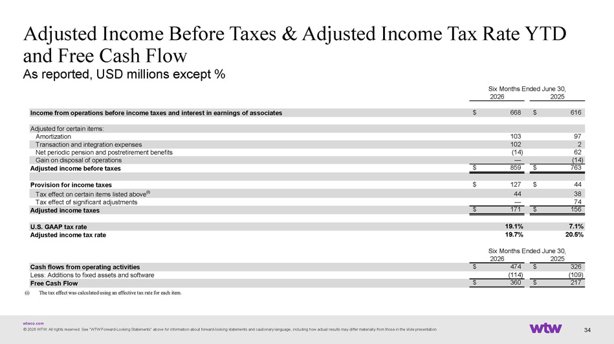
wtwco.com Adjusted Income Before Taxes & Adjusted Income Tax Rate YTD and Free Cash Flow As reported, USD millions except % © 2026 WTW. All rights reserved. See “WTW Forward - Looking Statements“ above for information about forward - looking statements and cautionary language, including how actual results may differ materially from those in the slide presentation. 34 (i) ? ﻿ The tax effect was calculated using an effective tax rate for each item. 2026 2025 Income from operations before income taxes and interest in earnings of associates 668$ 616$ Adjusted for certain items: Amortization 103 97 Transaction and integration expenses 102 2 Net periodic pension and postretirement benefits (14) 62 Gain on disposal of operations — (14) Adjusted income before taxes 859$ 763$ Provision for income taxes 127$ 44$ Tax effect on certain items listed above (i) 44 38 Tax effect of significant adjustments — 74 Adjusted income taxes 171$ 156$ U.S. GAAP tax rate 19.1% 7.1% Adjusted income tax rate 19.7% 20.5% 2026 2025 Cash flows from operating activities 474$ 326$ Less: Additions to fixed assets and software (114) (109) Free Cash Flow 360$ 217$ Six Months Ended June 30, Six Months Ended June 30,

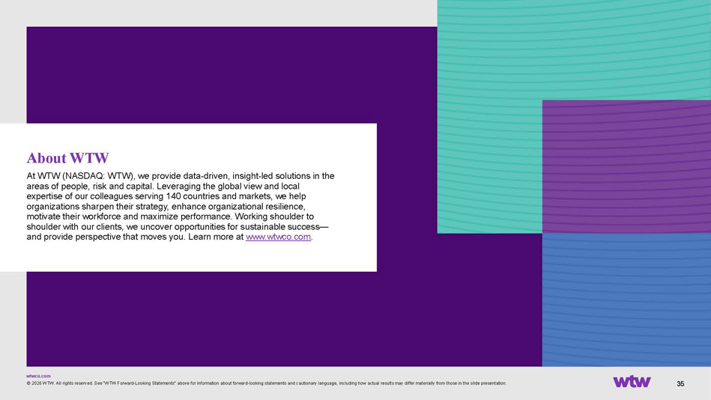
wtwco.com 35 About WTW At WTW (NASDAQ: WTW), we provide data - driven, insight - led solutions in the areas of people, risk and capital. Leveraging the global view and local expertise of our colleagues serving 140 countries and markets, we help organizations sharpen their strategy, enhance organizational resilience, motivate their workforce and maximize performance. Working shoulder to shoulder with our clients, we uncover opportunities for sustainable success — and provide perspective that moves you. Learn more at www.wtwco.com . © 2026 WTW. All rights reserved. See “WTW Forward - Looking Statements“ above for information about forward - looking statements and cautionary language, including how actual results may differ materially from those in the slide presentation.

