UNITED STATES

SECURITIES AND EXCHANGE COMMISSION
WASHINGTON, DC 20549

FORM 8-K

CURRENT REPORT

PURSUANT TO SECTION 13 OR 15(D) OF THE
SECURITIES EXCHANGE ACT OF 1934

Date of report (Date of earliest event reported): June 7, 2008

WILLIS GROUP HOLDINGS LIMITED

 | (Exact Name of Registrant as Specified in Its Charter)
 |  | Bermuda
 |  | (State or Other Jurisdiction of Incorporation)
001-16503 | 98-0352587
(Commission File Number) |  |  | (IRS Employer Identification No.)
 |  | c/o Willis Group Limited
 |  | Ten Trinity Square
 |  | London EC3P 3AX, England
 |  | (Address of Principal Executive Offices)
 | (44) (20) 7488-8111
 | (Registrant’s Telephone Number, Including Area Code)
 |  | Not Applicable
 | (Former Name or Former Address, if Changed Since Last Report)

Check the appropriate box below if the Form 8-K filing is intended to simultaneously satisfy the filing obligation of the registrant under any of the following provisions (see General Instruction A.2. below):

- Written communications pursuant to Rule 425 under the Securities Act (17 CFR 230.425)

- Soliciting material pursuant to Rule 14a-12 under the Exchange Act (17 CFR 240.14a-12)

- Pre-commencement communications pursuant to Rule 14d-2(b) under the Exchange Act (17 CFR 240.14d-2(b))

- Pre-commencement communications pursuant to Rule 13e-4(c) under the Exchange Act (17 CFR 240.13e-4(c))

Item 8.01 Other Events

On June 8, 2008, Willis Group Holdings Limited (“Willis”) and Hilb Rogal & Hobbs Company (“HRH”) announced that they had entered into an Agreement and Plan of Merger, dated as of June 7, 2008 (the “Merger Agreement”), that provides, among other things, for HRH to be merged with a wholly-owned subsidiary of Willis (the “Merger”). The Merger Agreement has been approved by the Boards of Directors of Willis and HRH and is subject to customary closing conditions, including regulatory and HRH stockholder approvals.

A copy of the press release is attached hereto as Exhibit 99.1. In addition, Willis and HRH provided supplemental information regarding the proposed Merger in connection with presentations to analysts and investors. A copy of the investor presentation is attached hereto as Exhibit 99.2.

On June 8, 2008, a video recording of a presentation by Joseph J. Plumeri, the Chairman and Chief Executive Officer of Willis, regarding the Merger was made available on Willis’ website. A transcript of the presentation is attached as Exhibit 99.3 and is incorporated by reference herein. While every effort has been made to provide an accurate transcription, there may be typographical mistakes, inaudible statements, errors, omissions or inaccuracies in the transcript. The Company believes that none of these inaccuracies is material. A replay of the recorded presentation is available until about June 30, 2008 and can be accessed via Willis’ website (http://www.willis.com).

Forward-Looking Statements

This communication may contain forward-looking information regarding Willis Group Holdings Limited and Hilb Rogal & Hobbs Company and the combined company after the completion of the transaction that are intended to be covered by the safe harbor for “forward-looking statements” provided by the Private Securities Litigation Reform Act of 1995. These statements include, but are not limited to, the potential benefits of the business combination transaction involving Willis and HRH, including future financial and operating results, the combined company’s plans, objectives, expectations and intentions and other statements that are not historical facts. Such statements are based on current beliefs, expectations, forecasts and assumptions of Willis’s and HRH’s management that are subject to risks and uncertainties which could cause actual outcomes and results to differ materially from these statements. Other risks and uncertainties relating to the proposed transaction include, but are not limited to, the satisfaction of conditions to closing, including receipt of shareholder, regulatory and other approvals on the proposed terms and schedule, the proposed transaction may not be consummated on the proposed terms and schedule, uncertainty of the expected financial performance of Willis following completion of the proposed transaction, Willis may not be able to achieve the expected cost savings, synergies and other strategic benefits as a result of the proposed transaction or may take longer to achieve the cost savings, synergies and benefits than expected, the integration of HRH with Willis’s operations may not be successful or may be materially delayed or may be more costly or difficult than expected, general industry and market conditions, general domestic and international economic conditions and governmental laws and regulations affecting domestic and foreign operations.

For more information regarding other related risks, see Item 1A of Willis’s Annual Report on Form 10-K for the fiscal year ended December 31, 2007, and Item 1A of HRH’s Annual Report on Form 10-K for the fiscal year ended December 31, 2007, and similar sections of each company’s quarterly report on Form 10-Q for the fiscal quarter ended March 31, 2008. Copies of said 10-Ks and 10-Qs are available online at http://www.sec.gov or on request from the applicable company. You should not place undue reliance on forward-looking statements, which speak only as of the date of this communication. Except for any

2

obligation to disclose material information under the Federal securities laws, Willis and HRH undertake no obligation to release publicly any revisions to any forward-looking statements to reflect events or circumstances after the date of this communication.

Important Merger Information

In connection with the proposed transaction, Willis and HRH intend to file relevant materials with the Securities and Exchange Commission (“SEC”). Willis will file with the SEC a

Registration Statement on Form S-4 that includes a proxy statement of HRH that also constitutes a prospectus of Willis. HRH will mail the proxy statement/prospectus to its shareholders.

Investors are urged to read the proxy statement/prospectus regarding the proposed transaction when it becomes available, because it will contain important information. Investors will be

able to obtain a free copy of the proxy statement/prospectus, as well as other filings containing information about Willis and HRH without charge, at the SEC’s website

(http://www.sec.gov) once such documents are filed with the SEC. You may also obtain these documents, free of charge, from Willis’s website (www.willis.com) under the tab “Investor

Relations” and then under the heading “Financial Reporting” then under the item “SEC Filings.” You may also obtain these documents, free of charge, from HRH’s website

(www.hrh.com) under the heading “Investor Relations” and then under the tab “SEC Filings.”

Willis, HRH and their respective directors, executive officers and other employees may be deemed to be participants in the solicitation of proxies from HRH shareholders in connection with the proposed transaction. Information about Willis’s directors and executive officers is available in Willis’s proxy statement, dated March 17, 2008. Information about HRH’s directors and executive officers is available in HRH’s proxy statement, dated March 31, 2008. Additional information about the interests of potential participants will be included in the prospectus/proxy statement when it becomes available. This document shall not constitute an offer to sell or the solicitation of an offer to buy any securities, nor shall there be any sale of securities in any jurisdiction in which such offer, solicitation or sale would be unlawful prior to registration or qualification under the securities laws of any such jurisdiction. No offering of securities shall be made except by means of a prospectus, meeting the requirements of Section 10 of the U.S. Securities Act of 1933, as amended.

Item 9.01 Financial Statements and Exhibits

- Exhibits

Number |  | Description
Exhibit | 99.1 |  | Press Release dated June 8, 2008 titled “Willis Group Holdings and Hilb Rogal & Hobbs Agree To Combine in $2.1 Billion Transaction Aimed at Accelerating
 |  | Growth and Increasing Client Value”
Exhibit 99.2 |  | Investor Presentation
Exhibit 99.3 |  | Transcript of Website Presentation, dated June 8, 2008
 |  | 3

SIGNATURES

Pursuant to the requirements of the Securities Exchange Act of 1934, the Registrant has duly caused this report to be signed on its behalf by the undersigned hereunto duly authorized.

Date: June 9, 2008

WILLIS GROUP HOLDINGS LIMITED

By: /s/ Adam G. Ciongoli

Name: Adam G. Ciongoli

Title: General Counsel

4

 |  | EXHIBIT INDEX
Number |  | Description
Exhibit | 99.1 | Press Release dated June 8, 2008 titled “Willis Group Holdings and Hilb Rogal & Hobbs Agree To Combine in $2.1 Billion Transaction Aimed at Accelerating
 |  | Growth and Increasing Client Value”
Exhibit 99.2 |  | Investor Presentation
Exhibit 99.3 |  | Transcript of Website Presentation, dated June 8, 2008
Exhibit 99.1

WILLIS GROUP HOLDINGS AND HILB ROGAL & HOBBS AGREE TO

COMBINE IN $2.1 BILLION TRANSACTION AIMED AT ACCELERATING

GROWTH AND INCREASING CLIENT VALUE

- Doubles Willis North America Revenues and Strengthens Leadership in Attractive Growth Markets

- More Than Doubles Willis’s High-Growth Employee Benefits Business in North America; Adds Depth and Breadth to Other Key Practice Areas

- Strengthens Willis’s Middle Market Leadership and Reinforces Large Account Presence

- Purchase Price is 2.4x Estimated 2008 Revenues, Less Than 10x Estimated 2008 EBITDA

- Immediately Accretive to Willis Cash EPS; Accretive to GAAP EPS from Year Two

New York, NY/Richmond, VA, June 8, 2008 – Willis Group Holdings Limited (NYSE: WSH), the global insurance broker, and Hilb Rogal & Hobbs Company (NYSE:HRH), one of the world’s largest insurance and risk management intermediaries, announced today that the companies will combine forces in a transaction that will double Willis’s North America revenues and strengthen its leadership in attractive growth markets.

Under the terms of the definitive agreement, Willis will acquire all of the outstanding shares of common stock of HRH for $46.00 per share, 50 percent cash and 50 percent stock, subject to the collar described below, in a transaction having an equity value of approximately $1.7 billion and an enterprise value of approximately $2.1 billion. The transaction is expected to close in the fourth quarter of 2008 and is subject to customary closing conditions, including regulatory and HRH shareholder approval.

The total purchase price of $2.1 billion represents a multiple of 2.4 times estimated 2008 HRH revenues and less than 10 times estimated 2008 EBITDA (defined as earnings before interest expense, income taxes, depreciation and amortization), including the assumption of an estimated $400 million of HRH debt. Annualized synergies are expected to amount to approximately $140 million by 2012. Over time, Willis plans to repurchase a majority of the shares issued in connection with the transaction under its previously approved $1 billion buyback plan.

Willis expects the acquisition to be accretive to cash earnings per share from the close and to GAAP earnings per share from year two.

Dramatically Increases Scale of North America Operations in Attractive Growth Areas

Combining these complementary businesses will substantially improve Willis’s position in important areas in North America including California, Florida, Texas, Illinois, New York, Boston, New Jersey and Philadelphia, and in key business lines. In particular, it will more than double Willis’s North America revenues in Employee Benefits, an already strong area of expertise that Willis has targeted for further growth. In addition, it will further strengthen key practice areas including personal lines, real estate, health care, environmental, construction, complex property and executive risk.

The transaction will greatly strengthen Willis’s leadership as a middle market broker and reinforce its large account presence. It also will further expand the range of Willis’s specialty expertise and complement Willis’s substantial presence in the London market. With a more robust and diversified platform, the combined company will deliver greatly enhanced value to clients.

“This dynamic transaction is all about growth. It’s truly transformational for our North America business. Only HRH has the scale and fit in attractive growth areas to take our business to the next level,” said Joe Plumeri, Chairman and CEO of Willis. “HRH’s complementary strengths and geographic footprint will help us accelerate the performance momentum we’ve achieved through our Shaping our Future strategy.

“HRH has some of the best brokers in the world and I’m proud to have the opportunity to partner with people of this caliber,” Mr. Plumeri continued. “We share the same passion for excellence and there’s no limit to what we can accomplish together. It’s really the best of both worlds for our clients. We bring global reach and expertise, while HRH brings added talent and local market presence. All this should translate into significant value for our shareholders.”

Martin L. Vaughan, III, Chairman and CEO of HRH, said the combination has the full support of the Board of Directors and the senior management team at HRH. “Our complementary footprint and Willis’s strength in important Global Specialties such as aerospace, energy, construction, marine, financial institutions and executive risk make our two companies an outstanding strategic fit,” Mr. Vaughan said. “We are already developing detailed plans to make sure that the integration process is smooth and seamless for our clients. We see exciting opportunities for our talented Associates to enhance their careers in a truly global enterprise.”

F. Michael Crowley, President and Chief Operating Officer of HRH, said, “Joining these two great companies is a major step forward in achieving our shared vision of being the best insurance brokerage company in the world. Our companies share the same culture and values, in particular an absolute commitment to serving clients while at the same time providing an inspiring and rewarding environment for our Associates.”

2

Boosts North America Operations to Nearly Half of Willis Worldwide Revenues

The two companies have complementary strengths. In 2007, Willis Group delivered strong financial performance and demonstrated that its Shaping our Future strategy – specific initiatives designed to drive profitable growth – is working. The company continues to have peer-leading operating margins and organic revenue growth. HRH is a leading middle market U.S.-based insurance broker with a large account portfolio. HRH generated $800 million of revenues in 2007, with $57 million from its international operations, which are based in London.

The HRH footprint in the United States will result in a significant expansion of Willis’s already extensive retail platform. The combination will boost the contribution of North America to Willis’s overall revenues from 30 percent in 2007 to an estimated 45 percent on a pro forma basis, enhancing the mix among its North America, International and Global segments. It also will positively rebalance Willis’s business lines mix, with the Reinsurance businesses, which in 2007 accounted for 15 percent of Willis’s revenues, going to 12 percent of the revenues of the combined company. Meanwhile, the Employee Benefits business will increase from 10 percent of Willis’s current revenues to 13 percent of the revenues of the combined company.

Willis estimates that the transaction will be 7 percent accretive to cash earnings per share in 2009, 10 percent in 2010 and 14 percent in 2011. It is expected to be 3 percent dilutive to GAAP earnings per share in 2009, 2 percent accretive in 2010 and 6 percent in 2011. It is the company’s intention to buy back over time the majority of the shares issued as part of the transaction.

Overall annualized cost savings and efficiencies are expected to amount to approximately $100 million pre-tax ($70 million after tax) – 50 percent realized in 2009 and 100 percent realized in 2010. Implementation of Shaping our Future initiatives is expected to drive further efficiencies of $40 million pre-tax annualized by 2012. Willis expects to incur approximately $75 million in one-time costs related to the transaction.

Consistent with the agreement that Willis reached last week with the New York State Attorney General and New York State Department of Insurance – and in keeping with Willis’s commitment not to accept contingent compensation – Willis will phase out HRH’s contingent commissions over three years.

Terms of the Agreement

Under the terms of the definitive agreement, HRH shareholders can elect to receive the merger consideration in the form of cash or shares of common stock of Willis, subject to proration in order to ensure that the cash and stock elections each represent 50 percent of the total consideration paid. In addition, the cash consideration is subject to increase to an amount above 50 percent of the total consideration (i) if the stock election represents

3

less than 50 percent of the total consideration or (ii) to ensure that the number of shares issued by Willis does not exceed 19.9 percent of the total number of shares outstanding at the effective time of the transaction.

The definitive agreement includes a collar. Half of the value of the per-share merger consideration, or $23.00 (representing the cash component), is always fixed – whether a shareholder elects to receive cash or stock. The remaining value of the merger consideration (representing the stock component) is calculated based on the average trading price of Willis common stock during the ten-day period ending two days prior to the closing date. If the average Willis stock price during this period is greater than or equal to $31.46 or less than or equal to $40.04, the stock component is fixed and is equal to $23.00. Outside this collar, the exchange ratio is fixed (based on the exchange ratio that would result at the top and bottom of the collar) and, therefore, the value of the stock component may be worth more or less than $23.00, based on the value of Willis common stock, again, whether or not a shareholder elects to receive cash or stock. Depending on the Willis stock price, the merger consideration will either be an amount greater or less than $46.00 per share. However, the value of the merger consideration (based on the ten-day pre-closing Willis trading price) will be the same regardless of whether HRH shareholders elect to receive stock or cash.

Banc of America Securities LLC is acting as financial advisor and Weil Gotshal & Manges LLP is acting as legal advisor to Willis in connection with the transaction. In addition, Banc of America Securities LLC, as Lead Arranger and Book Manager, and Bank of America N.A., as Administrative Agent, have provided committed financing for the transaction. HRH has been advised by Sandler O’Neill & Partners, L.P., and Wachtell, Lipton, Rosen & Katz.

Combined Company to be Named Willis HRH in North America

The new organization in North America will be renamed Willis HRH upon completion of the transaction. It will be led by an Office of the Chairman including Don Bailey as Chairman and CEO, F. Michael Crowley as President and Martin L. Vaughan, III, as Vice Chairman of Willis Group Holdings.

Detailed plans are being developed to combine the two companies. The integration will be led by Mr. Bailey, effective immediately, to ensure a smooth and seamless process.

Teleconference Call:

On Monday, June 9, 2008, at 10:00 A.M. Eastern Time, Joe Plumeri, Chairman and Chief Executive Officer of Willis Group Holdings Limited, and Martin L. Vaughan, III, Chairman and Chief Executive Officer of Hilb Rogal & Hobbs Company, will hold a joint conference call to discuss today’s announcement with analysts. Interested parties may access the conference call by calling (888) 790-3153 (domestic) or +1 (517) 308-9033 (international) with a passcode of “Willis.” Media and individuals will be in a listen-only mode. Participants are asked to call in a few minutes prior to the call in order to register for the event.

4

Interested parties may also access the conference call in a listen-only mode via the Internet. To do so they should go to the “Investor Relations” section of the Willis and HRH websites at www.willis.com and www.hrh.com, respectively, and register for the call. A replay of the call will be available through July 09, 2008 at 11:59 PM Eastern Time, by calling (888) 568-0743 (domestic) or + 1 (402) 998-0215 (international) with no passcode, or by accessing the websites.

About Willis Group Holdings Limited

Willis Group Holdings Limited is a leading global insurance broker, developing and delivering professional insurance, reinsurance, risk management, financial and human resource consulting and actuarial services to corporations, public entities and institutions around the world. Willis has more than 300 offices in some 100 countries, with a global team of approximately 16,000 Associates serving clients in some 190 countries. Additional information on Willis may be found at www.willis.com.

About Hilb Rogal & Hobbs Company

Hilb Rogal & Hobbs Company (HRH) is the eighth largest insurance and risk management intermediary in the United States, with over 140 offices throughout the United States and the world. HRH helps clients manage their risks in property and casualty, employee benefits, professional liability and other areas of specialized exposure. In addition, HRH offers a full range of personal and corporate financial products and services. HRH is focused on understanding our clients’ businesses, employees and risks, as well as the insurance and financial markets, so that we can develop insurance, risk management and employee benefits solutions that best fit their needs. The company’s common stock is traded on the New York Stock Exchange, symbol HRH. More information about HRH may be found at www.hrh.com

CONTACTS

 | Media |  |  |  |  |  | Investors
Willis: | Valerie Di Maria |  |  |  |  | Kerry K. Calaiaro
 | (212) 915-8272 |  |  |  | (212) 915-8084
 | valerie.dimaria@willis.com |  |  |  |  |  | kerry.calaiaro@willis.com
 | Ingrid Bosch
 | +44 (0) 20 3124 7182
 | boschi@willis.com
HRH: | Liz Cougot |  |  |  |  | Carolyn Jones
 | (804) 747-3120 |  |  |  | (804) 747-3108
 | liz.cougot@hrh.com |  |  |  |  | carolyn.jones@hrh.com
 |  |  |  |  | 5

Forward Looking Statements

This communication may contain forward-looking information regarding Willis Group Holdings Limited and Hilb Rogal & Hobbs Company and the combined company after the completion of the transaction that are intended to be covered by the safe harbor for “forward-looking statements” provided by the Private Securities Litigation Reform Act of 1995. These statements include, but are not limited to, the potential benefits of the business combination transaction involving Willis and HRH, including future financial and operating results, the combined company’s plans, objectives, expectations and intentions and other statements that are not historical facts. Such statements are based on current beliefs, expectations, forecasts and assumptions of Willis’s and HRH’s management that are subject to risks and uncertainties which could cause actual outcomes and results to differ materially from these statements. Other risks and uncertainties relating to the proposed transaction include, but are not limited to, the satisfaction of conditions to closing, including receipt of shareholder, regulatory and other approvals on the proposed terms and schedule, the proposed transaction may not be consummated on the proposed terms and schedule, uncertainty of the expected financial performance of Willis following completion of the proposed transaction, Willis may not be able to achieve the expected cost savings, synergies and other strategic benefits as a result of the proposed transaction or may take longer to achieve the cost savings, synergies and benefits than expected, the integration of HRH with Willis’s operations may not be successful or may be materially delayed or may be more costly or difficult than expected, general industry and market conditions, general domestic and international economic conditions and governmental laws and regulations affecting domestic and foreign operations.

For more information regarding other related risks, see Item 1A of Willis’s Annual Report on Form 10-K for the fiscal year ended December 31, 2007, and Item 1A of HRH’s Annual Report on Form 10-K for the fiscal year ended December 31, 2007, and similar sections of each company’s quarterly report on Form 10-Q for the fiscal quarter ended March 31, 2008. Copies of said 10-Ks and 10-Qs are available online at http://www.sec.gov or on request from the applicable company. You should not place undue reliance on forward-looking statements, which speak only as of the date of this communication. Except for any obligation to disclose material information under the Federal securities laws, Willis and HRH undertake no obligation to release publicly any revisions to any forward-looking statements to reflect events or circumstances after the date of this communication.

Important Merger Information

In connection with the proposed transaction, Willis and HRH intend to file relevant materials with the Securities and Exchange Commission (“SEC”). Willis will file with the SEC a Registration Statement on Form S-4 that includes a proxy statement of HRH that also constitutes a prospectus of Willis. HRH will mail the proxy

6

statement/prospectus to its shareholders. Investors are urged to read the proxy statement/prospectus regarding the proposed transaction when it becomes available, because it will contain important information. Investors will be able to obtain a free copy of the proxy statement/prospectus, as well as other filings containing information about Willis and HRH without charge, at the SEC’s website (http://www.sec.gov) once such documents are filed with the SEC. You may also obtain these documents, free of charge, from Willis’s website (www.willis.com) under the tab “Investor Relations” and then under the heading “Financial Reporting” then under the item “SEC Filings.” You may also obtain these documents, free of charge, from HRH’s website (www.hrh.com) under the heading “Investor Relations” and then under the tab “SEC Filings.”

Willis, HRH and their respective directors, executive officers and other employees may be deemed to be participants in the solicitation of proxies from HRH shareholders in connection with the proposed transaction. Information about Willis’s directors and executive officers is available in Willis’s proxy statement, dated March 17, 2008. Information about HRH’s directors and executive officers is available in HRH’s proxy statement, dated March 31, 2008. Additional information about the interests of potential participants will be included in the prospectus/proxy statement when it becomes available. This document shall not constitute an offer to sell or the solicitation of an offer to buy any securities, nor shall there be any sale of securities in any jurisdiction in which such offer, solicitation or sale would be unlawful prior to registration or qualification under the securities laws of any such jurisdiction. No offering of securities shall be made except by means of a prospectus, meeting the requirements of Section 10 of the U.S. Securities Act of 1933, as amended.

# # #

7


Exhibit 99.2

Willis Group Holdings acquires
Hilb Rogal & Hobbs

June 9, 2008

Forward-looking statements

This presentation contains certain “forward-looking statements” within the meaning of Section 27A of the Securities Act of 1933, and Section 21E of the Securities Exchange Act of 1934, which are intended to be covered by the safe harbors created by those laws. These forward-looking statements include information about possible or assumed future results of our operations. All statements, other than statements of historical facts, included in this presentation that address activities, events or developments that we expect or anticipate may occur in the future, including such things as our outlook and guidance regarding future operating margin and adjusted Earnings Per Share, future capital expenditures, expected growth in commissions and fees, business strategies, competitive strengths, goals, the anticipated benefits of new initiatives, growth of our business and operations, plans, and references to future successes are forward-looking statements. Also, when we use the words such as “anticipate”, “believe”, “estimate”, “expect”, “intend”, “plan”, “probably”, or similar expressions, we are making forward-looking statements.

Many risks and uncertainties may impact the matters addressed in these forward-looking statements. Many possible events or factors could affect our future financial results and performance, including those set forth in the Appendix and in the Risk Factors section of our Annual Report on Form 10-K filed on February 27, 2008. These could cause our results or performance to differ materially from those we express in our forward-looking statements. Although we believe that the assumptions underlying our forward-looking statements are reasonable, any of these assumptions, and therefore also the forward-looking statements based on these assumptions, could themselves prove to be inaccurate. In light of the significant uncertainties inherent in the forward-looking statements included in this presentation, our inclusion of this information is not a representation or guarantee by us that our objectives and plans will be achieved.

Our forward-looking statements speak only as of the date made and we will not update these forward-looking statements unless the securities laws require us to do so. In light of these risks, uncertainties and assumptions, the forward-looking events discussed in this presentation may not occur, and we caution you against unduly relying on these forward-looking statements.

1

Willis Group Holdings acquires Hilb Rogal & Hobbs

Transaction overview


Willis and HRH overviews

Pro forma combined company

Financial summary

Summary

Appendix

2



Transaction overview

Transaction rationale
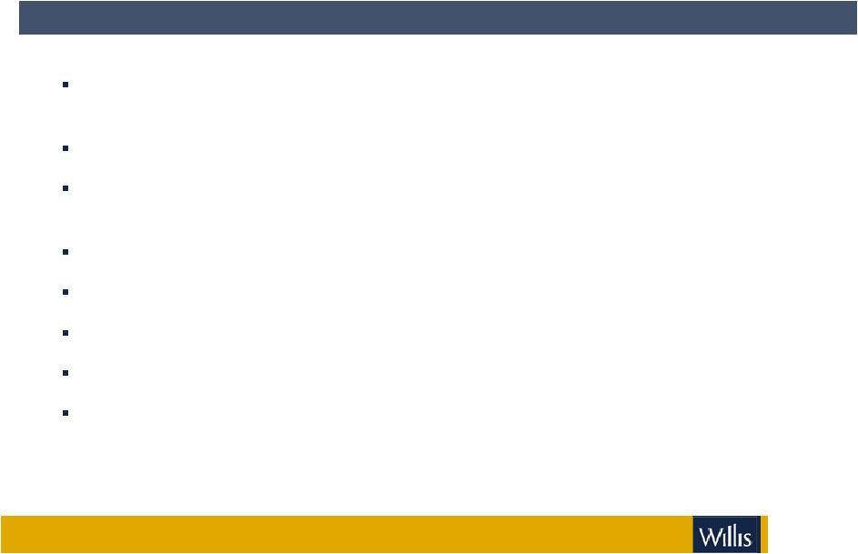

The acquisition of Hilb Rogal & Hobbs is strategically and financially compelling

Accelerates growth and increases client value through larger, more diversified platform

Complementary geographic footprint doubles Willis’ North American revenues

More than doubles Willis’ revenues in targeted, high potential North America Employee Benefits business

Adds depth and breadth to other key practice areas

Strengthens Willis’ middle market leadership and reinforces large account presence

Immediately accretive to Willis Cash EPS; accretive to GAAP EPS from year 2

Attractive valuation; 2.4x 2008E revenue, less than 10x 2008E EBITDA

Anticipated synergies of $100 million, with additional $40 million annualized efficiencies post-integration from the implementation of Shaping our Future

4

Terms of transaction
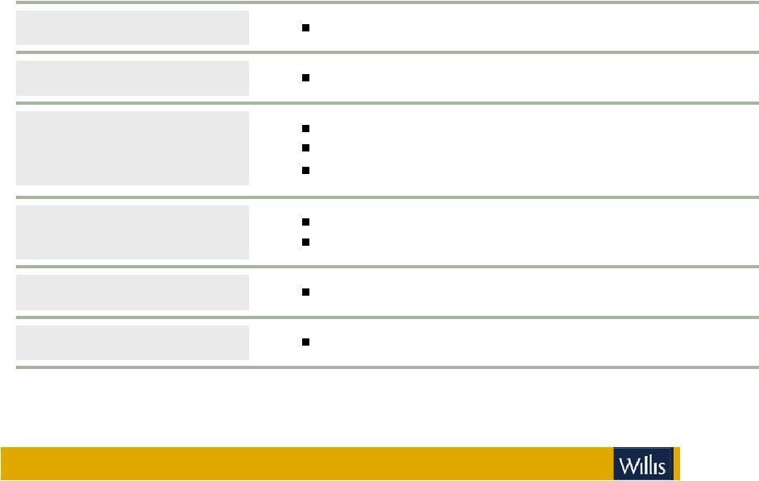

TRANSACTION

PRICE PER SHARE

CONSIDERATION

AGGREGATE CONSIDERATION

EXPECTED CLOSING

APPROVALS

Willis to acquire 100% of Hilb Rogal & Hobbs (HRH)

$46.00

50% cash, 50% stock

Tax free transaction to Hilb Rogal & Hobbs shareholders Transaction includes a collar(1)

$1.7 billion equity value

$2.1 billion enterprise value(2)

4Q 2008

Customary regulatory approvals and HRH shareholder vote

(1) The transaction includes a 12% collar, that is, if Willis’ share price increases or decreases up to 12%, the aggregate consideration remains $46.00

per share; if, however, the Willis share price increases or decreases more than 12%, 50% of the consideration would adjust based on the value of Willis’ stock (resulting in a transaction value per share less than or greater than $46.00)

5

(2) See appendix for definitions of non-GAAP measures



Willis and HRH overview

Overview of Willis

COMPANY DESCRIPTION
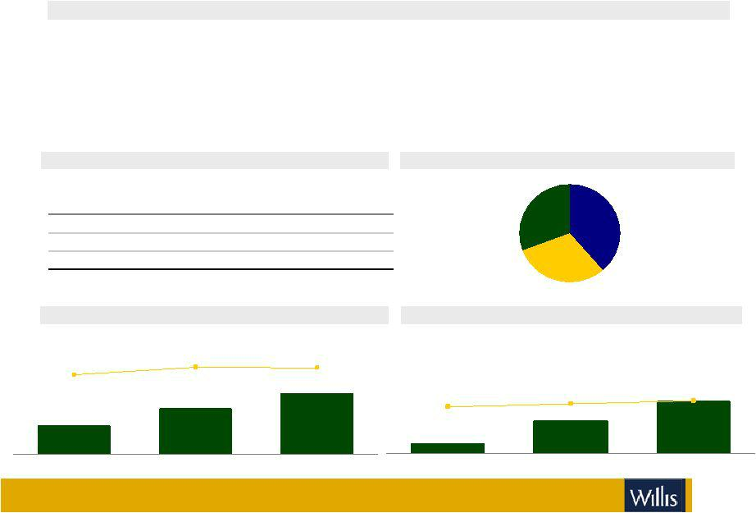

- 3rd largest provider of insurance brokerage, reinsurance and risk management consulting services worldwide

- Operates three business segments

International (39%) – international retail brokerage
Global (31%) – worldwide specialist brokerage, consulting services and reinsurance
North America (30%) - Retail operations in the US & Canada

- 13,000 employees in approximately 300 offices in 100 countries

SENIOR MANAGEMENT

Name | Age | Title
Joseph J. Plumeri | 64 | Chairman & CEO
Grahame Millwater | 44 | President
Patrick C. Regan | 41 | Group COO & Group CFO

REVENUE AND REVENUE GROWTH

($ in millions)

0% | 7% | 6%
 |  | $2,578
 | $2,428
$2,267
2005 | 2006 | 2007

(1) See appendix for definitions of non-GAAP measures

2007 REVENUE BREAKDOWN

North America
^{30%} International

39%

Global

31%

ADJUSTED EBITDA AND EBITDA MARGIN (1)

($ in millions)

 |  | 27%
24% | 25% | $684
 | $614
$535
2005 | 2006 | 2007

7

Overview of Willis
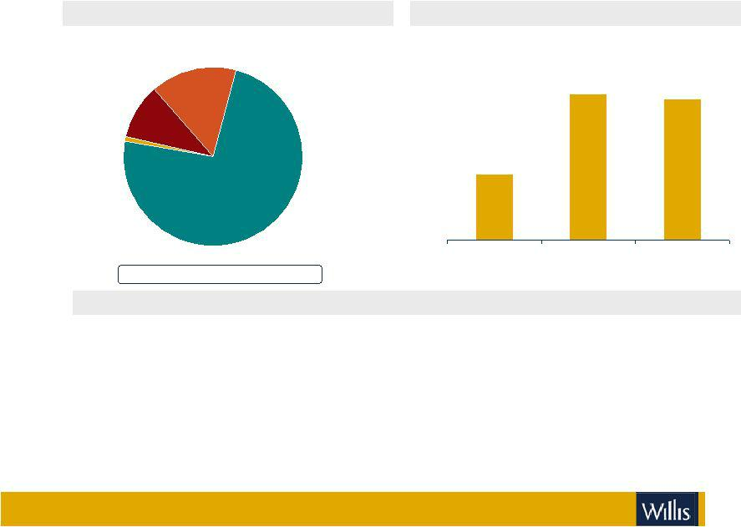

2007 REVENUE BY PRODUCT |  | CASH FLOW FROM OPERATIONS (1)
 | ($ in millions)
Reinsurance
15% |  |  | 392
Employee | 400 |  | 392 | 388
Benefits | 400 |  | 392 | 388
10% | 380
Personal Lines | 360
1% | 360
 | 340 | 330
 | 320
Commercial | 300
P&C | 300
74% | 280
 |  | 2005 | 2006 | 2007

2007 Total Revenues: $2,578 million

SERVICES AND CLIENTS

- Employee benefits

- Reinsurance

- Property & casualty

• Energy | • Marine
• Construction | • Financial and
• Aerospace | Executive Risk
• Real estate

- Client base ranges from personal to multi national accounts

- Primarily comprised of middle market accounts

8

(1) See appendix for definitions of non-GAAP measures

Overview of HRH

COMPANY DESCRIPTION
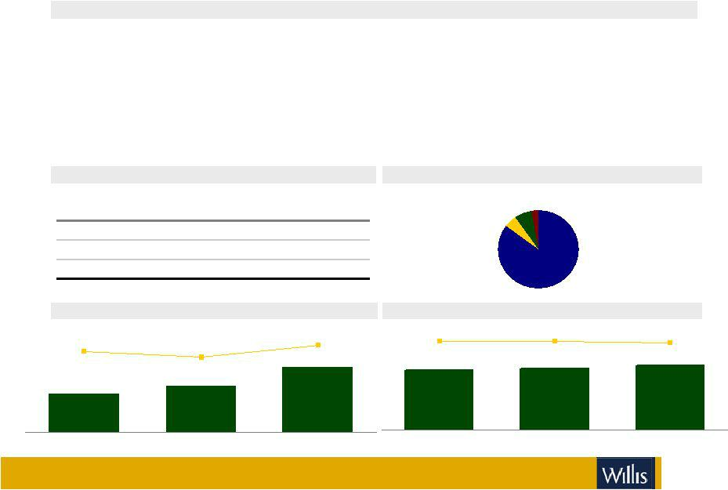

- Based in Glen Allen, Virginia

- Offers P&C, employee benefits and specialized exposure insurance

- U.S. middle market focused broker with national footprint
Domestic Retail (85%) – seven U.S. regional operating units providing marketing and specialized industry or product expertise
Excess and Surplus (5%) – operating units specializing in excess and surplus lines brokerage (California, Florida, Illinois and Texas)
International (7%) – primarily U.K based wholesale and reinsurance brokerage

- 4,200 employees in over 140 offices throughout the U.S.; 200 employees outside the U.S

SENIOR MANAGEMENT

Name | Age | Title
Martin (Mell) Vaughan | 60 | Chairman & CEO
Michael Crowley | 55 | President & COO
Michael Dinkins | 52 | EVP & CFO

REVENUE AND REVENUE GROWTH
($ in millions) |  | 12%
9% | 5% | 12%
 |  | $800
$674 | $711
2005 | 2006 | 2007

2007 REVENUE BREAKDOWN

International Other
7% ^{3%}
Excess &

Surplus
5%
Domestic

Retail

85%

EBITDA AND EBITDA MARGIN

($ in millions)

27% | 27% | 24%
$174 | $181 | $190

2005 2006 2007

9

Overview of HRH
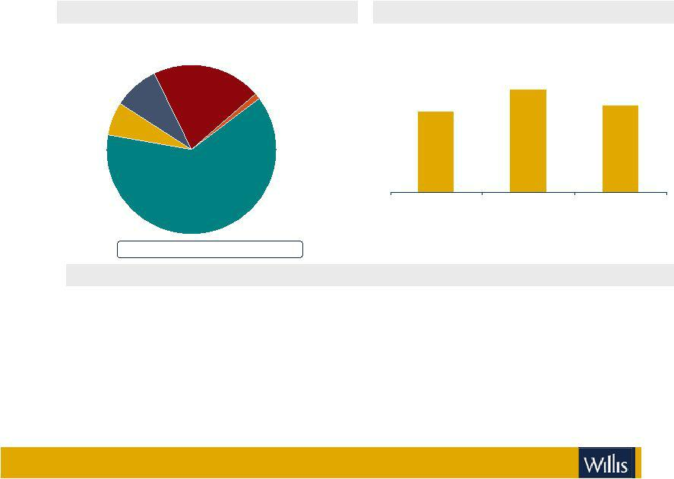

2007 REVENUE BY PRODUCT |  |  | CASH FLOW FROM OPERATIONS (1)
 |  | ($ in millions)
Wholesale | Employee
Wholesale | Benefits
9% | Benefits
9% | 21% |  |  | 121
 | Reinsurance |  | 95 | 102
Personal Lines | 1% | 100 | 95
6%

Commercial | 0
Commercial | 2005 | 2006 | 2007
P&C | 2005 | 2006 | 2007
63%

2007 Total Revenues: $800 million

SERVICES AND CLIENTS

- Personal lines

- Employee benefits

- Property & casualty

  - Construction

  - Healthcare

  - Real estate

- Client base ranges from personal to large national accounts

- Primarily comprised of middle market and major commercial and industrial accounts

10

(1) See appendix for definitions of non-GAAP measures



Pro forma combined company

Strategic objectives

ENHANCE

GROW

ADD VALUE

Critical mass in key areas

Opportunity for accelerated growth

California, Florida, Texas, Illinois, New York, Boston, New Jersey, Philadelphia

Leverage unique specialty expertise throughout our retail network

Personal lines, energy, aerospace, real estate, health care, construction, complex property, executive risk, environmental

Implement Shaping our Future strategy for profitable growth

Demonstrated execution with measurable success

Post integration launch Shaping our Future HRH

12

Broker rankings

 | U.S. Broker Rankings |  |  | Global Broker Rankings
 | 2006 Brokerage |  |  | 2007 Brokerage
Rank | Company | Revenues | Rank | Company | Revenues
1 | Marsh & McLennan | $5,342 | 1 | Marsh & McLennan | $11,350
2 | Aon | 2,751 | 2 | Aon | 7,471
 | Pro forma Willis / Hilb Rogal & Hobbs | 1,783 |  | Pro forma Willis / Hilb Rogal & Hobbs | 3,378
3 | A.J. Gallagher | 1,251 | 3 | Willis Group Holdings Ltd. | 2,578
4 | Willis Group Holdings Ltd. | 1,100 | 4 | A.J. Gallagher | 1,623
5 | Wells Fargo Insurance ServvicesInc. | 1,009 | 5 | Wells Fargo | 1,530
6 | Brown & Brown Inc. | 865 | 6 | Brown & Brown | 960
7 | BB&T Insurance Services Inc. | 842 | 7 | JardineLloyd Thompson | 940
8 | Hilb Rogal & Hobbs Co. | 683 | 8 | BB&T Insurance Services Inc. | 853
9 | USI Holdings Crop. | 546 | 9 | Hilb Rogal & Hobbs Co. | 800
10 | Lockton Cos. L.L.C. | 453 | 10 | Lockton Cos. L.L.C. | 667


Source: Business Insurance Annual Insurance Broker Survey, July 2007, | Source: Company reports
Revenues generated by U.S. clients

13

Complementary geographic fit
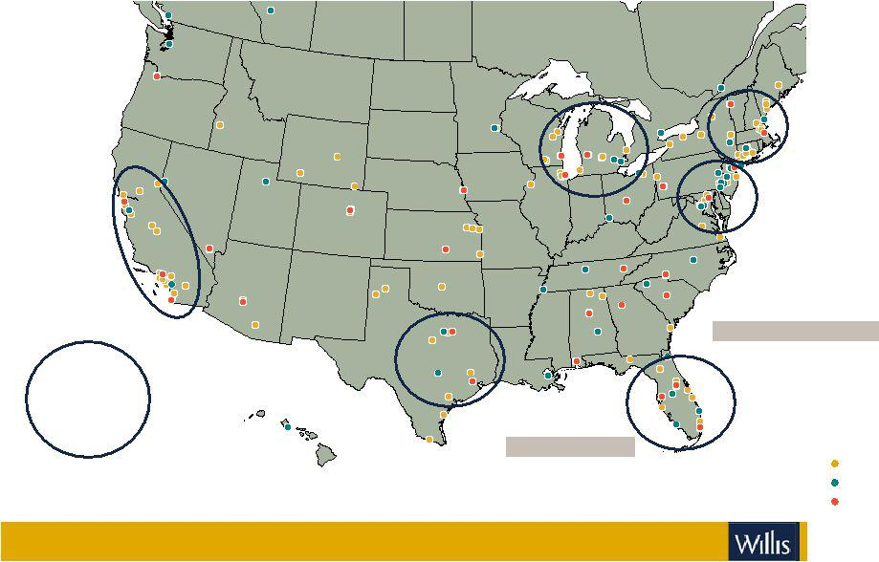

International Presence

Key

Growth
Areas

London, England

# of Offices

Willis | 70 | HRH
Willis | 70 | WSH
HRH | 140 | WSH
HRH | 140 | Overlap
 |  | 14

Pro forma combined total revenues by business mix
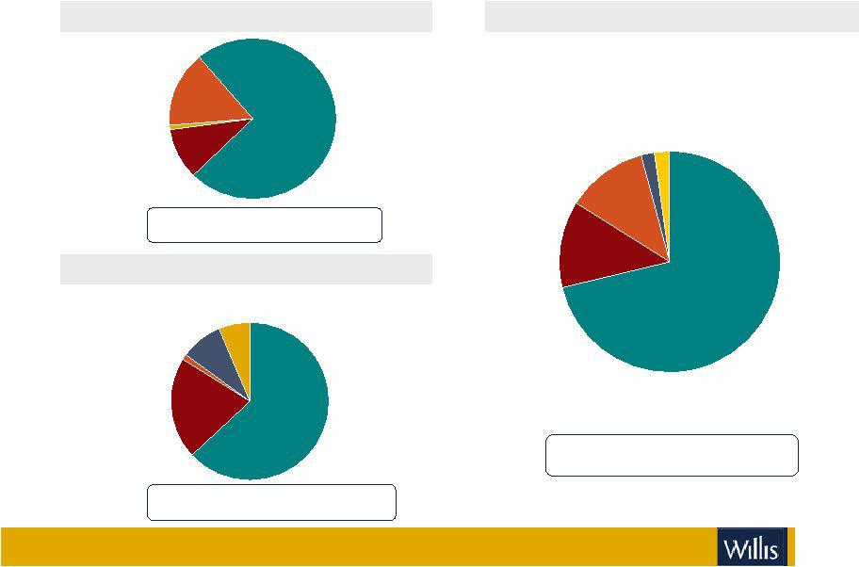

WILLIS

WillisRe

15%

Personal | Commercial
Personal | P&C
lines | P&C
lines | 74%
1% | 74%
Employee
Benefits
10%

2007 Total Revenues: $2,578 million

65% Commissions / 35% Fees

HRH

Personal

Lines
Wholesale ^{6%}

9%

Reinsurance

1%

Employee

Benefits
21%
Commercial

P&C

63%

2007 Total Revenues: $800 million

85% Commissions / 15% Fees

PRO FORMA

Personal

Wholesale Lines

2% 2%

Reinsurance

12%

Employee

Benefits

13%

2007 Total Revenues: $3,378 million

70% Commissions / 30% Fees

Commercial

P&C

71%

15



Financial summary

Financial structure
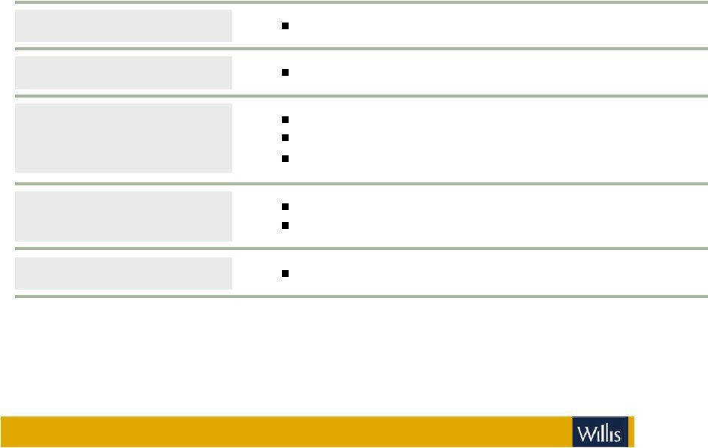

TRANSACTION

PRICE PER SHARE

CONSIDERATION

AGGREGATE CONSIDERATION

APPROVALS

Willis to acquire 100% of Hilb Rogal & Hobbs (HRH)

$46.00

50% cash, 50% stock

Tax free transaction to Hilb Rogal & Hobbs shareholders Transaction includes a collar ⁽¹⁾

$1.7 billion equity value

$2.1 billion enterprise value (2)

Customary regulatory approvals and HRH shareholder vote

(1) The transaction includes a 12% collar, that is, if Willis’ share price increases or decreases up to 12%, the aggregate consideration remains $46.00

per share; if, however, the Willis share price increases or decreases more than 12%, 50% of the consideration would adjust based on the value of Willis’ stock (resulting in a transaction value per share less than or greater than $46.00)

17

(2) See appendix for definitions of non-GAAP measures

Transaction financial summary


VALUATION

SYNERGIES

RESTRUCTURING PROGRAM

FINANCING

REPURCHASE ASSUMPTIONS

2.4x 2008E revenue

Less than 10x Hilb Rogal & Hobbs estimated 2008E EBITDA

Accretion (dilution) relative to Willis' previously stated guidance, which assumed buyback accretion of up to $0.30 per share by 2010

Cash EPS accretive by 7% 2009, 10% 2010, 14% 2011

GAAP EPS dilutive by (3)% 2009; accretive by 2% 2010, 6% 2011

Assumed $100 million in annual cost savings

50% in 2009, 100% thereafter

8% of pro forma combined North America 2007 cost base; 3% of combined pro forma 2007 total cost base

Assumed efficiencies from implementation of Shaping our Future at HRH starting in 2010 with $40 million annualized by 2012

$75 million pre-tax

Fully funded

Combination of new $1.0 billion senior credit facilities and $1.25 billion bridge financing Investment grade status retained

$1 billion existing authorized buyback

Anticipate repurchase of the majority of shares issued in the transaction over time

18

Pro forma combined financial goals

Adjusted operating margin
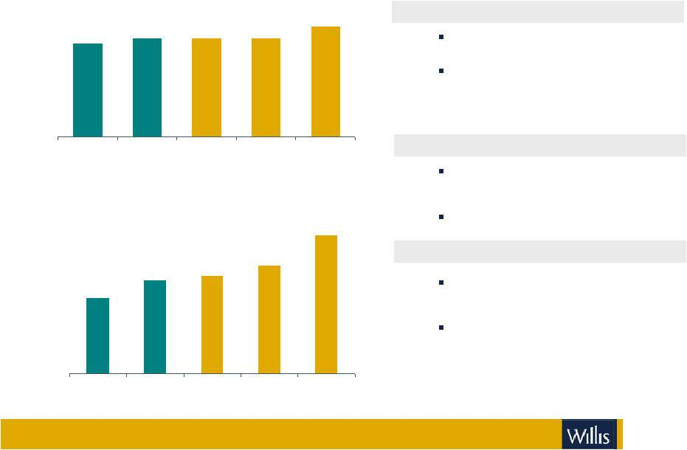

27%
_{23%} 24% 24% 24%

2006 2007 2008E 2009E 2010E

Adjusted EPS

$4.05-

$4.15

$3.15-
$2.85- _{$3.25}
_{$2.77} $2.95

$2.25

2006 2007 2008E 2009E 2010E

Note: See appendix for definitions of non-GAAP measures

OPERATING MARGIN

Revised targets to 24% in 2009 and 27% in 2010

Excluding transaction amortization margins estimated at 25% and 29%, respectively, in 2009 and 2010

EARNINGS PER SHARE

Revised target for 2009 at $3.15-$3.25 to reflect first year post acquisition

Raised to $4.05-$4.15 for 2010

CAPITAL MANAGEMENT

Existing $1 billion buyback authorization with $925 million remaining

Anticipate repurchase of majority of shares issued in the transaction over time

19

North America leadership team

Office of the Chairman:

Don Bailey, Chairman and CEO

Mike Crowley, President

Mell Vaughan, Vice Chairman, Willis Group Holdings

Other key leadership:

Vic Krauze, COO

Derek Smyth, CFO

Joe Gunn, Chief Growth Officer

20

Summary

Will accelerate growth and increase client value through larger, more diversified platform


Complementary geographic footprint doubles Willis’ North American revenues

More than doubles Willis’ revenues in targeted North America Employee Benefits business

Adds depth and breadth to other key practice areas

Strengthens Willis’ middle market leadership and reinforces large account presence

Immediately accretive to Willis Cash EPS; accretive to GAAP EPS from year 2 Attractive valuation; 2.4x 2008E revenue, less than 10x 2008E EBITDA

Anticipated synergies of $100 million, with additional $40 million annualized efficiencies post-integration from the implementation of Shaping our Future

21



Appendix

22

Important merger information

In connection with the proposed transaction, Willis and Hilb Rogal & Hobbs intend to file relevant materials with the Securities and Exchange Commission (“SEC”). Willis will file with the SEC a Registration Statement on Form S-4 that includes a proxy statement of Hilb Rogal & Hobbs that also constitutes a prospectus of Willis. Hilb Rogal & Hobbs will mail the proxy statement/prospect us to its shareholders.Investors are urged to read the proxy statement/prospectus regarding the proposed transaction when it becomes available, because it will contain important information. Investors will be able to obtain a free copy of the proxy statement/prospectus, as well as other filings containinginformation about Willis and Hilb Rogal & Hobbs without charge, at the SEC’s website (http://www.sec.gov) once such documents are filed

with the SEC. You may also obtain these documents, free of charge, from Willis’s website (www.willis.com) under the tab “Investor Relations” and then under the heading “Financial Reporting” then under the item “SEC Filings.” You may also obtain these documents, free of charge, from Hilb Rogal & Hobbs’ website (www.hrh.com) under the heading“Investor Relations” and then under the tab “SEC Filings.”

Willis, Hilb Rogal & Hobbs and their respective directors, executive officers and other employees may be deemed to be participants in the solicitation of proxies from Hilb, Rogal & Hobbs shareholders in connection with the proposed transaction. Information about Willis’s directors and executive officers is available in Willis’s proxy statement, dated March 17, 2008. Information about Hilb Rogal & Hobbs’directors and executive officers is available in Hilb Rogal & Hobbs’proxy statement, dated March 31, 2008. Additional information about the interests of potential participants will be included in the prospectus/proxy statement when it becomes available. This document shall not constitute an offer to sell or the solicitation of an offer to buy any securities, nor shall there be any sale of securities in any jurisdiction in which such offer, solicitation or sale would be unlawful prior to registration or qualification under the securities laws of any such jurisdiction. No offering of securities shall be made except by means of a prospectus meeting the requirements of Section 10 of the U.S. Securities Act of 1933, as amended.

23

Appendix: Additional cautionary disclosures regarding forward-looking Information

There are important uncertainties, events and factors that could cause our actual results or performance to differ materially from those in the forward-looking statements contained in this document, including regional, national or global political, economic, business, competitive, market and regulatory conditions and the following:

- completion of the merger is dependent on, among other things, receipt of shareholders and regulatory approvals, the timing of which cannot be predicted with precision and which may not be received at all,

- our ability to implement and realize anticipated benefits of the Shaping our Future initiative and other new initiatives,

- the extent and timing of, and prices paid in connection with, any share repurchases under existing or future programs,

- increases in client retentions,

- our ability to retain existing clients and attract new business, and our ability to retain key employees,

- changes in commercial property and casualty markets, or changes in premiums and availability of insurance products due to a catastrophic event such as a hurricane,

- volatility or declines in other insurance markets and the premiums on which our commissions are based,

- impact of competition,

- the timing or ability to carry out share repurchases or take other steps to manage our capital,

- fluctuations in exchange and interest rates that could affect expenses and revenue,

- rating agency actions that could inhibit ability to borrow funds or the pricing thereof,

- legislative and regulatory changes affecting both our ability to operate and client demand,

- potential costs and difficulties in complying with a wide variety of foreign laws and regulations, given the global scope of our operations,
- changes in the tax or accounting treatment of our operations,

- our exposure to potential liabilities arising from errors and omissions claims against us,

- the results of regulatory investigations, legal proceedings and other contingencies, and

- the timing of any exercise of put and call arrangements with Associated companies.

The foregoing list of factors is not exhaustive and new factors may emerge from time to time that could also affect actual performance and results. See also the Risk Factors section of our Annual Report on Form 10-K filed on February 27, 2008.

24

Appendix: Definitions of non-GAAP measures

Adjusted earnings before interest, tax, depreciation and amortization(adjusted EBITDA) is adjusted operating income as defined below, before depreciation and amortization.

Adjusted earnings per share (AdjustedEPS) is definedas adjusted net income per dilutedshare.

Adjusted net income is definedas net income excludingnet gains/losses on disposal of operations. For 2006, excludes gain on disposal of London headquarters net of leaseback costs of $92 million, $25 million of severance costs, $41 million strategic initiative expenditure and a one off $71 tax credit. For 2005, excludes charges for regulatory settlements and related expenses of $36 million, other provisions of $14 million and severance costs of $19 million.

Adjusted operating income is definedas operatingincome excludinggains/losses on disposals. For 2006, excludes gain on disposal of London headquarters net of leaseback costs of $99million, $35 million of severance costs and $59 million strategic initiative expenditure. For 2005 excludes charges for regulatory settlements and related legal and administrative expenses of $60 million, $20 million additional charge to increase legal provisions and $28 million of severance costs.

Adjusted operating margin is definedas adjusted operating income to total revenues.

Cash flow is defined as cash flow from operating and investing activities excluding acquisitions and disposals and additional pension contributions.

Funds from operations is adjusted net income as defined, before depreciation and amortization.

Enterprise value = current market capitalization + debt as of most recent quarter - non-fiduciary cash as of most recent quarter

25



WILLIS GROUP HOLDINGS

Exhibit 99.3

Joe Plumeri Message About HRH – for willis.com

June 8, 2008

Hello, everybody! I’m thrilled to be talking to you about an agreement we’ve announced to combine our company with Hilb Rogal & Hobbs, one of the world’s largest insurance and risk management companies. This is truly a major step toward making Willis the best insurance brokerage company in the world and it’s a unique opportunity to serve more clients, in more markets, with a more diverse array of services.

Willis and HRH share the same passion for excellence and there’s no limit to what we can accomplish together. So let me tell you some of the reasons why we think this combination makes such terrific sense for our clients, shareholders and Associates. Willis has global reach and expertise. HRH brings added talent and local market presence in the United States. By combining with HRH, we’re bringing together the best of both worlds to serve our clients even better. All that should translate into significant added value for our clients and real growth for our business.

This will truly transform our business in North America. Our North America revenues will double and we’ll become an even stronger player in many very attractive markets. We’ll strengthen our lead as a middle market broker and reinforce our large account presence. We’ll boost our position in several important places including California, Florida, Texas, Illinois, New Jersey, New York, Boston and Philadelphia.

We’ll more than double the revenues of our Employee Benefits business—a strong area of expertise that we’ve already targeted for growth. And we’ll add to our capabilities in other key practice areas such as personal lines, real estate, health care, environmental, construction, complex property and executive risks.

We’re proud of our Glocal approach—delivering global resources and expertise to serve clients locally. That’s going to be all the more meaningful with HRH and—thanks to our integrated One Flag approach—we’ll have one of the strongest global franchises in our industry.

This will always be a people business. We’ve succeeded because of our dedicated, talented Associates around the world. Now, we’ll have more of the same kind of passionate team players.

We are convinced this will help us in our effort to become the Employer of Choice, where people can find real opportunity for growth.

We expect the transaction to close in the fourth quarter of 2008, when we’ll call the new enterprise in North America Willis-HRH to reflect the importance of the two companies. Here at Willis, we can’t wait to get going on this exciting journey. Thank you very much and please take a look at our site and the great services we offer our clients.

